Chapter 19 Oxidative Phosphorylation

- All oxidative steps in the degradation of carbohydrates, fats, and amino acids converge at this final stage of cellular respiration, in which the energy of oxidation drives the synthesis of ATP.

19.1 Electron-Transfer Reactions in Mitochondria

- In eukaryotes, oxidative phosphorylation occurs in mitochondria.
- Oxidative phosphorylation involves the reduction of O₂ to H₂O with electrons donated by NADH and FADH₂.
- Mitochondria have two membranes (outer and inner).
- The inner membrane bears the components of the respiratory chain and the ATP synthase.

Electrons Pass through a Series of Membrane-Bound Carriers
- Oxidative phosphorylation begins with the entry of electrons into the chain of electron carriers called the respiratory chain (Fig. 19-1).

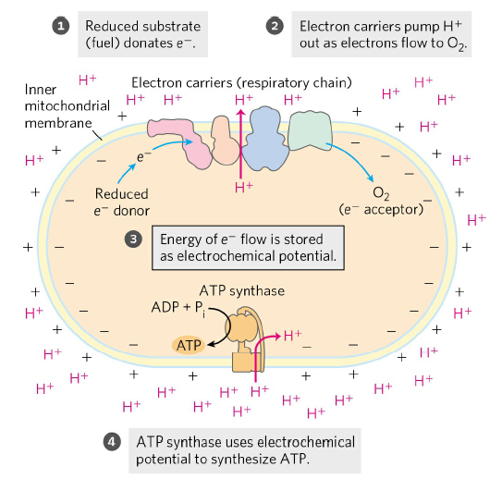
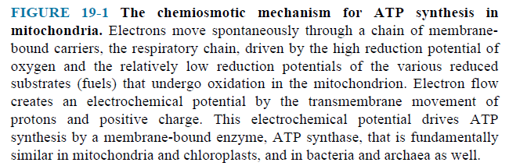

- In addition to NAD-linked dehydrogenases and FMN or FAD-linked flavoproteins, three other types of electron-carrying molecules function in the respiratory chain.
- A hydrophobic quinone (ubiquinone) is also called coenzyme Q (simply Q) (Fig. 19-3) and two different types of iron-containing proteins (cytochromes) (Fig. 19-4) and iron-sulfur proteins) (Fig. 19-5).
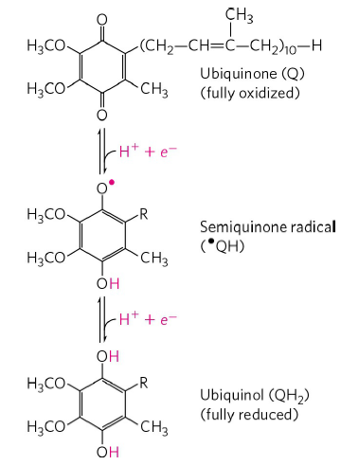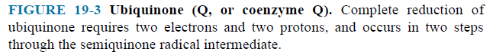
- Cytochromes have iron-containing heme prosthetic groups (Fig. 19-4a).

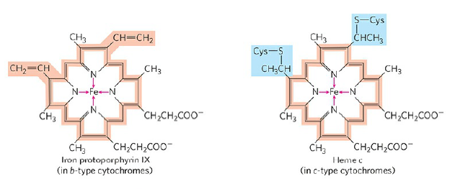
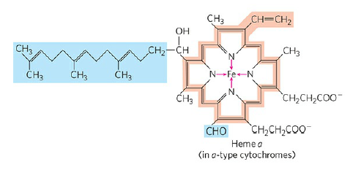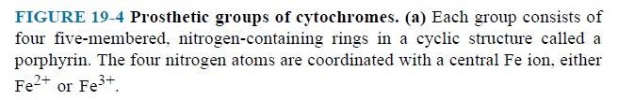

- In iron-sulfur proteins, the iron is present not in heme but in association with inorganic sulfur atoms or with the sulfur atoms of Cys residues in the protein, or both (Fig. 19-5).

