DNA Topolojisinin (Geometrisinin) Düzenlenmesi

- Bazı DNA’lar yani kromozomlar katlanmış durumdadır. (Fig. 24-10) (Fig. 24-13)
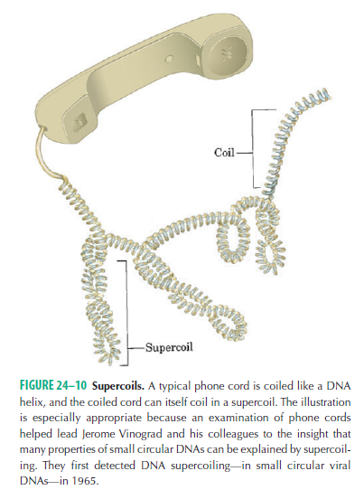

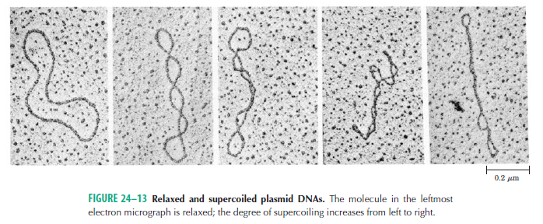
- Bu katlanmalardaki düzenlenmeler DNA’nın fonksiyonel aktiviteleri için merkezi bir durumdur. (Replikasyon).
- DNA’nın yani çift zincirin, zincirlerine ayrılmasıyla reaksiyonlar başlamaktadır.
- Değişik şekilde zincirler birbirinden ayrılır.
- DNA’nın katlanması topoizomerazlar diye bilinen enzimler sayesinde kontrol edilebilir.
- Mekanizmalarına göre Tip I topoizomerazlar ve Tip II topoizomerazlar diye ikiye ayrılırlar.
- Fosfodiester bağını keserler.

Tip I Topoizomerazlar

- Enzim çift zincirli DNA’da zincirler ile tek tek etkileşiyor. (Fig. 24-21)
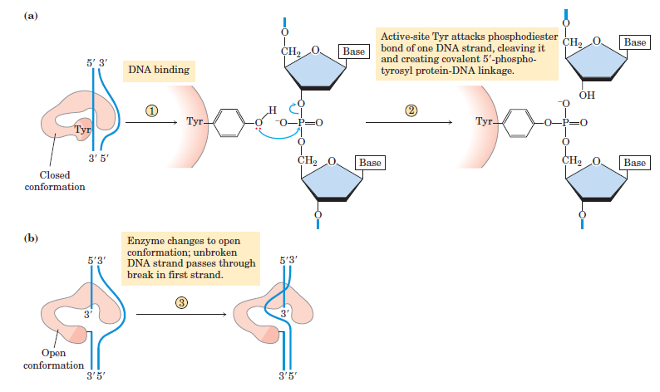

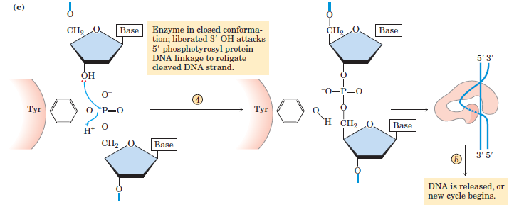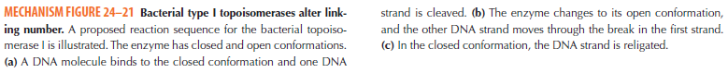
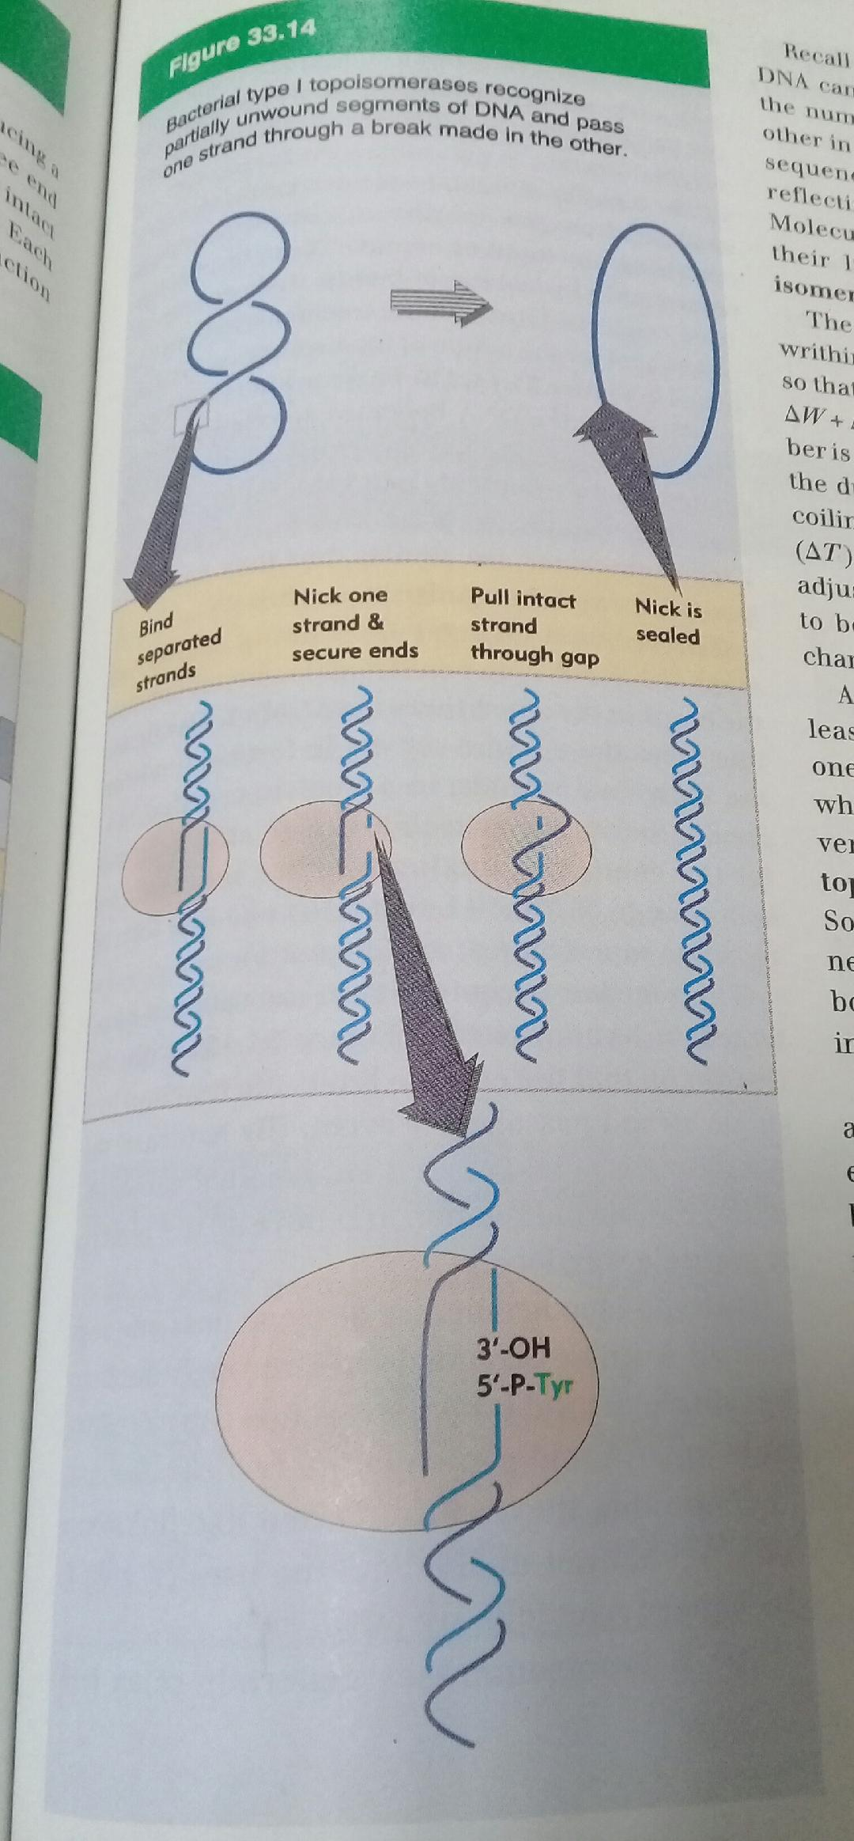

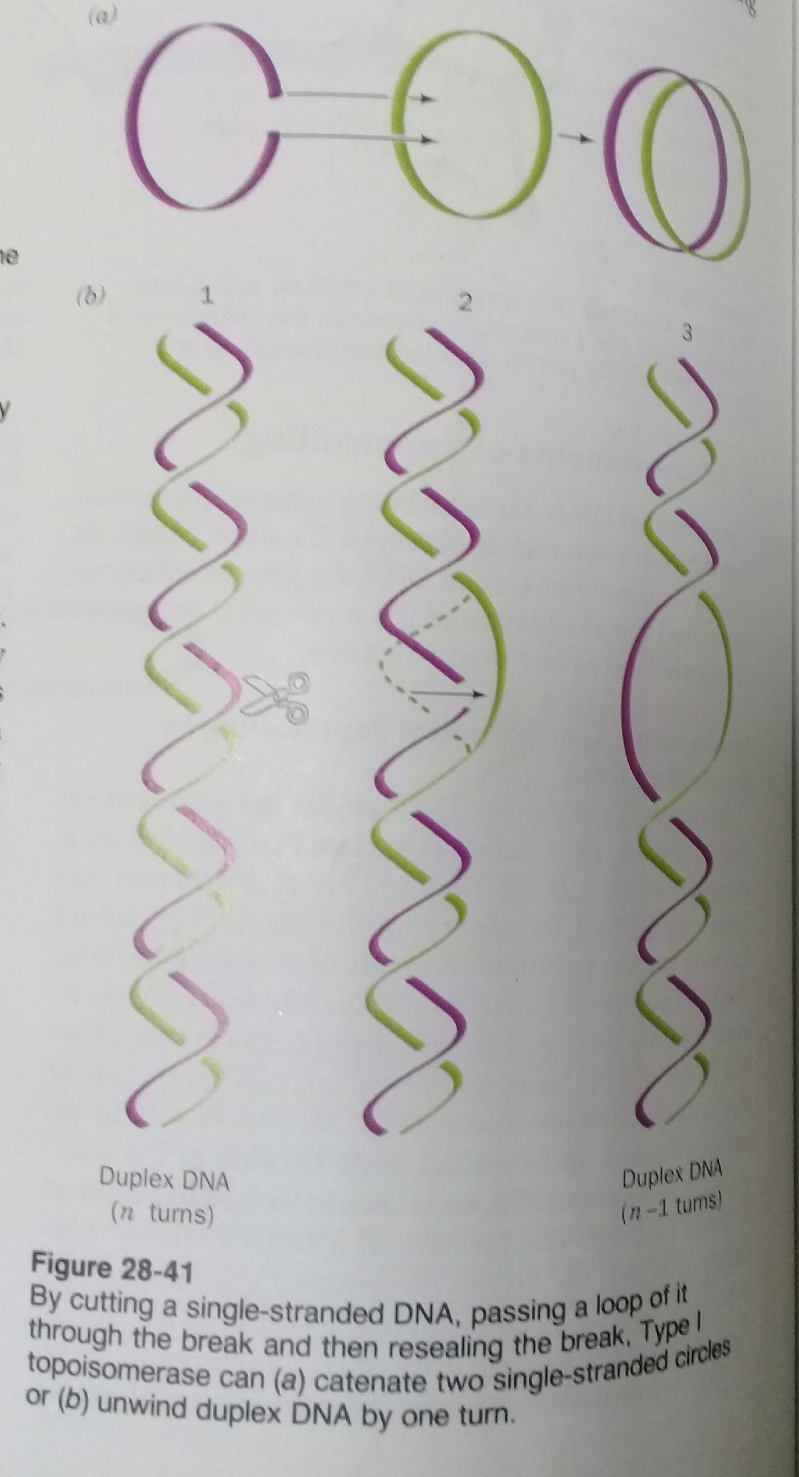

Tip II Topoizomerazlar

- Enzim çift zincirli DNA’da her iki zincirle de etkileşiyor. ATP’ye de ihtiyaç duyuluyor. (Fig. 24-22)
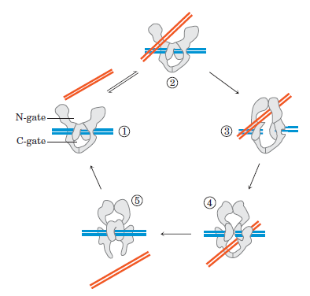
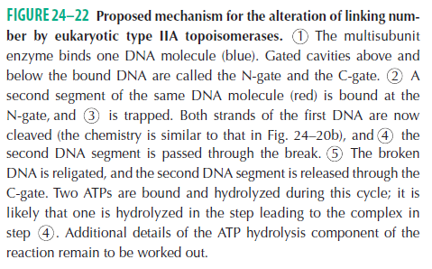

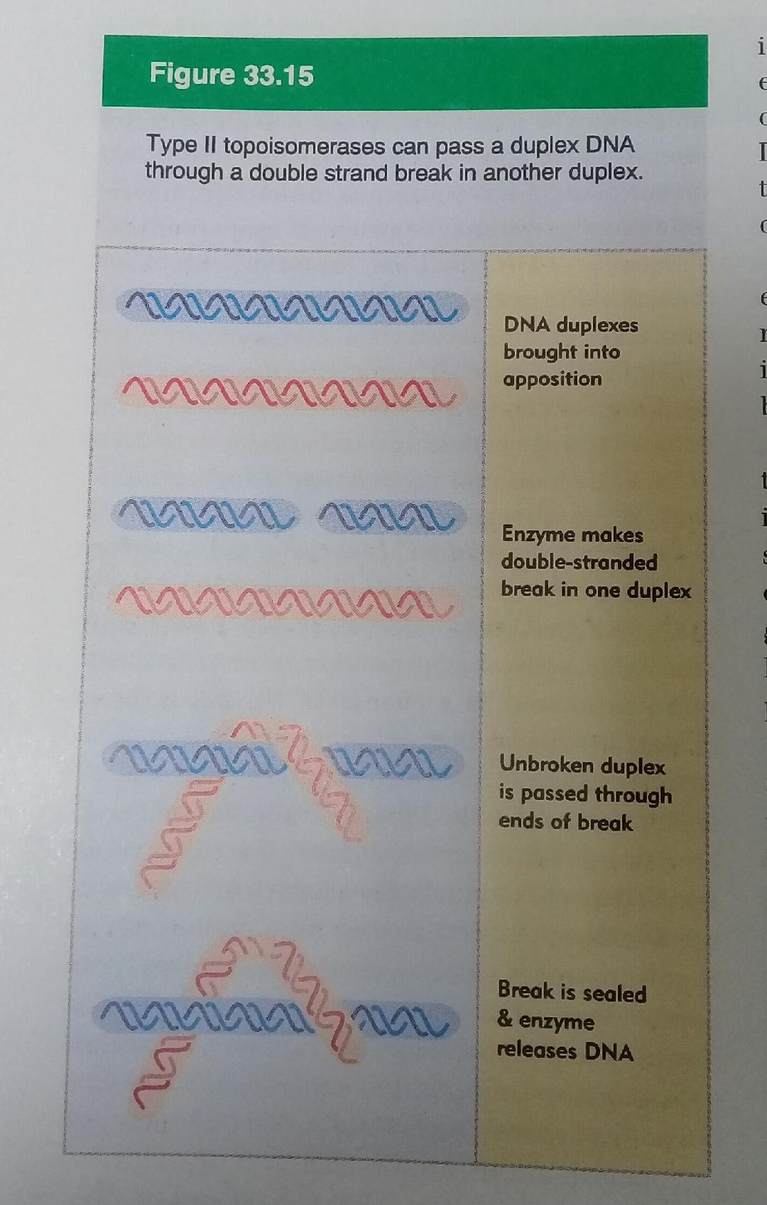

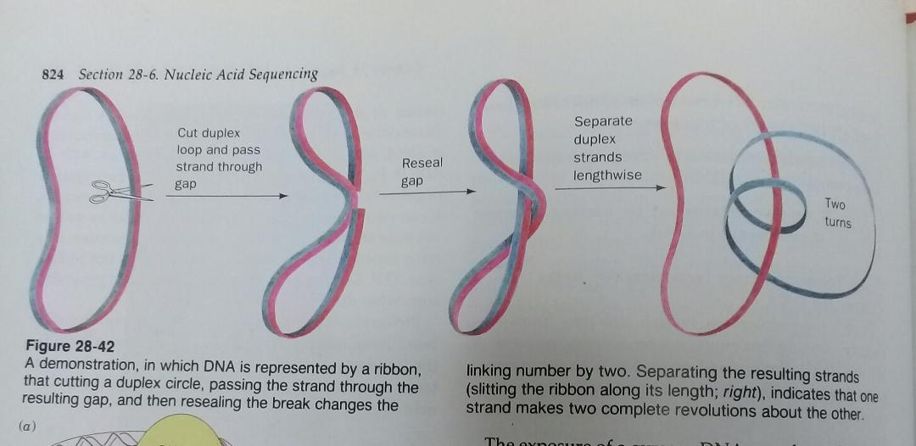

- DNA Giraz enzimi Tip II topoizomerazlara örnektir. Replikasyonda çalışmaktadır.

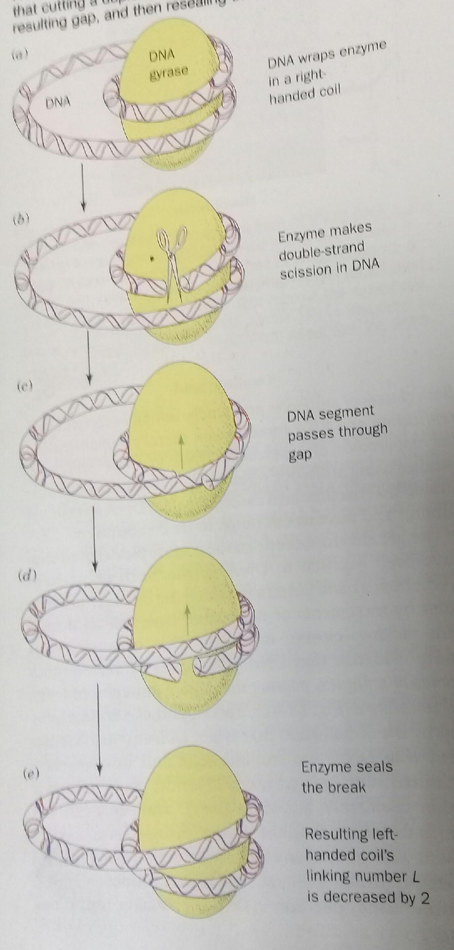

DNA Metabolism
- DNA is the repository of genetic information.
- The nucleotide sequences of DNA encode the primary structures of all cellular RNAs and proteins and, through enzymes, indirectly affect the synthesis of all other cellular constituents.

DNA Replication
- Replication is to produce many identical copies of large, complex macromolecules.

DNA Replication Follows a Set of Fundamental Rules

DNA Replication Is Semiconservative
- Each DNA strand serves as a template for the synthesis of a new strand, producing two new DNA molecules, each with one new strand and one old strand.

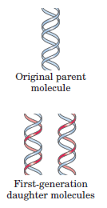

Replication Begins at an Origin and Usually Proceeds Bidirectionally
- The two replication forks meet at a point on the side of the circle opposite to the origin.

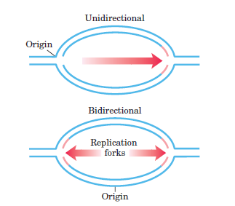
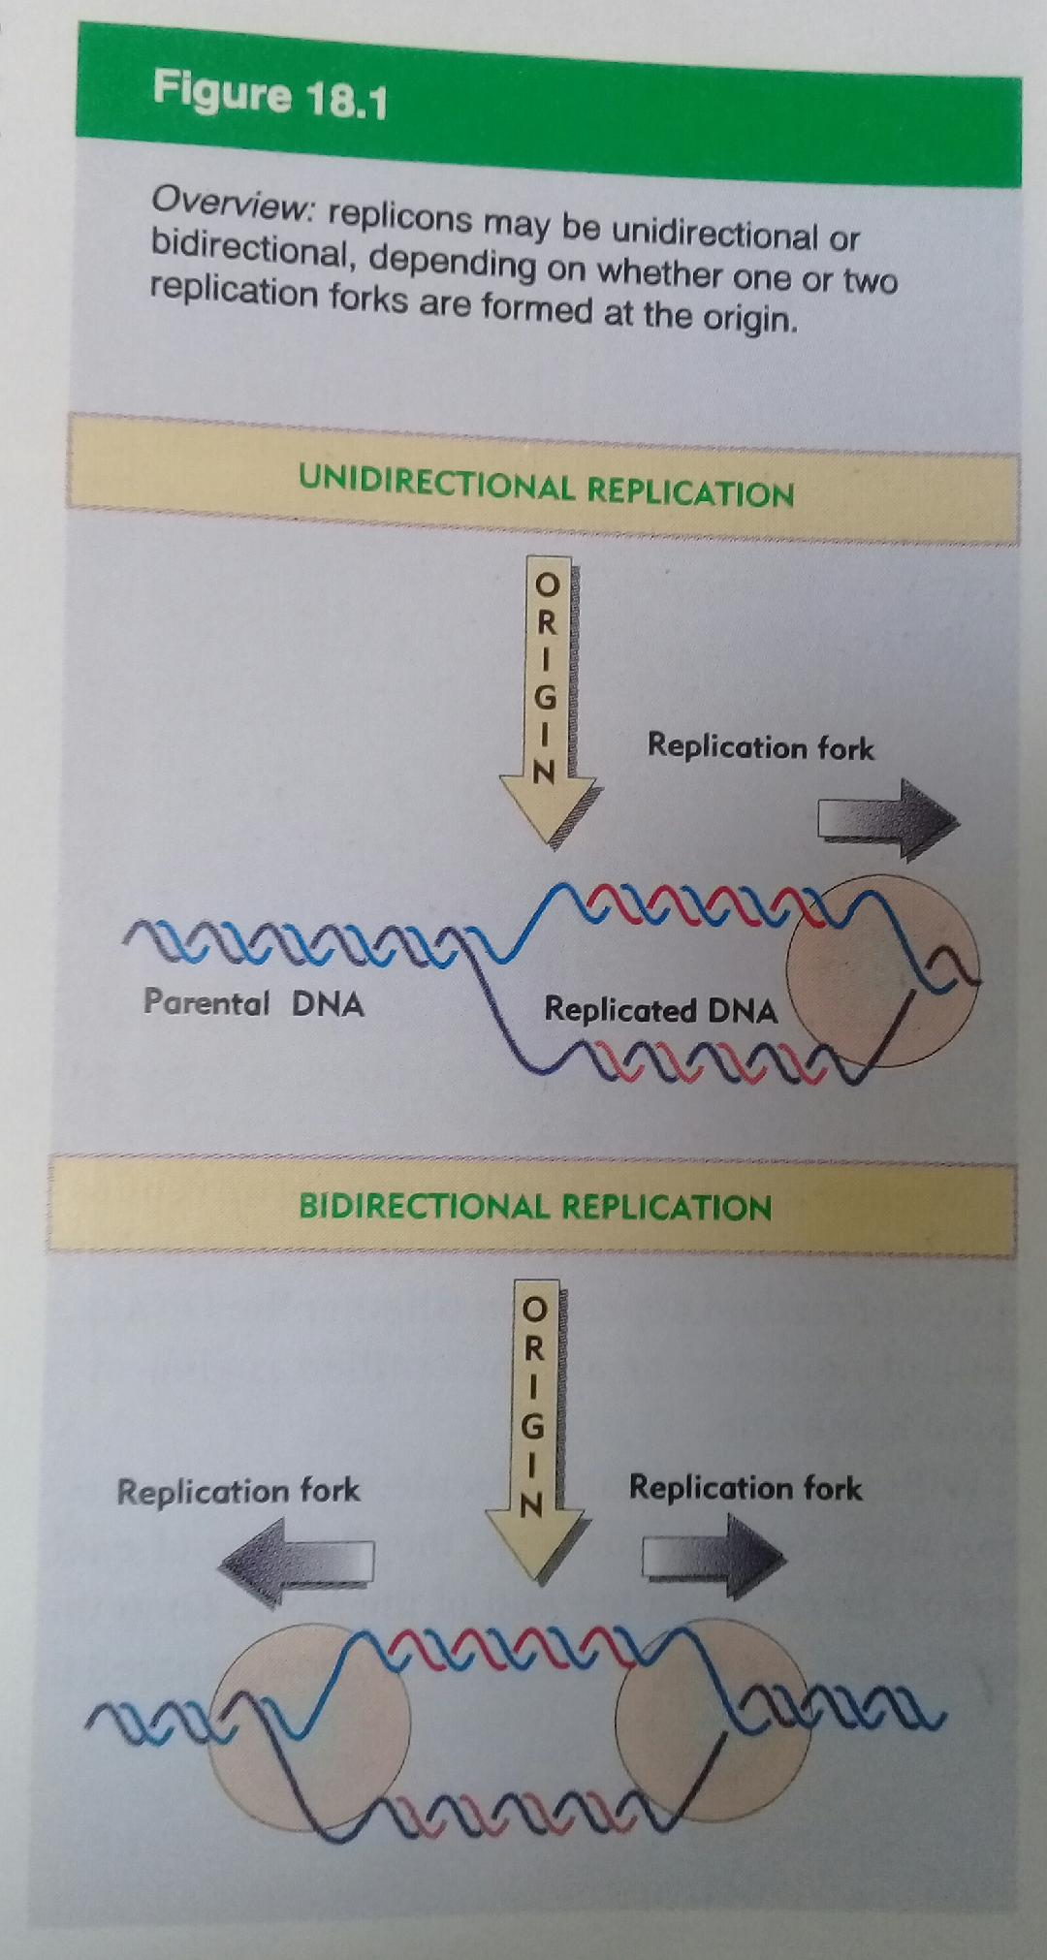
- Specific origins of replication have been identified and characterized in bacteria and eukaryotes.

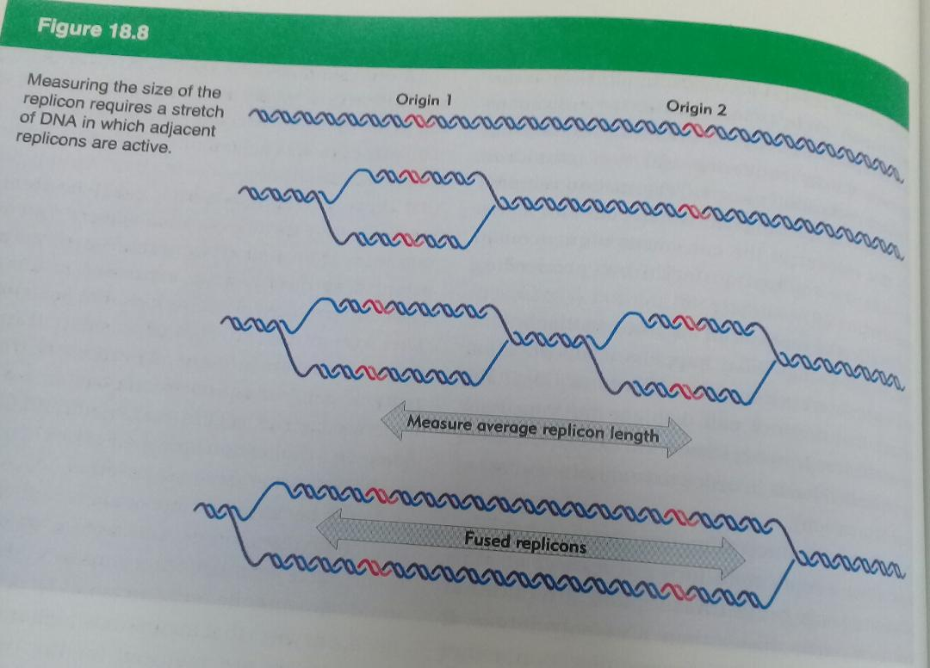

DNA Synthesis Proceeds in a 5’ 3’ Direction and Is Semidiscontinuous
- A new strand of DNA is always synthesized in the 5’ 3’ direction.
- If synthesis always proceeds in the 5’ 3’ direction, how can both strands be synthesized simultaneously?
- One of the new DNA strands is synthesized in short pieces, called Okazaki fragments (Fig. 25–4).

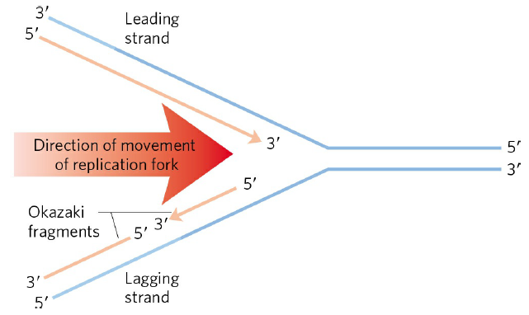
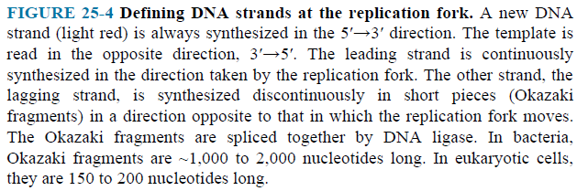

- One strand is synthesized continuously and the other discontinuously.
- The continuous strand, or leading strand, is the one in which 5’ 3’ synthesis proceeds in the same direction as replication fork movement.
- The discontinuous strand, or lagging strand, is the one in which 5’ 3’ synthesis proceeds in the direction opposite to the direction of fork movement.

DNA Is Synthesized by DNA Polymerases
- The general reaction is (Fig. 25–5a,b).
(dNMP)_{n} + dNTP (dNMP)_{n+1} + PP_{i}
DNA Lengthened DNA
- All DNA polymerases require a template and a primer.
- A primer is a strand segment (complementary to the template) with a free 3’-hydroxyl group to which a nucleotide can be added.

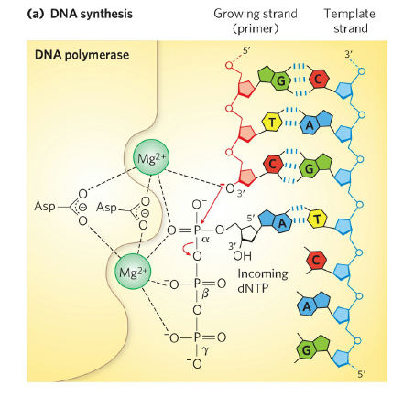
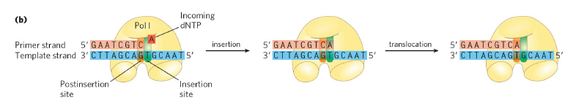
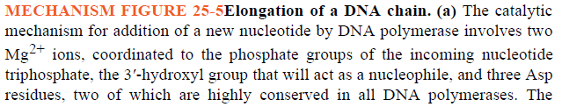
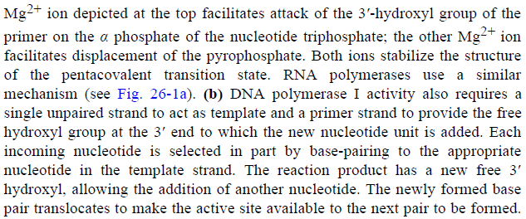
Replication Is Very Accurate
- In E. coli, a mistake is made only once for every 10⁹ to 10¹⁰ nucleotides added.
- For the E. coli chromosome of 4.6 x 10⁶ bp, this means that an error occurs only once per 1,000 to 10,000 replications.
- Incorrect bases can be rejected before the phosphodiester bond is formed.
- All DNA polymerases have a separate 3’ 5’ exonuclease activity that checks each nucleotide after it is added.
- If the polymerase has added the wrong nucleotide, this exonuclease activity removes the mispaired nucleotide, and the polymerase begins again (Fig. 25–7).
- This activity, known as proofreading.
- The polymerizing and proofreading activities have separate active sites within the enzyme.

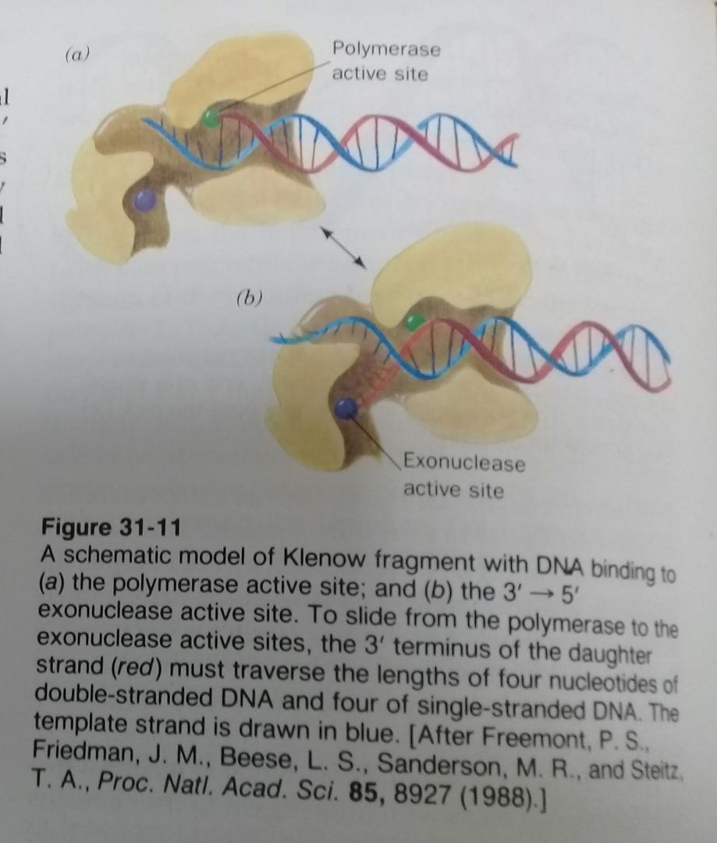
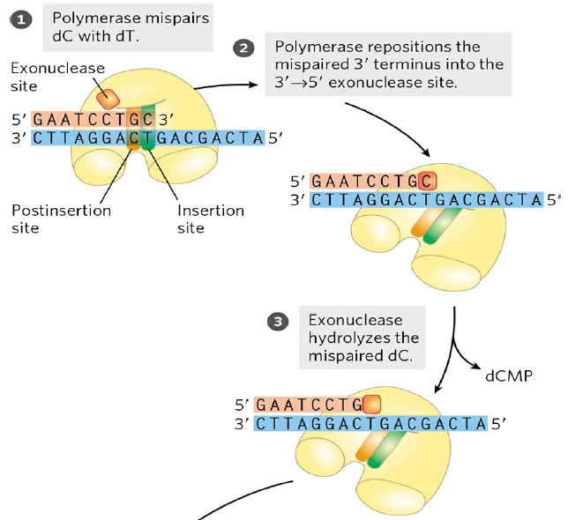
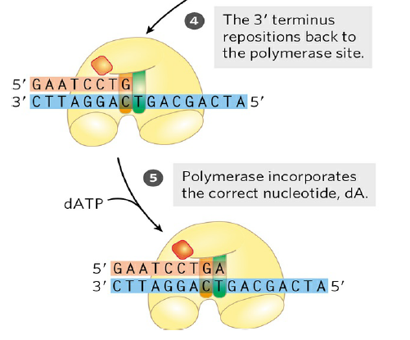
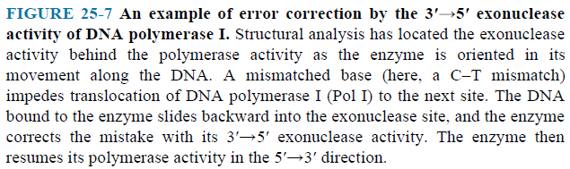

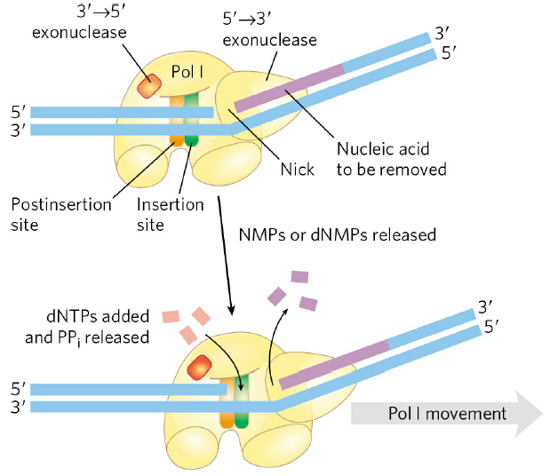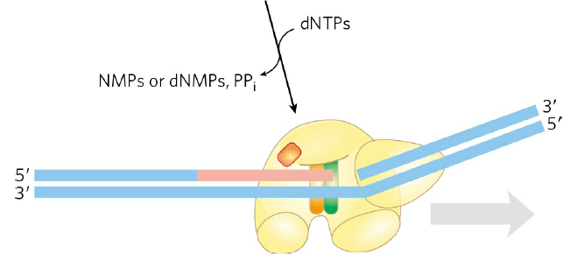
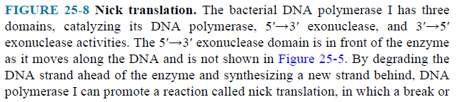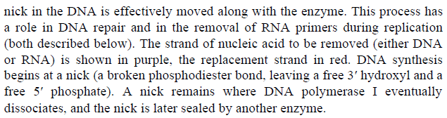

E. coli Has at Least Five DNA Polymerases
- The properties of DNA polymerase I, II and III are compared (Table 25–1).
- DNA polymerase II is an enzyme involved in one type of DNA repair.
- DNA polymerase III is the principal replication enzyme in E. coli.
- DNA polymerases IV and V are involved in an unusual form of DNA repair.
- The 5’ 3’ exonuclease activity of DNA polymerase I can replace a segment of DNA (or RNA) paired to the template strand, in a process known as nick translation (Fig. 25–8).

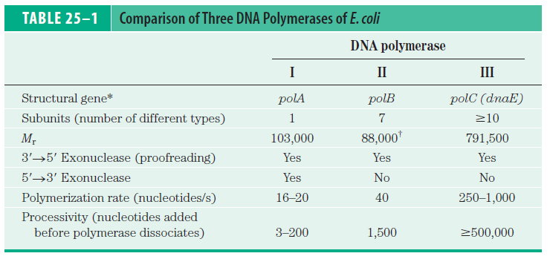
Number/cell 400 unknown 10-20
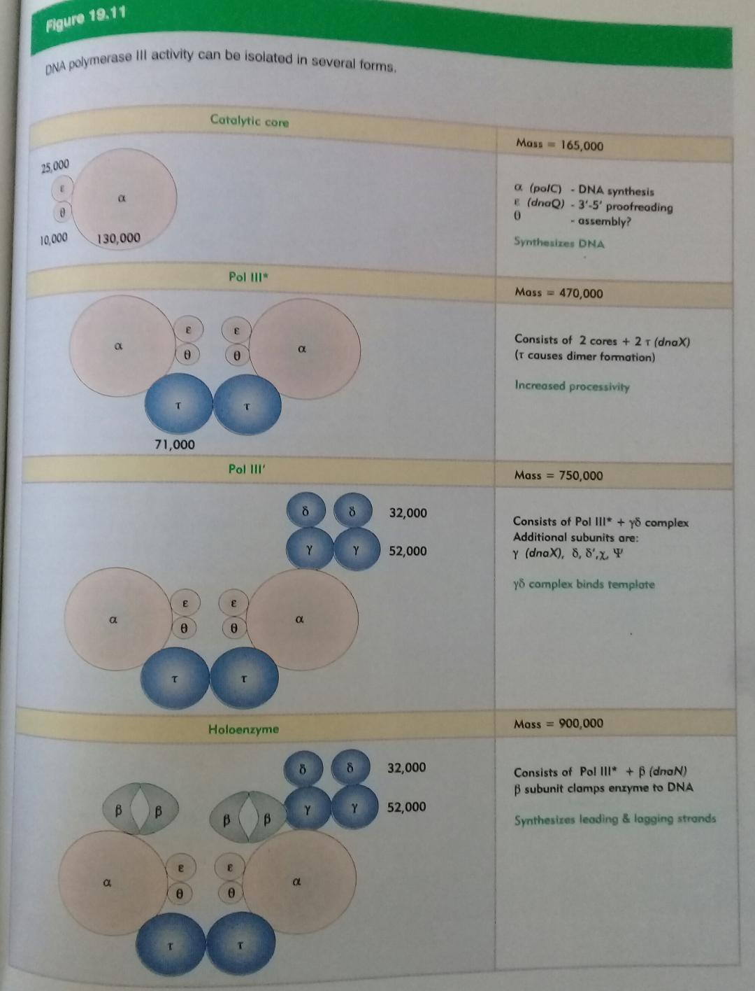
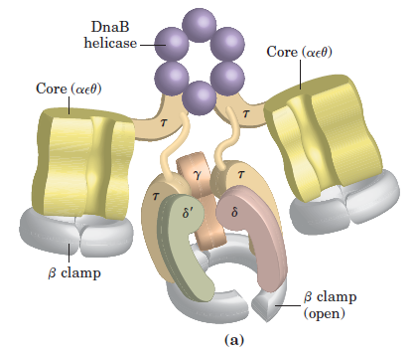
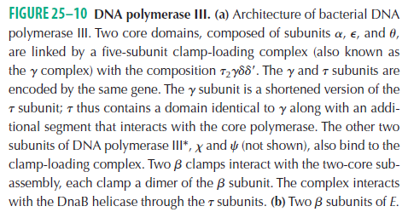

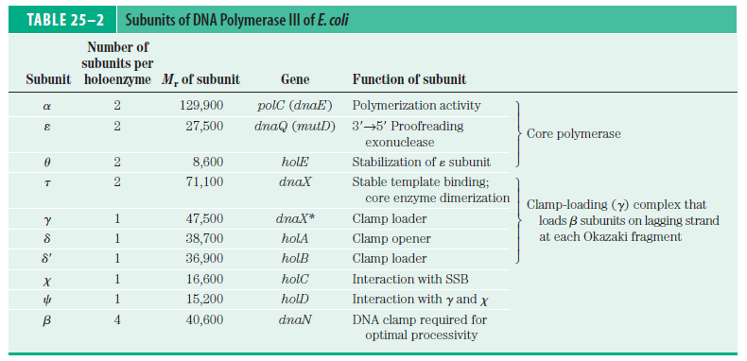
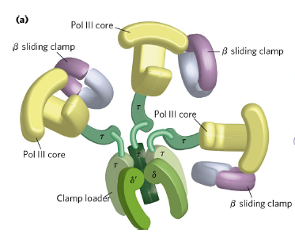

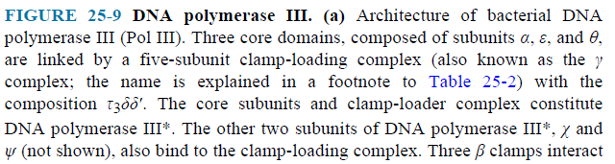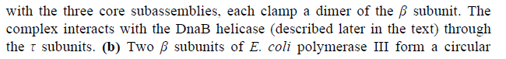

DNA Replication Requires Many Enzymes and Protein Factors
- The entire complex has been termed the DNA replicase system or replisome.
- Helicases move along the DNA and separate the strands.
- The separated strands are stabilized by DNA-binding proteins.
- Before DNA polymerases can begin synthesizing DNA, primers must be present on the template—generally short segments of RNA synthesized by enzymes known as primases.
- After an RNA primer is removed and the gap is ﬁlled in with DNA, a nick remains in the DNA backbone in the form of a broken phosphodiester bond. These nicks are sealed by DNA ligases.

Replication of the E.coli Chromosome Proceeds in Stages
- The synthesis of a DNA molecule can be divided into three stages: initiation, elongation and termination.

Initiation
- The E. coli replication origin, oriC, consists of 245 bp.

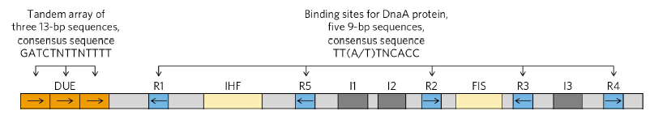
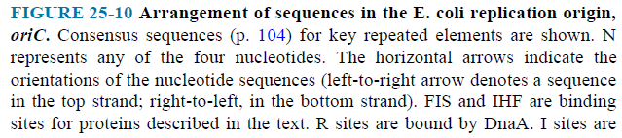

- At least 10 different enzymes or proteins participate in the initiation phase (Table 25–3).
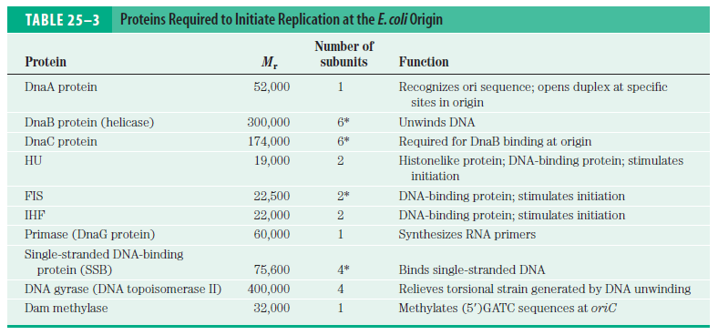
- Eight DnaA protein molecules assemble to form a helical complex (Fig. 25–11).
- The complex formed at the replication origin also includes several DNA-binding proteins—HU, IHF, and FIS—that facilitate DNA bending.
- Hexamers of the DnaB protein bind to each strand, with the aid of DnaC protein.
- The DnaB helicase activity further unwinds the DNA.
- The DnaB helicases travel in opposite directions, creating two potential replication forks.

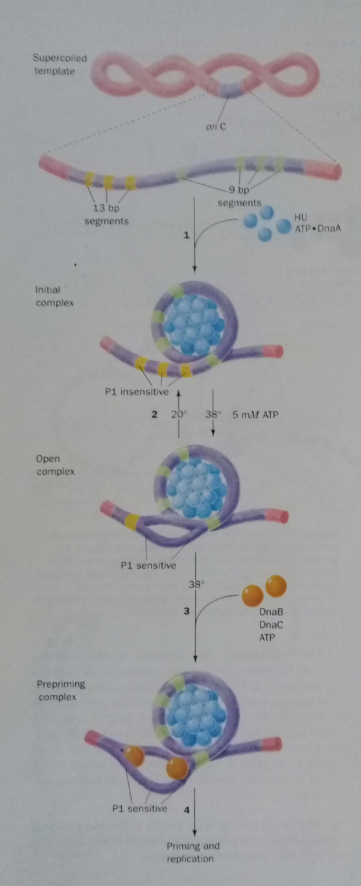
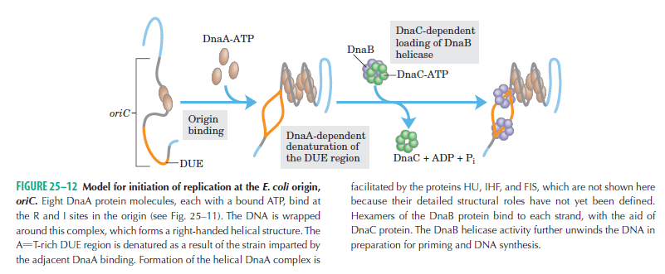
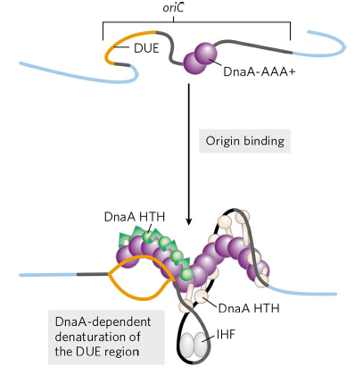
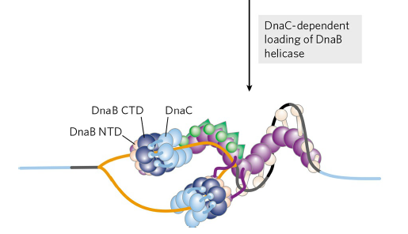
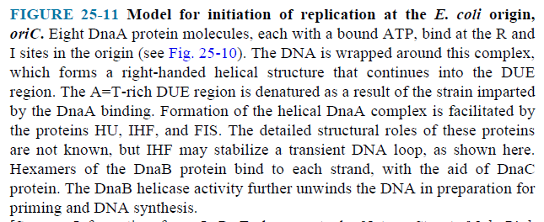

- Many molecules of single-stranded DNA–binding protein (SSB) bind to and stabilize the separated strands.
- DNA gyrase relieves the topological stress induced ahead of the fork by the unwinding reaction.
- The timing of replication initiation is affected by DNA methylation. The oriC DNA is methylated by the Dam methylase.

Elongation
- The elongation phase includes two distinct but related operations: leading strand synthesis and lagging strand synthesis.
- The leading strand is synthesized continuously in the same direction as replication fork movement.
- The lagging strand is synthesized discontinuously as short Okazaki fragments, which are subsequently ligated.
- Parent DNA is ﬁrst unwound by DNA helicases, and the resulting topological stress is relieved by topoisomerases.
- After each separated strand is stabilized by SSB, synthesis of leading and lagging strands is different.
- Leading strand synthesis begins with the synthesis by primase (DnaG protein) of a short RNA primer at the replication origin.
- For the lagging strand synthesis, DnaG interacts with DnaB helicase. The primer is synthesized in the direction opposite to that in which the DnaB helicase is moving.
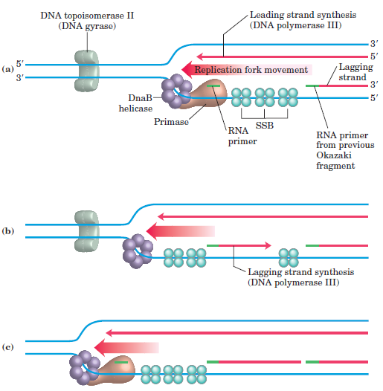

- Deoxyribonucleotides are added to these primers by a DNA polymerase III which is the primary replication enzyme
- Both strands are produced by a single asymmetric DNA polymerase III dimer.
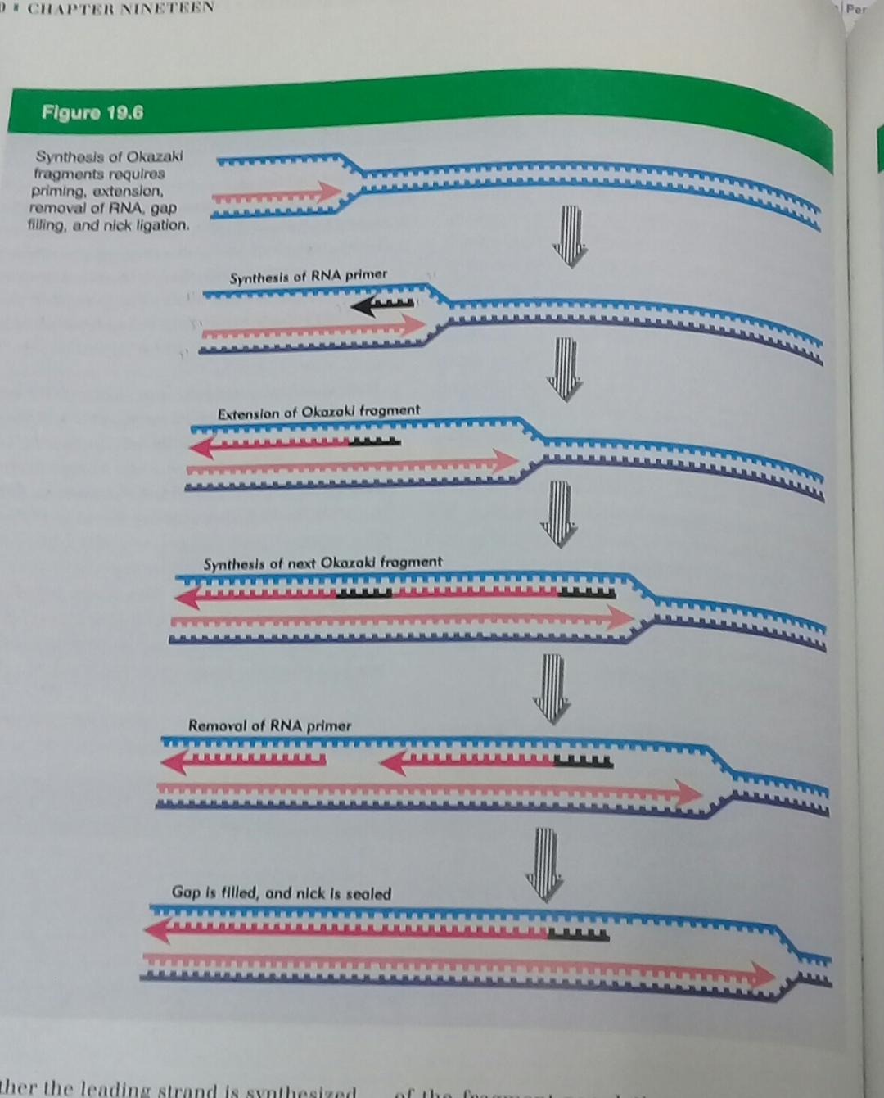
- This is accomplished by looping the DNA of the lagging strand.

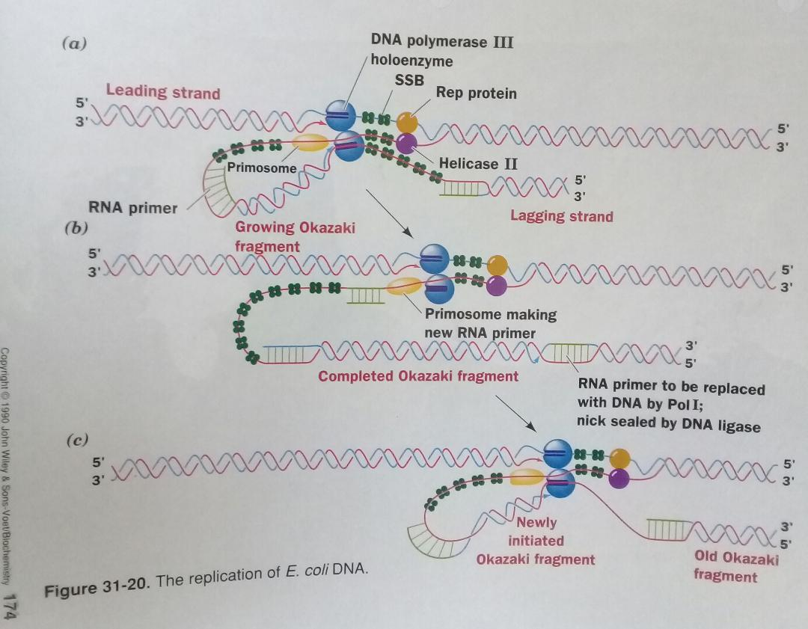
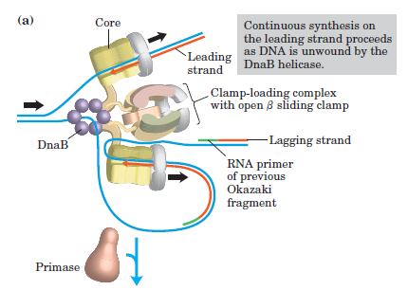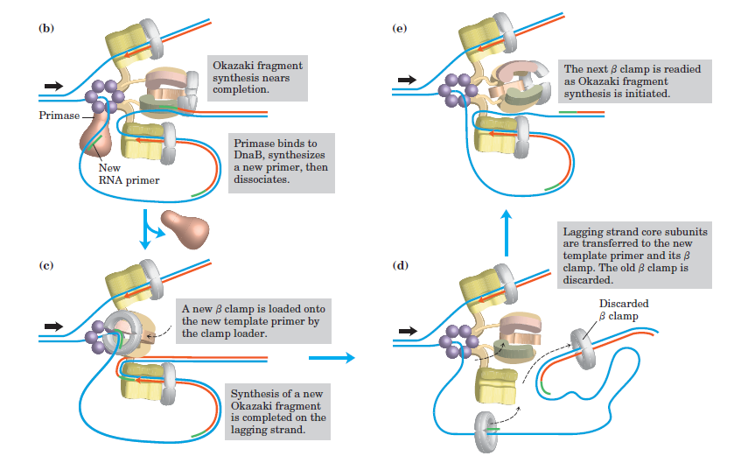
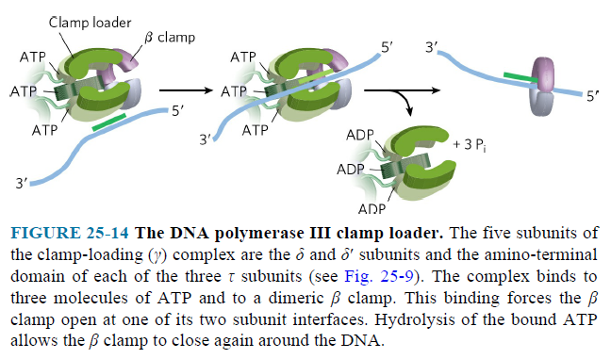
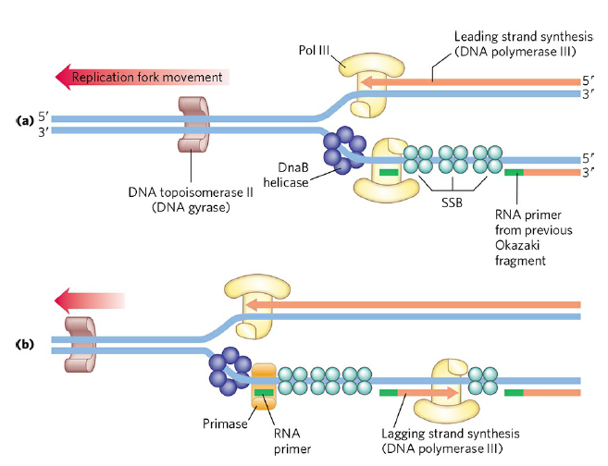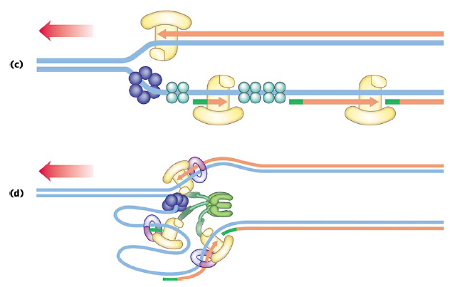
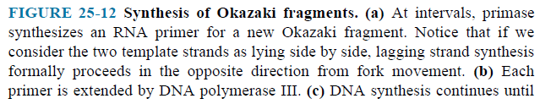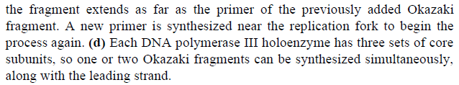
- The proteins acting at the replication fork are summarized in (p1023, Table 25–4).
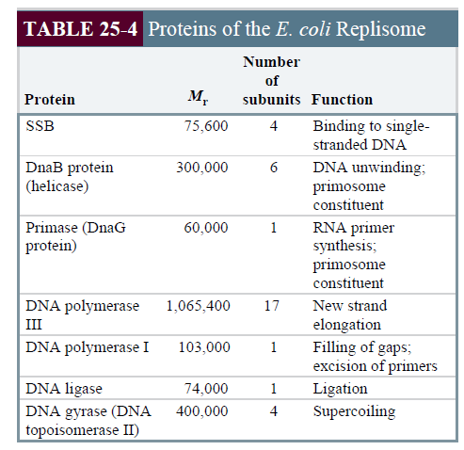
- DnaB helicase and DnaG primase constitute a functional unit within the replication complex, the primosome.
- DnaB helicase, bound in front of DNA polymerase III, unwinds the DNA at the replication fork.
- DnaG primase occasionally associates with DnaB helicase and synthesizes a short RNA primer.
- When synthesis of an Okazaki fragment has been completed, replication halts, and the core subunits of DNA polymerase III dissociate from their sliding clamp (and from the completed Okazaki fragment) and associate with the new clamp.
- This initiates synthesis of a new Okazaki fragment.
- Once an Okazaki fragment has been completed, its RNA primer is removed and replaced with DNA by DNA polymerase I, and the remaining nick is sealed by DNA ligase (Fig. 25–16).
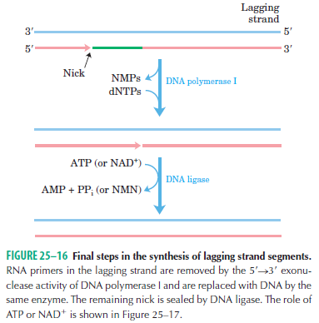
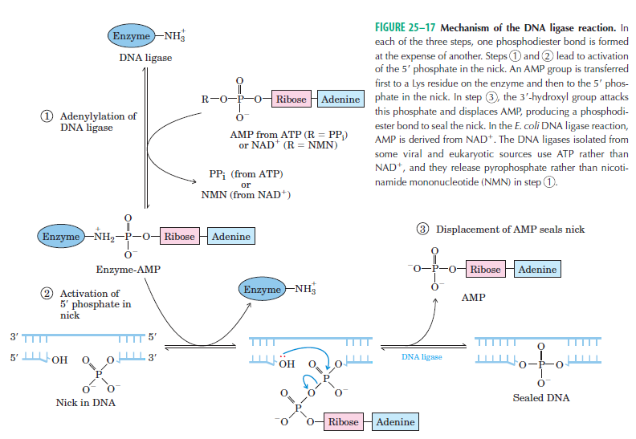

- DNA ligase catalyzes the formation of a phosphodiester bond between a 3’ hydroxyl at the end of one DNA strand and a 5’ phosphate at the end of another strand.

Termination
- The two replication forks of the circular E. coli chromosome meet at a terminus region containing multiple copies of a 20 bp sequence called Ter (Fig. 25–17).
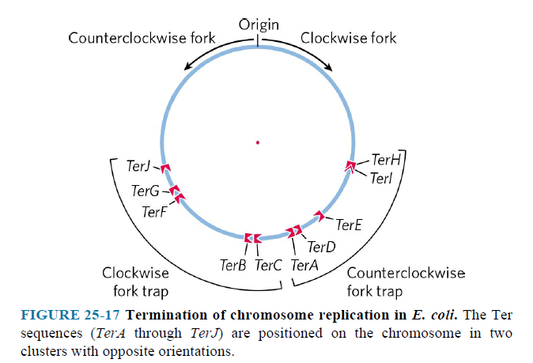
- The Ter sequences function as binding sites for the protein Tus (terminus utilization substance).
- The Tus-Ter complex can arrest a replication fork from only one direction.

Replication in Eukaryotic Cells Is Similar but More Complex
- Eukaryotic chromosomes are always much larger than bacterial chromosomes, so multiple origins are probably a universal feature of eukaryotic cells.
- Eukaryotes have several types of DNA polymerases.

