Chapter 18
Amino Acid Oxidation and the Production of Urea
- Oxidative degradation of amino acids makes a significant contribution to the generation of metabolic energy.
- Overview of amino acid catabolism in mammals. The amino groups and the carbon skeleton take separate but interconnected pathways (Fig. 18-1).

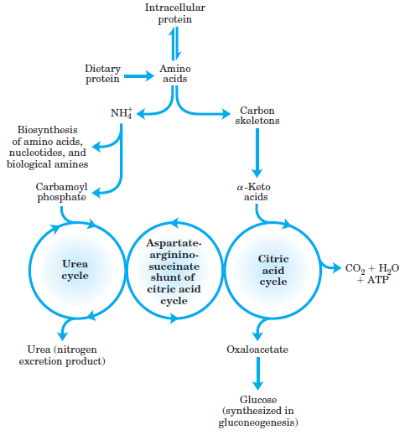

18.1 Metabolic Fates of Amino Acids
- Nitrogen, N₂, is abundant in the atmosphere but is too inert for use in most biochemical processes.
- Because only a few microorganisms can convert N₂ to biologically useful forms such as NH₃, amino groups are carefully husbanded in biological systems.
- An overview of the catabolic pathways of ammonia and amino groups in vertebrates (Fig. 18-2 a).
- Most amino acids are metabolized in the liver.
- Some of the ammonia generated in this process is recycled and used in a variety of biosynthetic pathways; the excess is either excreted directly or converted to urea or uric acid for excretion, depending on the organism (Fig. 18-2 b).
- Four amino acids play central roles in nitrogen metabolism: glutamate, glutamine, alanine and aspartate.

Dietary Protein Is Enzymatically Degraded to Amino Acids
- In the stomach, pepsin hydrolyzes ingested proteins at peptide bonds on the amino-terminal side of the aromatic amino acid residues Phe, Trp, and Tyr, cleaving long polypeptide chains into a mixture of smaller peptides.
- The digestion of proteins continues in the small intestine by trypsin, chymotrypsin, carboxypeptidases A and B and aminopeptidase having different amino acid specificities.
- The free amino acids enter the blood and travel to the liver.

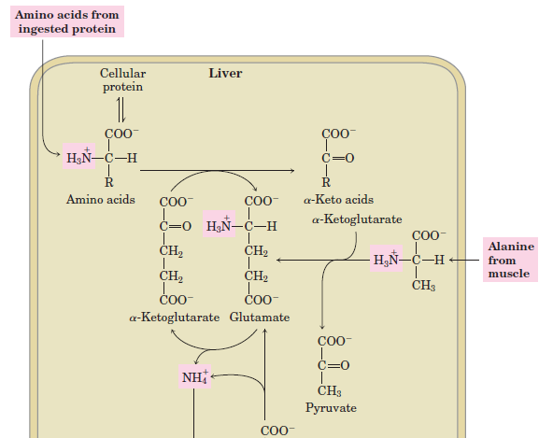
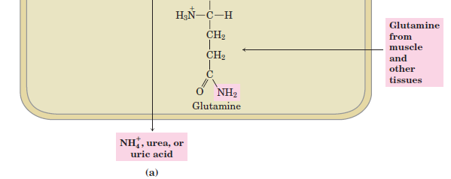
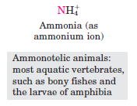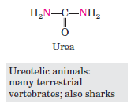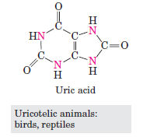
(b)
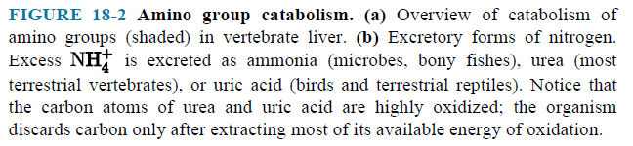

Pyridoxal Phosphate (PLP) Participates in the Transfer of
α-Amino Groups to α-Ketoglutarate
- The first step in the catabolism of most amino acids is removal of the α-amino groups, promoted by enzymes called aminotransferases or transaminases.
- The effect of transamination reactions is to collect the amino groups from many different amino acids in the form of glutamate (Fig. 18-4).
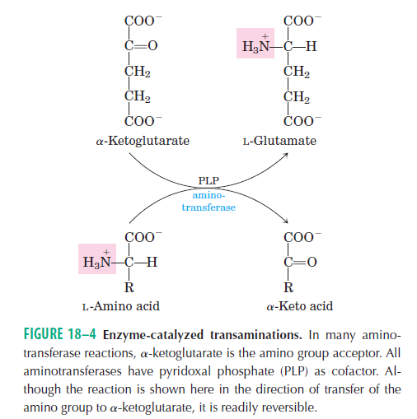
Glutamate Releases Its Amino Group as Ammonia in the Liver
- Glutamate is transported from the cytosol into the mitochondrial matrix.
- Glutamate undergoes oxidative deamination catalyzed by glutamate dehydrogenase (Fig. 18-7).
- The α-ketoglutarate formed from glutamate deamination can be used in the citric acid cycle and for glucose synthesis.

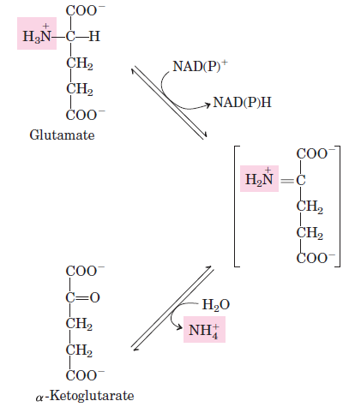

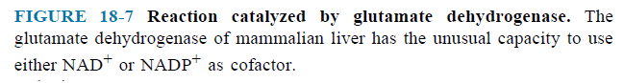

Glutamine Transports Ammonia in the Blood
- Ammonia is toxic to animal tissues.
- In most animals, much of the free ammonia is converted to a nontoxic compound.
- The free ammonia is combined with glutamate to yield glutamine by the action of glutamine synthetase (Fig. 18-8).

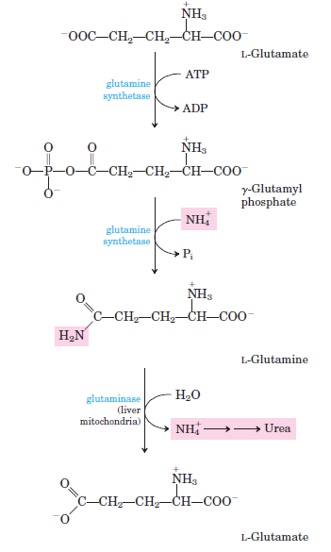

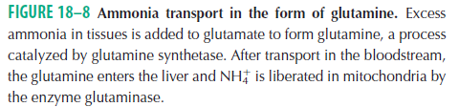

Alanine Transports Ammonia from Skeletal Muscles to the Liver
- Alanine plays a special role in transporting amino groups to the liver in a nontoxic form, via a pathway called the glucose-alanine cycle (Fig. 18–9).

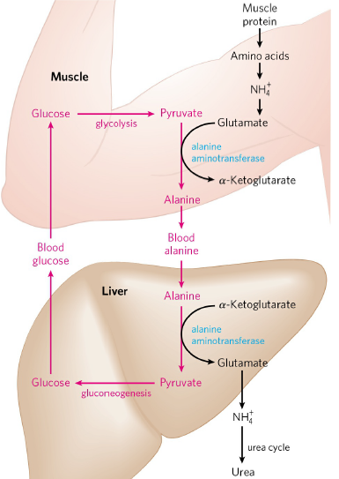

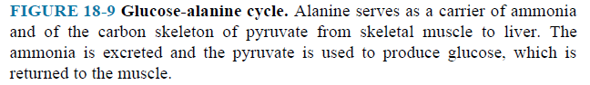
- In muscle, amino acids are degraded for fuel. Amino groups are collected in the form of glutamate.
- Glutamate can transfer its α-amino group to pyruvate. Alanine is formed.
- The alanine passes into the blood and travels to the liver.
- The amino group is transferred from alanine to α-ketoglutarate, forming pyruvate and glutamate.
- The pyruvate, in the liver, is converted to glucose, which is transported back to muscle as part of the glucose alanine cycle.
- Glutamate can enter mitochondria, where the glutamate dehydrogenase reaction releases NH₄⁺. NH₄⁺ is converted to urea by urea cycle.
- Glutamate can undergo transamination with oxaloacetate to form aspartate.

  - Nitrogen Excretion and the Urea Cycle
- In ureotelic organisms, the ammonia deposited in the mitochondria of liver is converted to urea in the urea cycle.
- The urea passes into the blood and thus to the kidneys and is excreted into the urine.

Urea Is Produced from Ammonia in Five Enzymatic Steps
- The urea cycle begins inside liver mitochondria, but three of the subsequent steps take place in the cytosol (Fig. 18-10).
- NH₄ and CO₂ (as HCO₃⁻) are converted to carbamoyl phosphate by carbamoyl phosphate synthetase I.
- The cycle has four enzymatic steps.
- Carbamoyl phosphate and ornithine are converted to citrulline by ornithine transcarbamoylase. The citrulline passes into the cytosol.
- The second amino group now enters from aspartate. Citrulline and aspartate are converted to argininosuccinate by argininosuccinate synthetase.
- The argininosuccinate is then cleaved by argininosuccinase to form free arginine and fumarate.
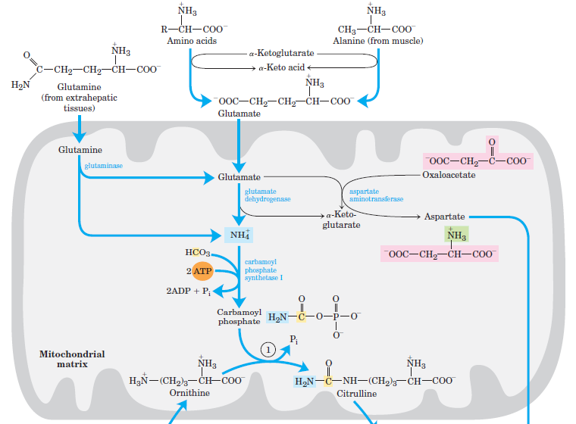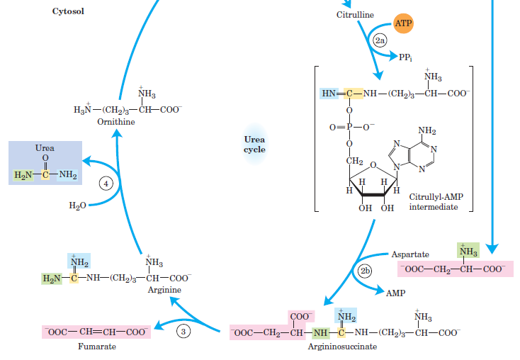
FIGURE 18-10 The urea cycle and reactions that feed amino groups into the cycle.

- Arginase cleaves arginine to yield urea and ornithine.
- Ornithine is transported into the mitochondrion to initiate another round of the urea cycle.

The Citric Acid and Urea Cycles Can Be Linked
- Fumarate produced in the urea cycle is also an intermediate of the citric acid cycle.
- These two cycles are interconnected by fumarate (Fig. 18-12).
- Several enzymes of the citric acid cycle, including fumarase and malat dehydrogenase, are also present as isozymes in the cytosol.

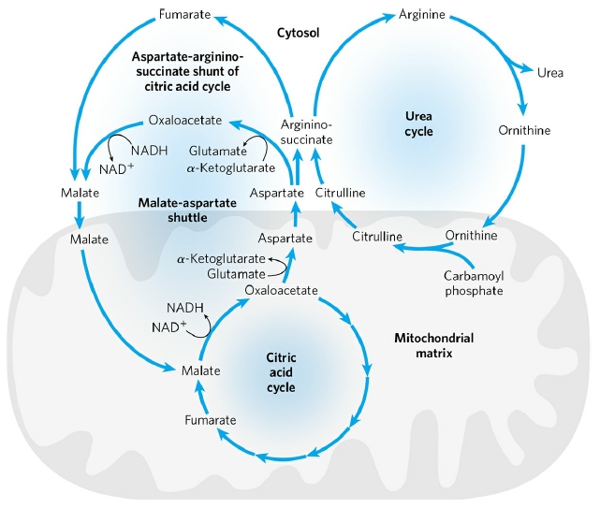
FIGURE 18-12 Links between the urea cycle and citric acid cycle.
- The fumarate can be converted to malate in the cytosol. The malate can be transported into mitochondria for use in the citric acid cycle.
- Aspartate formed in mitochondria by transamination between oxaloacetate and glutamate can be transported to the cytosol.
- Aspartate serves as nitrogen donor in the urea cycle reaction.
- These reactions provide metabolic links between the separate pathways. It is called aspartate-argininosuccinate shunt.

18.3 Pathways of Amino Acid Degradation
- The pathways of amino acid catabolism normally account for only 10% to 15% of the human body’s energy production; these pathways are not nearly as active as glycolysis and fatty acid oxidation.
- The 20 catabolic pathways converge to form only six major products.
- They are α-ketoglutarate, succinyl-CoA, fumarate, oxaloacetate, pyruvate and acetyl-CoA. All of them enter the citric acid cycle (Fig. 18-15).
- Some amino acids can be converted to glucose. They are called glucogenic amino acids.
- Some amino acids can be converted to ketone bodies. They are called ketogenic amino acids.
- Some amino acids (tryptophan, phenylalanine, tyrosine, threonine, and isoleucine) can be converted to both glucose and ketone bodies.
- Remember. Catabolism of both carbohydrates and lipids produces NADH and FADH₂.
- The degradation of amino acids also results NADH and FADH₂ through the action of the citric acid cycle.
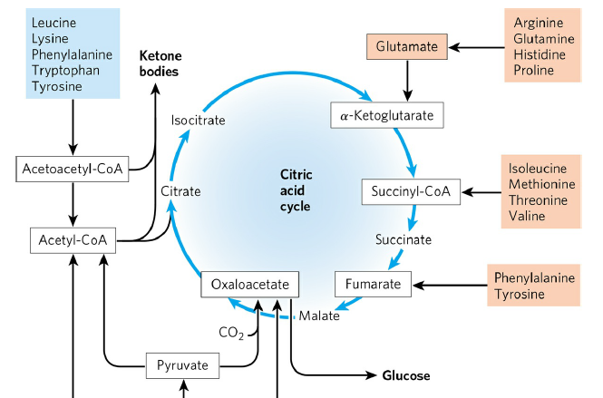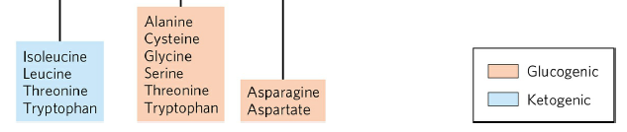

FIGURE 18-15 Summary of amino acid catabolism.

