19.2 ATP Synthesis
- ATP synthesis is explained by chemiosmotic model (Fig. 19-19).
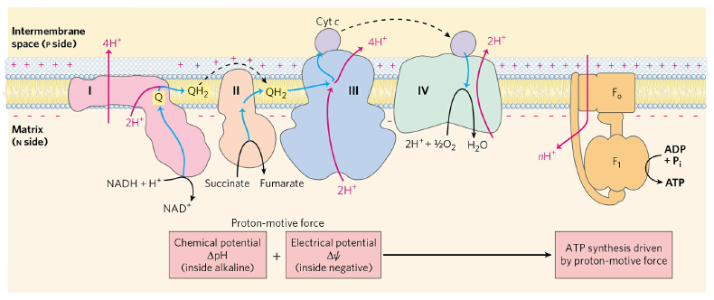
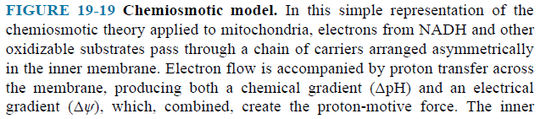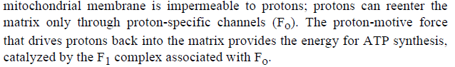
- Electron flow is accompanied by proton transfer across the membrane, producing both a chemical gradient and an electrical gradient.
- The proton-motive force drives the synthesis of ATP as protons flow back into the matrix through a proton pore associated with ATP synthase.
- ATP synthase has two functional domains, F₀ and F₁.
- If
- 10 protons are pumped out per NADH
- 6 protons are pumped out per FADH₂
- 4 protons must flow in to produce 1 ATP
- 2.5 molecules of ATP are generated by using 1 NADH in oxidative phosphorylation.
- 1.5 molecules of ATP are generated by using 1 FADH₂ in oxidative phosphorylation.
Shuttle Systems Indirectly Convey Cytosolic NADH into Mitochondria for Oxidation
- Complex I can accept electrons only from NADH in the matrix.
- The inner membrane is not permeable to NADH.
- How can the NADH generated by glycolysis in the cytosol be reoxidized to NAD⁺ by O₂ via the respiratory chain?
- Special shuttle systems carry cytosolic NADH into mitochondria by indirect route.
- One of them is malate-aspartate shuttle (Fig. 19-31). Complex I can accept electrons from NADH.
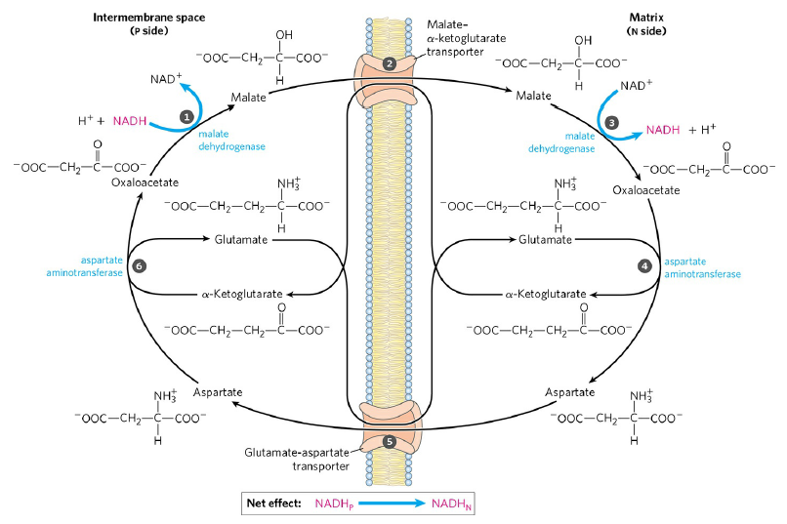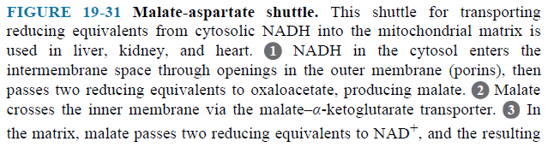
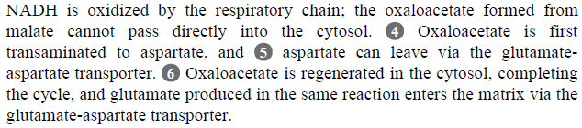

- The other is glycerol 3-phosphate shuttle (Fig. 19-32). Ubiquinone can accept electrons from FADH₂.
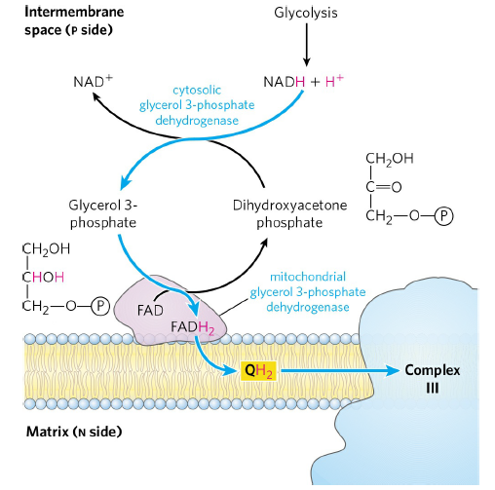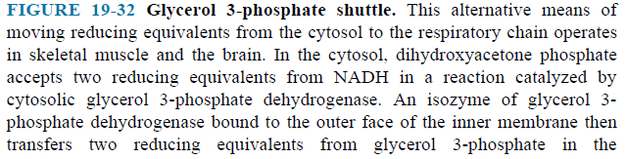
- Complete oxidation of a molecule of glucose to CO₂ yields 30 or 32 ATP (Table 19-5).

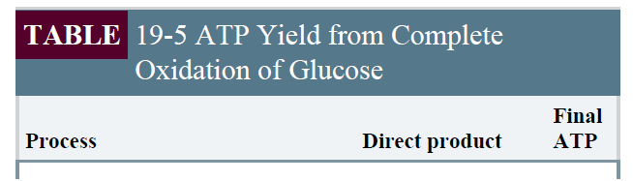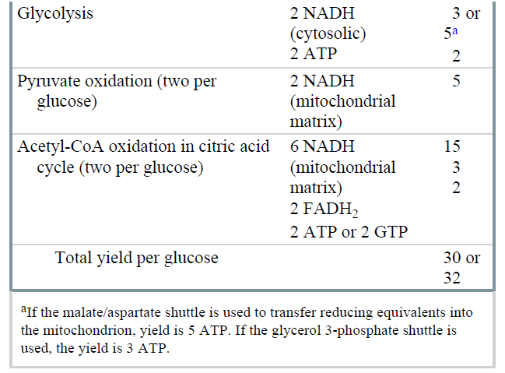

THE END

