Chapter 3 Amino Acids, Peptides and Proteins
- Cells can produce proteins (enzymes, hormones, antibodies)
- with different properties and activities by joining the same 20 amino acids in many different combinations and sequences.
3.1 Amino Acids
- Proteins are polymers of amino acids.

Amino Acids Share Common Structural Features
- All 20 amino acids are α-amino acids.
- They have a carboxyl group and an amino group bonded to the same carbon atom (the α carbon).
- They differ from each other in their side chains (R groups),
- vary in structure, size and electric charge.
- The common amino acids of proteins have been assigned three-letter abbreviations and one-letter symbols (Table 3–1).
- The α carbon is bonded to four different groups (except glycine)
- a carboxyl group, an amino group, an R group and a hydrogen atom.
- is a chiral center.
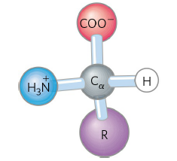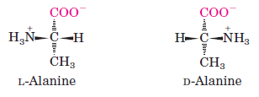
- All molecules with a chiral center are also optically active,
- rotate plane-polarized light.
The Amino Acid Residues in Proteins Are L Stereoisomers
- The term “residue” reflects the loss of the elements of water when one amino acid is joined to another.
- L stereoisomers rotate plane-polarized light to the left.
- D-amino acids residues have been found only in a few.
Amino Acids Can Be Classified by R Group
- They differ from each other in their side chains (R groups)
  - vary in structure, polarity, size, electric charge
  - are grouped into five classes (Fig. 3-5).
- Nonpolar, aliphatic R groups stabilize protein structure by hydrophobic interactions.
- proline has a distinctive cyclic structure.
- Aromatic R groups participate in hydrophobic interactions and hydrogen bonds
- absorb ultraviolet light at 280 nm.
- Polar, uncharged R groups form hydrogen bonds.
- cysteine is oxidized to form cystine by a disulfide bond (Fig. 3-7).

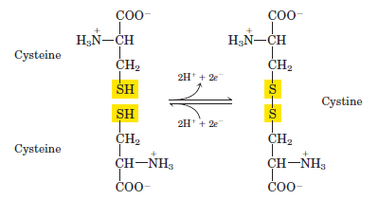

- Positively charged (basic) R groups participate in ionic interactions and hydrogen bonds.
- Negatively charged (asidic) R groups participate in ionic interactions and hydrogen bonds.

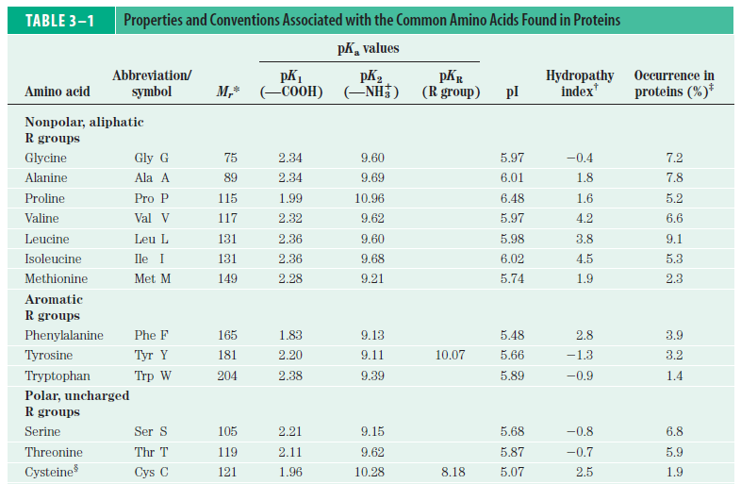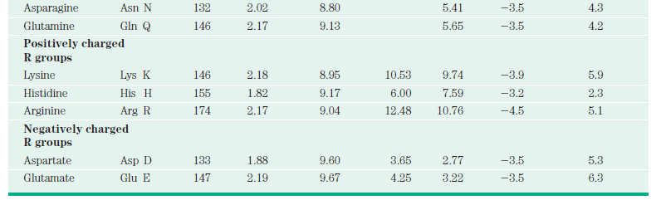
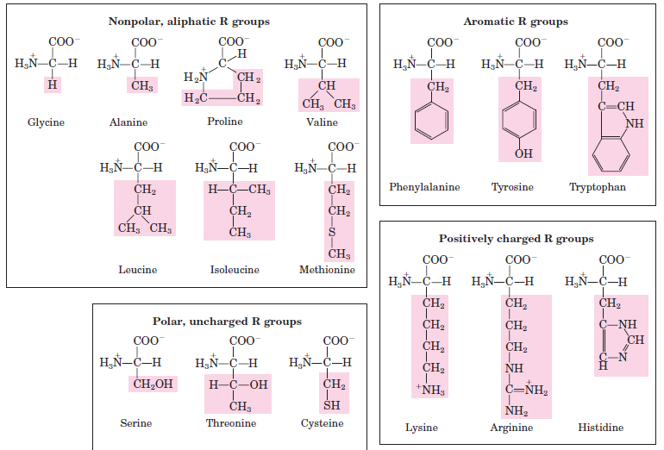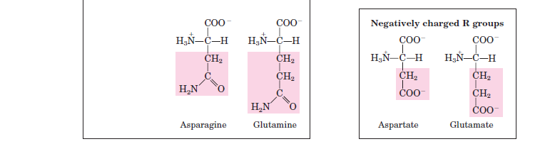

Uncommon Amino Acids Also Have Important Functions
- In addition to the 20 common amino acids, proteins may contain residues created by modification of common residues.
- some of them are 4-hydroxyproline, 5-hydroxylysine, ornithine, citrulline
- 300 additional amino acids have been found in cells.

Amino Acids Can Act as Acids and Bases
- When an amino acid lacking an ionizable R group is dissolved in water at neutral pH
- it exists as dipolar ion or zwitterion
- a zwitterion can act as either an acid or a base (Fig. 3-9).
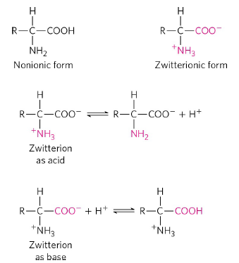

- Alanine, is a diprotic acid when fully protonated
- the —COOH group and the —NH₃⁺ group can yield protons.

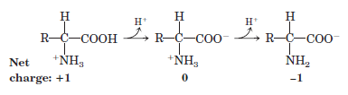
Amino Acids Have Characteristic Titration Curves
Titration Curves Predict the Electric Charge of Amino Acids
- Amino acids have pK_{a} (pK₁, pK₂, pK_{R}) values (Table 3-1).
- The two ionizable groups of glycine, the carboxyl group and the amino group, are titrated with a strong base such as NaOH.
- Titration curve of glycine has two stages (Fig. 3-10).

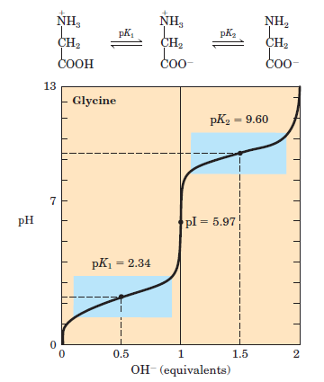

- [0 equilavent OH⁻], very low pH, fully protonated form (1), net charge = +1
- [0.5 equilavent OH⁻], midpoint of the first stage, [1] = [2], pH = pK₁ ₌ 2.34, first buffering power
- [1 equilavent OH⁻], zwitterion (2), net charge = 0, isoelectric point or isoelectric pH, pI = pH = pK₁ + pK₂ / 2 = 2.34 + 9.60 / 2 = 5.97
- [1.5 equilavent OH⁻], midpoint of the second stage, [2] = [3], pH = pK₂ ₌ 9.60, second buffering power
- [2 equilavent OH⁻], very high pH, fully unprotonated form (3), net charge = -1

Amino Acids Differ in Their Acid-Base Properties
- Amino acids with an ionizable R group have more complex titration curves.
- Titration of glutamate has three stages (Fig. 3-12).

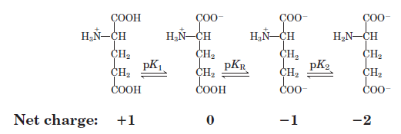
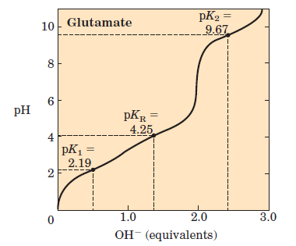
FIGURE 3–12 Titration curve for glutamate.

- [0 equilavent OH⁻], very low pH, fully protonated form (1), net charge = +1
- [0.5 equilavent OH⁻], midpoint of the first stage, [1] = [2], pH = pK₁ ₌ 2.19, first buffering power
- [1 equilavent OH⁻], zwitterion (2), net charge = 0, isoelectric point pI = pH = pK₁ + pK_{R} / 2 = 2.19 + 4.25 / 2 = 3.22
- [1.5 equilavent OH⁻], midpoint of the second stage, [2] = [3], pH = pK_{R =} 4.25,second buffering power
- [2 equilavent OH⁻], (3), net charge = -1, pH = pK_{R} + pK₂ / 2 = 4.25 + 9.67 / 2 = 6.96
- [2.5 equilavent OH⁻], midpoint of the third stage, [3] = [4], pH = pK₂ ₌ 9.67,third buffering power
- [3 equilavent OH⁻], very high pH, fully unprotonated form (4), net charge = -2
- Only histidine has an R group (pKa = 6.0) providing significant buffering power near the neutral pH
- usually found in the intracellular and extracellular fluids of most animals and bacteria.
3.2 Peptides and Proteins
- Peptides and proteins are polymers of amino acids.
Peptides Are Chains of Amino Acids
- Two amino acids are covalently joined
- peptide bond is formed to yield a dipeptide (Fig. 3-13).
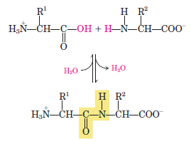

- When a few amino acids are joined, the structure is called an oligopeptide.
- When many amino acids are joined, the product is called a polypeptide.
- The structure of a pentapeptide is shown in (Fig. 3-14).

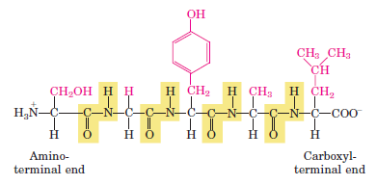

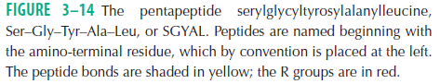

- In a peptide
- the amino acid residue at the end with a free amino group is the amino-terminal (or N-terminal) residue
- the residue at the other end, which has a free carboxyl group, is the carboxyl-terminal (C-terminal) residue.
- The amino-terminal end is placed on the left, the carboxyl-terminal end on the right.
- The sequence is read left to right, beginning with the amino-terminal end.

Biologically Active Peptides and Polypeptides Occur in a Vast Range of Sizes and Compositions
- Naturally occurring peptides range in length from two to many thousands of amino acid residues (Table 3-2).

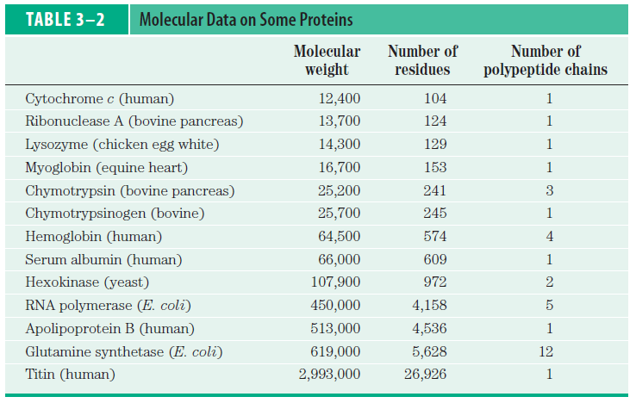
- Even the smallest peptides can have biologically important effects.
- for example, a number of hormones are small peptides (oxytocin -nine amino acid residues).
- Some proteins
- consist of a single polypeptide chain
- have two or more polypeptides (multisubunit proteins) (Table 3-2).
- The amino acid composition of proteins is also highly variable (Table 3-3).
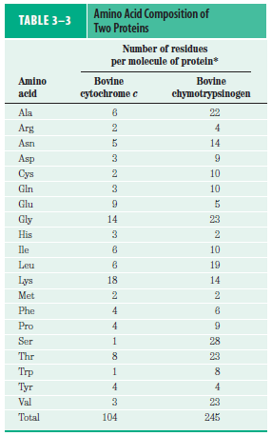

Some Proteins Contain Chemical Groups Other Than Amino Acids
- These are called conjugated proteins.
  - chemical group is called its prosthetic group
- Conjugated proteins are classified on the basis of the chemical nature of their prosthetic groups (Table 3-4). For example,
  - lipoproteins contain lipids,
  - glycoproteins contain sugar groups,
  - metalloproteins contain a specific metal.
- Some proteins contain more than one prosthetic group.

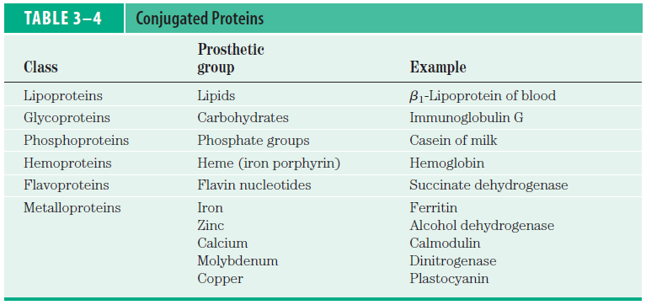

- Usually the prosthetic group plays an important role in the protein’s biological function.

3.3 Working with Proteins
Proteins Can Be Separated and Purified
- Cells contain thousands of different kinds of proteins.
- How can one protein be purified?
- Methods for separating proteins take advantage of properties
- vary from one protein to the next
- including size, charge and binding properties.
- The first step is to break open these cells
- releasing their proteins into a solution called a crude extract.
- If necessary, differential centrifugation can be used to prepare subcellular fractions or to isolate specific organelles.
- Various methods are available for purifying one or more of the proteins.
- Early steps utilize differences in protein solubility.
- The solubility of proteins is lowered at high salt concentrations, (NH₄)₂SO₄.
- an effect called salting out.
- addition of (NH₄)₂SO₄ in the right amounts can selectively precipitate some proteins, while others remain in solution.
- A procedure called dialysis separates proteins from small solutes by taking advantage of the proteins’ larger size.
- partially purified extract is placed in a bag or tube made of a semipermeable membrane and having buffer solution.
- membrane allows the exchange of salt and buffer but not proteins.
- dialysis retains large proteins within the membranous bag or tube.
- Dialysis might be used, for example, to remove ammonium sulfate from the protein preparation.

- Column chromatography separates proteins (Fig. 3-16).
- a porous solid material with appropriate chemical properties (the stationary phase) is held in a column, and a buffered solution (the mobile phase) migrates through it.
- individual proteins migrate faster or more slowly through the column depending on their properties (charge, size, binding affinity).

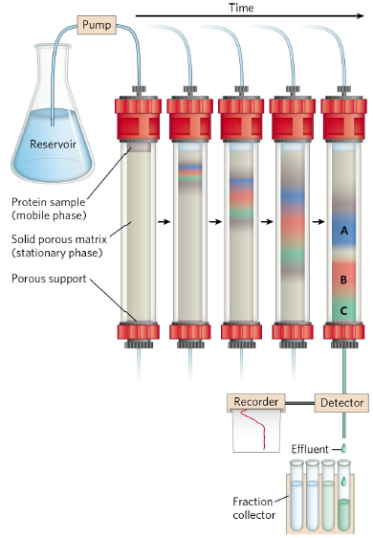

- Ion-exchange chromatography exploits differences in the sign and magnitude of the net electric charge of proteins at a given pH (Fig. 3-17a).
- The column matrix is a synthetic polymer containing bound charged groups; those with bound anionic groups are called cation exchangers, and those with bound cationic groups are called anion exchangers.

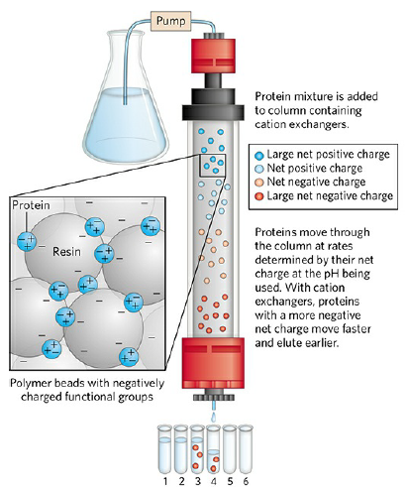

FIGURE 3-17a Ion-exchange chromatography

- Size exclusion chromatography, also called gel filtration separates proteins according to size (Fig. 3-17b).
- the solid phase consists of polymer beads.
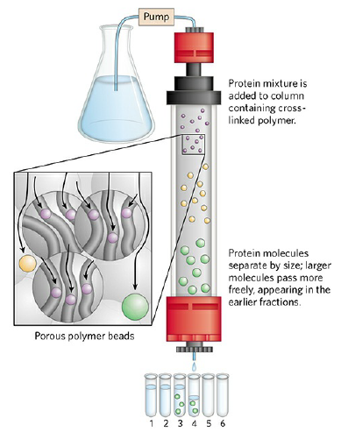
FIGURE 3-17b Size exclusion chromatography

- Size exclusion chromatography can also be used to approximate the size of a purified protein.
- standard proteins of known molecular weight are subjected to column.
- these marker proteins can be used to estimate the molecular weight of an unknown protein.
- a plot of molecular weight of the marker proteins versus relative migration (tube number) is linear, which allows the molecular weight of the unknown protein to be read from the graph (Fig. 3-19).
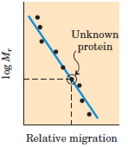

- Affinity chromatography is based on binding affinity (Fig. 3-17c).
- the beads in the column have a covalently attached chemical group called a ligand—a group or molecule that binds to a macromolecule such as a protein.

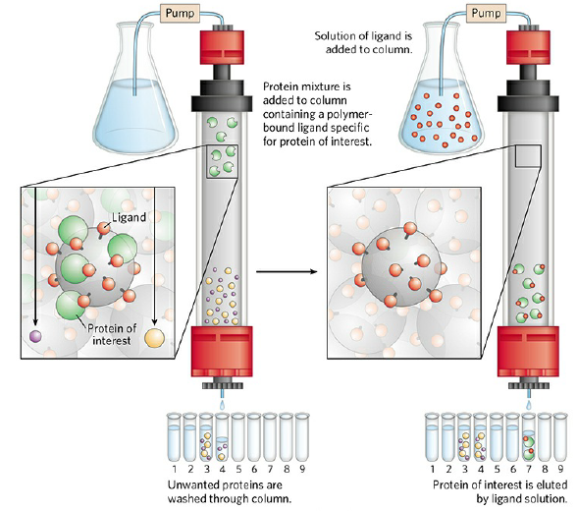
FIGURE 3-17c Affinity chromatography

- High-performance liquid chromatography (HPLC) use high-pressure pumps.
- pumps speed the movement of the protein molecules down the column.
- HPLC improves resolution
- As each purification step is completed, the sample size becomes smaller (Table 3–5).

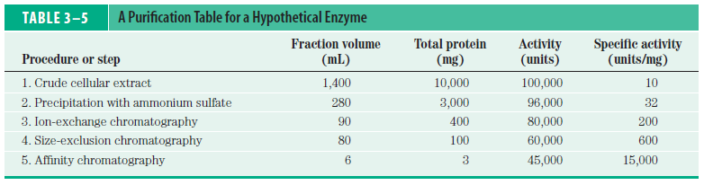

- amount of enzymes in a solution can be measured or assayed in terms of the catalytic effect.
- 1 unit of enzyme activity is defined as the amount of enzyme causing transformation of 1 μmol of substrate to product per minute.
- the term activity refers to total units of enzyme in a solution.
- the specific activity is the number of enzyme units per milligram of total protein (units / mg).
- The specific activity is a measure of enzyme purity: it increases during purification of an enzyme and becomes maximal and constant when the enzyme is pure.

Proteins Can Be Separated and Characterized by Electrophoresis
- Another important technique for the separation of proteins is based on the migration of charged proteins in an electric field, a process called electrophoresis (Fig. 3-18).

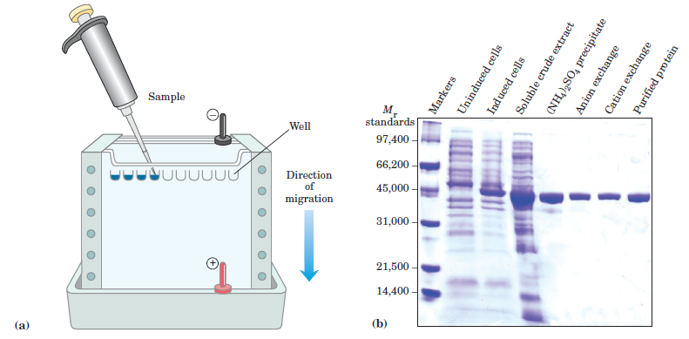

- different samples are loaded in wells at the top of the polyacrylamide gel.
- proteins can be visualized after electrophoresis by treating the gel with a stain such as Coomassie blue, which binds to the proteins.
- each band represents a different protein.
- smaller proteins move through the gel more rapidly than larger proteins.
- Number and molecular weight of different proteins can be estimated (Fig. 3-19).
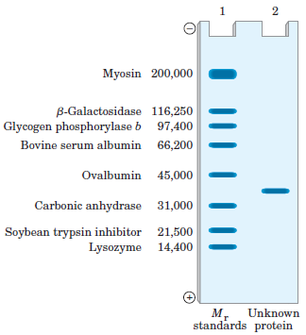

3.4 The Structure of Proteins: Primary Structure
- There are several levels of protein structure (Fig. 3-23).
- primary structure consists of a sequence of amino acids by peptide and disulfide bonds (covalent bonds).
- secondary structure refers coiled primary structure by H bonds.
- tertiary structure describes three-dimensional folding by noncovalent interactions.
- quaternary structure refers noncovalent interactions and disulfide bonds of two or more polypeptide subunits having tertiary structure.
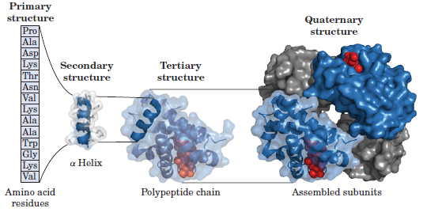

The Amino Acid Sequences of Proteins Have Been Determined by Different Methods
- Amino-terminal amino acid residue is determined by using 1-fluoro-2,4-dinitrobenzene.
- Amino-terminal amino acid residues are determined by using Edman degradation (40 sequential residues)
- Large proteins must be sequenced in smaller segments.
- Mass spectrometry permits the sequencing of short polypeptides (20 to 30 amino acid residues).
- Sequence of nucleotides in the gene deduces the sequence of a polypeptide.
- Amino acid sequences provide important biochemical information.

