Chapter 10 Lipids

- Lipids have different categories.
- storage lipids
- structural lipids
- signal, cofactor and pigments lipids
- Biological lipids are insoluble in water.

10.1 Storage Lipids
- Fats and oils are the principal stored forms of energy in living organisms.
- They are derivatives of fatty acids.
- The fatty acids are hydrocarbon derivatives.
- Fatty acid–containing compounds are two types (triacylglycerols and waxes).

Fatty Acids Are Hydrocarbon Derivatives
- They are carboxylic acids with hydrocarbon chains ranging from 4 to 36 carbons long (C₄ to C₃₆) (Table 10-1).
- Some of them are saturated.
- Some of them contain one or more double bonds.

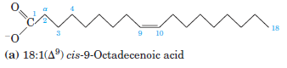

- The double bonds are in the cis configuration.
- The family of polyunsaturated fatty acids (PUFAs) with a double bond between the third and fourth carbon from the methyl end of the chain are of special importance in human nutrition.
- An alternative nomenclature is sometimes used for these fatty acids.
- The carbon of the methyl group (that is, the carbon most distant from the carboxyl group) is called the ω (omega) carbon and is given the number 1.
- PUFAs with a double bond between C-3 and C-4 are called omega-3 (ω-3) fatty acids.
- PUFAs with a double bond between C-6 and C-7 are called omega-6 (ω-6) fatty acids.

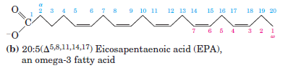

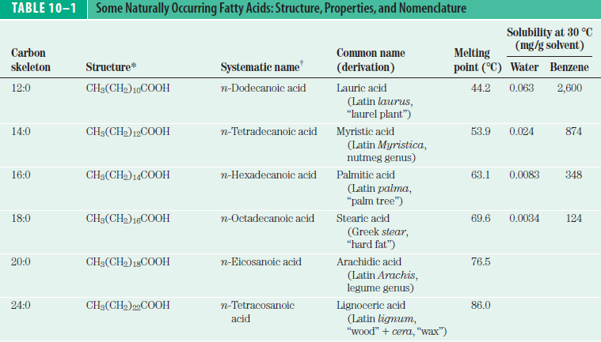
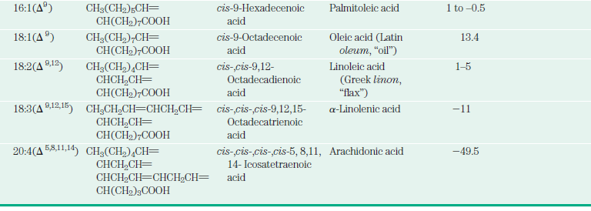

- Humans require but do not have the enzymatic capacity to synthesize the omega-3 PUFA α- linolenic acid (18:3(Δ ^{9,12,15}).
- Linoleate and α- linoleate are essential fatty acids for mammals, because they are necessary precursors for the synthesis of other products.
- Therefore, humans must obtain it in the diet.

Triacylglycerols Are Fatty Acid Esters of Glycerol
- The simplest lipids constructed from fatty acids are the triacylglycerols.
- They are also referred to as triglycerides, fats or neutral fats.
- They are composed of three fatty acids each in ester linkage with a single glycerol (Fig. 10-3).
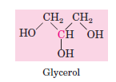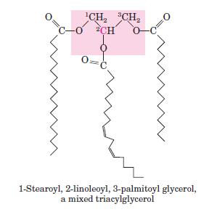

- Most naturally occurring triacylglycerols are mixed.
- They contain two or three different fatty acids.

Triacylglycerols Provide Stored Energy and Insulation
- Oily droplets in the aqueous cytosol and fat cells serve as depots of metabolic fuel.
- Lipases catalyze the hydrolysis of stored triacylglycerols.
- There are two significant advantages to using triacylglycerols as stored fuels, rather than polysaccharides such as glycogen and starch.
- First, the carbon atoms of fatty acids are more reduced than those of sugars, and oxidation of triacylglycerols yields more than twice as much energy as the oxidation of carbohydrates.
- Second, because triacylglycerols are hydrophobic and therefore unhydrated, the organism does not have to carry the extra weight of water of hydration (2 g per gram of polysaccharide).
- Obese people with 15 to 20 kg of triacylglycerols can have their energy needs for months.
- In contrast, the human body can store less than a day’s energy supply in the form of glycogen.
- Carbohydrates such as glucose and glycogen do offer certain advantages as quick sources of metabolic energy, one of which is their ready solubility in water.
- In some animals, triacylglycerols stored under the skin serve not only as energy stores but as insulation against low temperatures (seals, penguins, bears).

Waxes Serve as Energy Stores and Water Repellents
- Biological waxes are esters of long-chain (C₄ to C₃₆) saturated and unsaturated fatty acids with long-chain (C₁₆ to C₃₀) alcohols (Fig. 10-6).

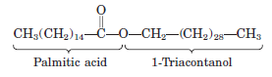

- In plankton, waxes are the chief storage form of metabolic fuel.
- Certain skin glands of vertebrates secrete waxes to protect hair and skin and keep it pliable, lubricated, and waterproof. (Birds, shiny leaves)

10.2 Structural Lipids in Membranes
- The central feature of biological membranes is a double layer of lipids, which acts as a barrier to the passage of polar molecules and ions.
- Membrane lipids are amphipathic:
- one end of the molecule is hydrophobic
- the other is hydrophilic.
- They are two classes
- phospholipids and glycolipids (Fig. 10-7).

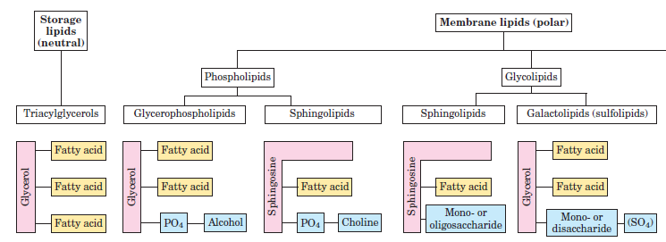

Glycerophospholipids Are Derivatives of Phosphatidic Acid
- Glycerophospholipids, also called phosphoglycerides, are membrane lipids in which
- two fatty acids are attached in ester linkage to the first and second carbons of glycerol
- a highly polar or charged group is attached through a phosphodiester linkage to the third carbon.
- Glycerophospholipids are named as derivatives of the parent compound, phosphatidic acid, according to the polar alcohol in the head group (Fig. 10–9).

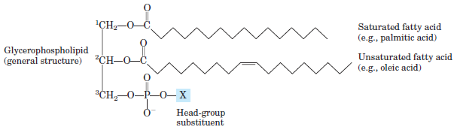
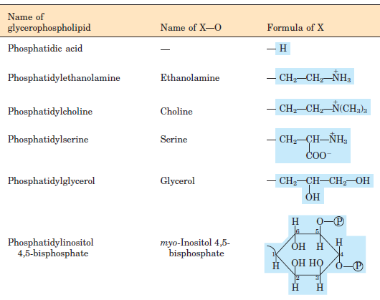

Some Glycerophospholipids Have Ether-Linked Fatty Acids

- Some animal tissues and some unicellular organisms are rich in ether lipids, in which
- one of the two acyl chains is attached to glycerol in ether linkage.
- The ether-linked chain may be saturated or may contain a double bond between C-1 and C-2, as in plasmalogens (Fig. 10–10).

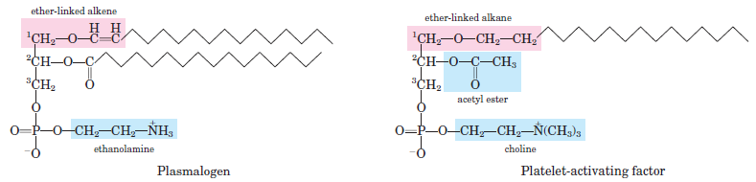

Chloroplasts Contain Galactolipids and Sulfolipids
- In plant cells, the galactolipids contain one or two galactose residues connected by a glycosidic linkage to C-3 of a 1,2-diacylglycerol (Fig. 10–11).
- Plant membranes also contain sulfolipids, in which
- a sulfonated glucose residue is joined to a diacylglycerol in glycosidic linkage (Fig. 10–11).
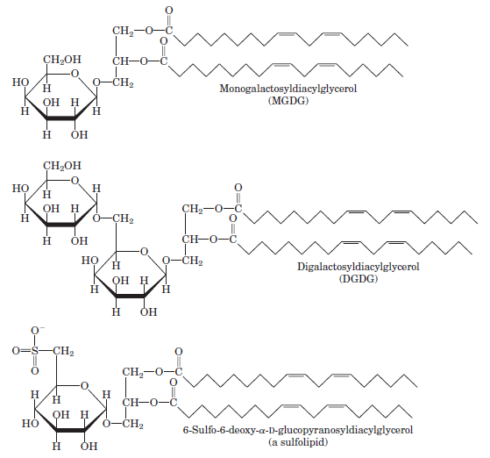

Sphingolipids Are Derivatives of Sphingosine
- Sphingolipids are composed of
- one molecule of the long-chain amino alcohol sphingosine or one of its derivatives,
- one molecule of a long-chain fatty acid,
- a polar head group that is joined by a glycosidic linkage in some cases and a phosphodiester in others (Fig. 10–13).

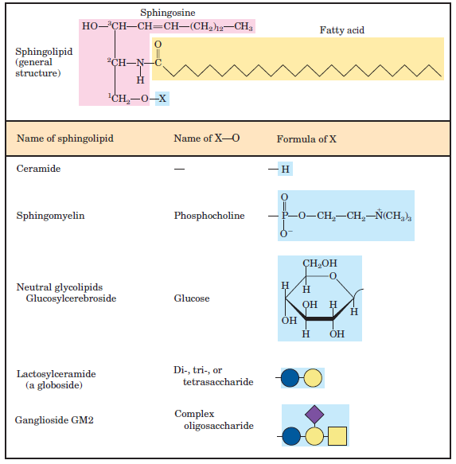

- Glycosphingolipids have one or more sugars connected directly to the ceramide
- Cerebrosides have a single sugar linked to ceramide.
- Globosides have two or more sugars linked to ceramide.
- Cerebrosides and globosides are sometimes called neutral glycolipids.
- Gangliosides, the most complex sphingolipids, have oligosaccharides.

Sphingolipids at Cell Surfaces Are Sites of Biological Recognition
- In humans, at least 60 different sphingolipids have been identified in cellular membranes.
- Many of these are especially prominent in the plasma membranes of neurons, and some are clearly recognition sites on the cell surface, but a specific function for only a few sphingolipids has been discovered thus far.
- The carbohydrate moieties of certain sphingolipids define the human blood groups and therefore determine the type of blood (Fig. 10–15).

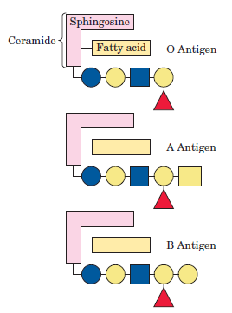
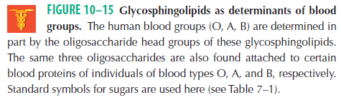

- Gangliosides are concentrated in the outer surface of cells, where they present points of recognition for extracellular molecules or surfaces of neighboring cells.

Sterols Have Four Fused Carbon Rings
- Sterols are structural lipids present in the membranes of most eukaryotic cells.
- The characteristic structure of sterols is the steroid nucleus.
- They are consisting of four fused rings, three with six carbons and one with five.
- Cholesterol is the major sterol in animal tissues (Fig. 10-17).

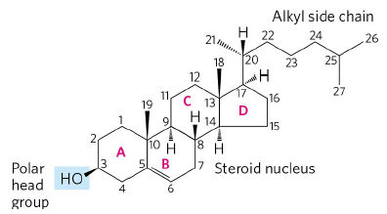

- In addition to their roles as membrane constituents,
- the sterols serve as precursors for a variety of products with specific biological activities.
- Steroid hormones, for example, are potent biological signals that regulate gene expression.
- Bile acids are polar derivatives of cholesterol
- They act as detergents in the intestine.

10.3 Lipids as Signals, Cofactors and Pigments
- This group of lipids is present in much smaller amounts.
- They have active roles in the metabolic traffic as metabolites and messengers.
- Phosphatidylinositol (Fig. 10-9) and its phosphorylated derivatives act at several levels to regulate cell structure and metabolism.
- Prostaglandins, thromboxanes, and leukotrienes (the eicosanoids), derived from arachidonate (20:4(Δ^{5,8,11,14})) (Table 10-1), are potent hormones.
- Steroid hormones, such as the sex hormones, derived from sterols. They serve as powerful biological signals, altering gene expression in target cells (Fig. 10-18).

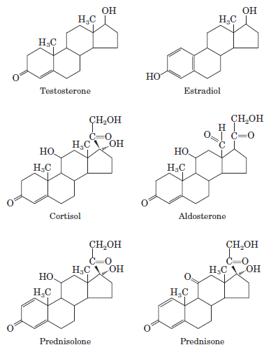
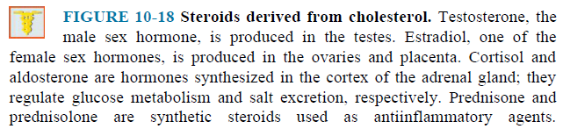

- Vitamins D, A, E, and K are fat-soluble compounds made up of isoprene units.

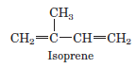

- All play essential roles in the metabolism or physiology of animals.
- Vitamin D is precursor to a hormone that regulates calcium metabolism. (Fig. 10-20)

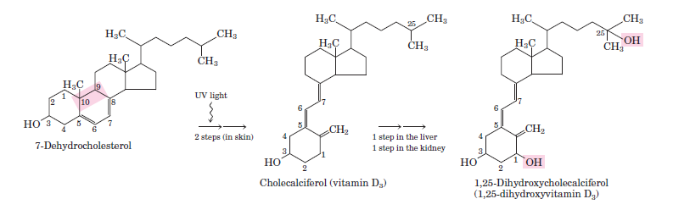

- Vitamin A is precursor to a hormone that furnishes the visual pigment of the vertebrate eye and is a regulator of gene expression during epithelial cell growth.
- Vitamins E and K and the lipid quinones are oxidation-reduction cofactors.
- Vitamin E functions in the protection of membrane lipids from oxidative damage.
- Vitamin K is essential in the blood-clotting process. Vitamin K deficiency slows blood clotting, which can be fatal.
- Ubiquinones and plastoquinones, also isoprenoid derivatives, are electron carriers in mitochondria and chloroplasts, respectively.
- Lipidic conjugated dienes serve as pigments in flowers and fruits and give bird feathers their striking colors.

