Chapter 17 Fatty Acid Catabolism

- The oxidation of long-chain fatty acids to acetyl-CoA is a central energy-yielding pathway in many organisms and tissues.
- In mammalian heart and liver, it provides as much as 80% of the energetic needs under all physiological circumstances.
- The electrons removed from fatty acids during oxidation pass through the respiratory chain, driving ATP synthesis.
- The acetyl-CoA produced from the fatty acids may be completely oxidized to CO₂ in the citric acid cycle, resulting in further energy conservation.
- Triacylglycerols (also called triglycerides or neutral fats) are suitable as storage fuels.
- The long alkyl chains of fatty acids are essentially hydrocarbons and have an energy more than twice that for the same weight of carbohydrate or protein.

17.1 Digestion, Mobilization and Transport of Fats

- Cells can obtain fatty acid fuels from three sources:
- fats consumed in the diet,
- fats stored in cells as lipid droplets,
- fats synthesized in one organ for export to another.

Dietary Fats Are Absorbed in the Small Intestine
- Triacylgycerols (Fig. 10-2) are degraded to fatty acids and glycerols by intestinal lipases.
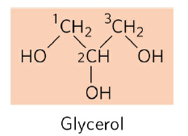
R-COOH
Fatty acid
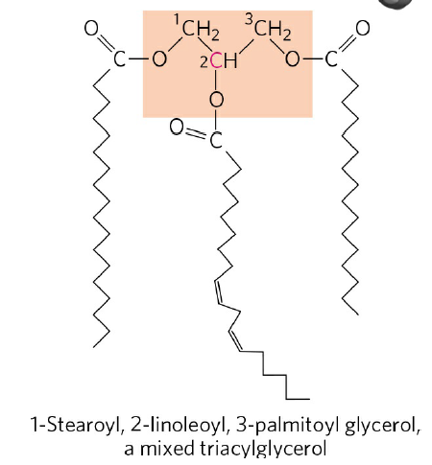
FIGURE 10-2 The mixed triacylglycerol shown here has three different fatty acids attached to the glycerol backbone.

- The fatty acids are packaged and delivered to muscle and adipose tissues by blood.
- In muscle, the fatty acids are oxidized for energy.
- In adipose tissue, they are reesterified for storage as triacylglycerols.

- The glycerols enter into the glycolytic pathway (Fig. 17-4).

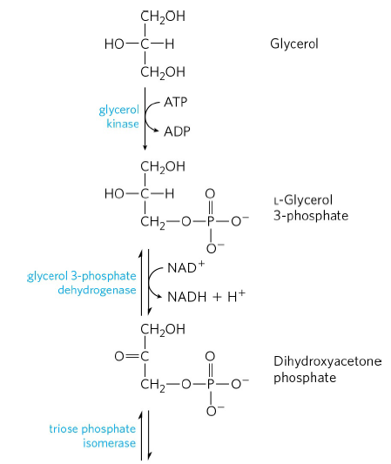
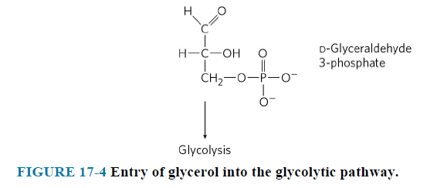

Fatty Acids Are Activated and Transported into Mitochondria
- The enzymes of fatty acid oxidation in animal cells are located in the mitochondrial matrix.
- The fatty acids with chain lengths of 12 or fewer carbons enter mitochondria without the help of membrane transporters.
- Those with 14 or more carbons cannot pass directly through the mitochondrial membranes and three enzymatic reactions are required to transport into mitochondria.
- The first reaction is catalyzed by fatty acyl-CoA synthetase present in the outer mitochondrial membrane. Fatty acyl–CoA esters are formed at the cytosolic side of the outer mitochondrial membrane (Fig. 17-5).
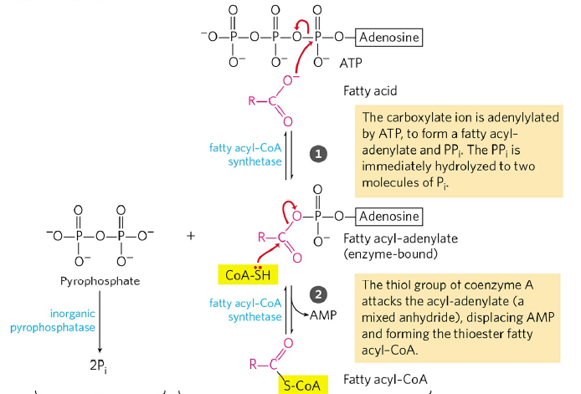
Fatty acid + CoA + ATP fatty acyl-CoA + AMP + 2 P_{i}

- The second reaction is catalyzed by carnitine acyltransferase 1. Fatty acyl–carnitine is formed at the outer membrane or in the intermembrane space (Fig. 17-6).
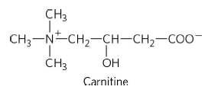
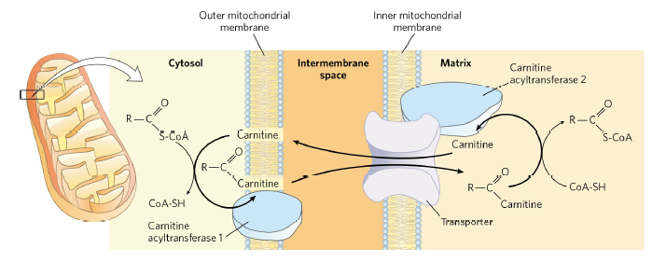
- The fatty acyl-carnitine enters the matrix by acyl-carnitine/carnitine transporter of the inner mitochondrial membrane (Fig. 17-6).
- The third reaction is regeneration of fatty acyl-CoA by carnitine acyltransferase 2 on the inner face of the inner mitochondrial membrane (Fig. 17-6).
- Carnitine reenters the intermembrane space via the acyl-carnitine/carnitine transporter (Fig. 17-6).

