Chapter 7 Carbohydrates and Glycobiology

- Carbohydrates are the most abundant biomolecules on Earth.
- Each year, photosynthesis converts more than 100 billion tons of CO₂ and H₂O into cellulose and other plant products.
- Certain carbohydrates (sugar and starch) are a dietary staple in most parts of the world.
- Oxidation of carbohydrates is the central energy-yielding pathway in most nonphotosynthetic cells.
- Carbohydrate polymers (also called glycans) serve as structural and protective elements in the cell walls of bacteria and plants and in the connective tissues of animals.
- Complex carbohydrate polymers covalently attached to the proteins or lipids act as signals.
- Carbohydrates are polyhydroxy aldehydes or ketones, or substance.
- Many, but not all, carbohydrates have the empirical formula (CH₂O)_{n} ; some contain nitrogen (N), phosphorus (P), or sulfur (S).
- There are three major classes of carbohydrates:
- Monosaccharides, or simple sugars, consist of a single unit.
- oligosaccharides consist of short chains of monosaccharide units, most of them are disaccharides.
- polysaccharides contain more than about 20 monosaccharide units.

  - Monosaccharides and Disaccharides
The Two Families of Monosaccharides Are Aldoses and Ketoses
- Monosaccharides are colorless, crystalline solids, and soluble in water.
- If the carbonyl group is in an aldehyde group, the monosaccharide is an aldose.
- If the carbonyl group is in a ketone group, the monosaccharide is a ketose.
- The simplest monosaccharides are

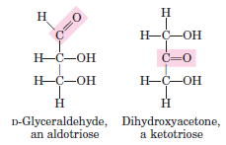

- Glucose and fructose are the most common monosaccharides in nature.

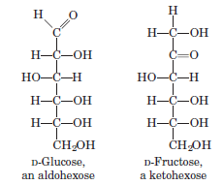

- They are the products of photosynthesis and key intermediates in the central energy-yielding reaction sequence in most organisms.
- Ribose and 2-deoxy-ribose are components of nucleotides and nucleic acids.

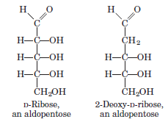

Monosaccharides Have Asymmetric Centers
- All the monosaccharides except dihydroxyacetone contain one or more asymmetric (chiral) carbon atoms.
- Glyceraldehyde contains one chiral center and therefore has two different optical isomers, or enantiomers.

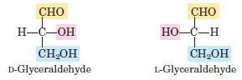

- In general, a molecule with n chiral centers can have 2^{n} stereoisomers. Glyceraldehyde has 2¹ = 2; the aldohexoses with four chiral centers have 2⁴ = 16 stereoisomers.
- When the hydroxyl group on the reference carbon (the chiral center most distant from the carbonyl carbon) is on the right, the sugar is the D isomer; when on the left, it is the L isomer.
- Of the 16 possible aldohexoses, eight are D forms and eight are L.
- Most of the hexoses of living organisms are D isomers.
- Why D isomers?
- An interesting and unanswered question.
- Remember. All of the amino acids found in protein are L isomers.
- One isomer had been selected for its reaction.
- (Fig. 7-3) shows the structures of the D stereoisomers of all the aldoses and ketoses having three to six carbon atoms.

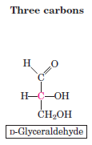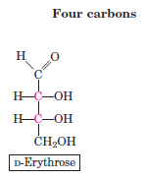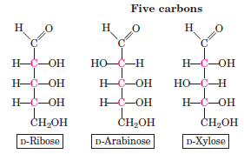
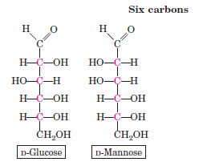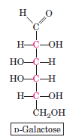
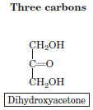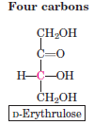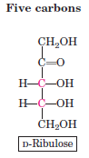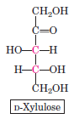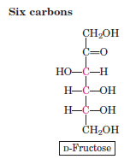

- Two sugars that differ only in the configuration around one carbon atom are called epimers;
- D-glucose and D-mannose (which differ at C-2)
- D-glucose and D-galactose (which differ at C-4) (Fig. 7–4).

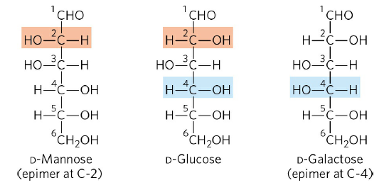

The Common Monosaccharides Have Cyclic Structures
- In aqueous solution, monosaccharides with five or more carbon atoms occur as cyclic (ring) structures.
- The carbonyl group forms a covalent bond with the oxygen of a hydroxyl group along the chain.
- Free hydroxyl group at C-5 reacts with the aldehyde group at C-1 (Fig. 7-6).
- Free hydroxyl group at C-5 (or C-6) reacts with the keto group at C-2.
- producing two stereoisomers, designated α and β.
- Isomeric forms of monosaccharides are called anomers.
- The carbonyl carbon atom is called the anomeric carbon.
- These ring compounds are called pyranoses and furanoses (Fig. 7-7).
- Cyclic sugar structures are represented in Haworth formulas than in the Fisher formulas used for linear sugar structures.
- The interconversion of α and β anomers in aqueous solution is called mutarotation.

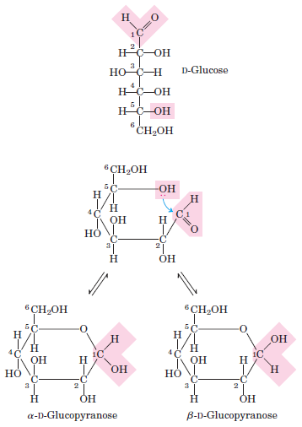

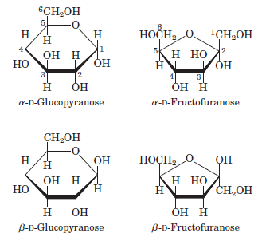

Organisms Contain a Variety of Hexose Derivatives
- There are a number of sugar derivatives (Fig. 7–9).
- a carbon atom is oxidized to a carboxyl group
- a hydroxyl group is replaced with another substituent

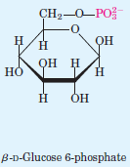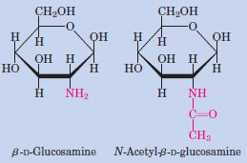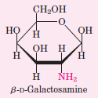

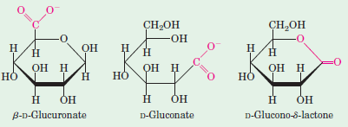

- Derivatives are part of many structural polymers (glycoproteins, glycolipids).

Monosaccharides Are Reducing Agents
- Monosaccharides can be oxidized by oxidizing agents such as cupric (Cu²⁺) ion.
- The carbonyl carbon is oxidized to a carboxyl group.
- Glucose and other sugars capable of reducing cupric ion are called reducing sugars.
Disaccharides Contain a Glycosidic Bond
- Disaccharides (such as maltose, lactose, and sucrose) consist of two monosaccharides joined covalently by an O-glycosidic bond
- it is formed when a hydroxyl group of one sugar reacts with the anomeric carbon of the other (Fig. 7–11) (Fig. 7-12).

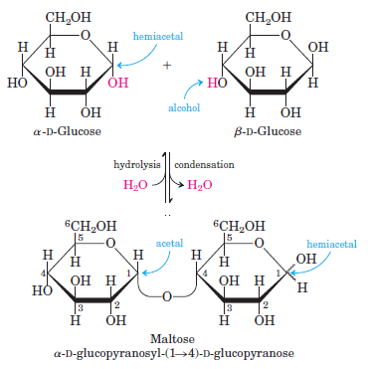

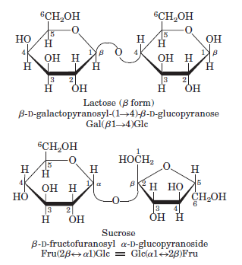

- In describing disaccharides or polysaccharides, the end of a chain with a free anomeric carbon (one not involved in a glycosidic bond) is commonly called the reducing end. The anomeric carbon is easily oxidized.
- Maltose is a reducing sugar.
- The configuration of the anomeric carbon atom in the glycosidic linkage is α. The glucose residue with the free anomeric carbon is capable of existing in α- and β-pyranose forms. Maltose is
Glc(α1 4)Glc.
- In contrast to maltose and lactose, sucrose contains no free anomeric carbon atom; the anomeric carbons of both monosaccharide units are involved in the glycosidic bond.
- Sucrose is a nonreducing sugar. The glycosidic bond protects the anomeric carbon from oxidation.
- N-glycosyl bonds join the anomeric carbon of a sugar to a nitrogen atom in glycoproteins and nucleotides.
7.2 Polysaccharides
- Polysaccharides, also called glycans, differ from each other
- in the identity of their recurring monosaccharide units,
- in the length of their chains,
- in the types of bonds linking the units,
- in the degree of branching.
- Homopolysaccharides contain only a single monomeric species.
- Heteropolysaccharides contain two or more different kinds.

Some Homopolysaccharides Are Stored Forms of Fuel
- The most important storage polysaccharides are starch in plant cells and glycogen in animal cells.
  - Starch contains two types of glucose polymer.
- amylose consists of long, unbranched chains of glucose residues connected by (α1 4) linkages.

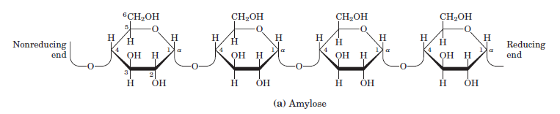

- Such chains vary in molecular weight from a few thousand to more than a million.
- amylopectin also has a high molecular weight (up to 200 million) is highly branched (unlike amylose).
- linear structure in (α1 4) linkages and branched structure in (α1 6) linkages (occurring every 24 to 30 residues).
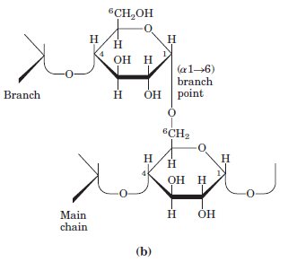
  - Like amylopectin, glycogen is a polymer of (α1 4)-linked subunits of glucose, with (α1 6)-linked branches.
- glycogen is more extensively branched (on average, every 8 to 12 residues) and more compact than starch.
  - Dextrans are bacterial and yeast polysaccharides made up of (α1 6)-linked poly-glucose; all have (α1 3) branches, and some also have
(α1 2) or (α1 4) branches.

Some Homopolysaccharides Serve Structural Roles
  - Cellulose is found in the cell walls of plants. Cotton is almost pure cellulose.
  - Like amylose, the cellulose molecule is a linear, unbranched homopolysaccharide, consisting of 10,000 to 15,000 glucose units.
  - But there is a very important difference: in cellulose the glucose residues have the β configuration (β1 4) (Fig. 7–14).

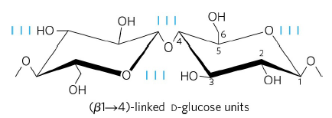

  - Chitin is a linear homopolysaccharide composed of N-acetylglucosamine residues in (β1 4) linkage (Fig. 7–17).

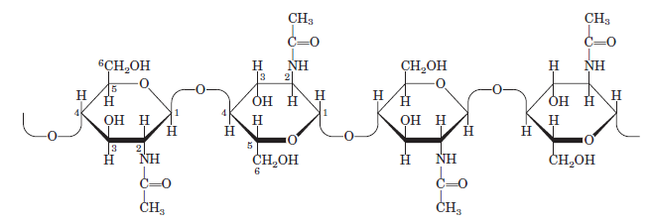

- The only chemical difference from cellulose is the replacement of the hydroxyl group at C-2 with an acetylated amino group.
- Chitin is the principal component of the hard exoskeletons (insects).

Hydrogen Bonding Influence Homopolysaccharide Folding
- Because polysaccharides have so many hydroxyl groups, hydrogen bonding has an especially important influence on their structure.

Bacterial and Algal Cell Walls Contain Structural Heteropolysaccharides
- The rigid component of bacterial cell walls (peptidoglycan) is a heteropolymer of alternating (β 1 4)-linked N-acetylglucosamine and N-acetylmuramic acid residues.
- Cell walls of marine red algae contain agar, a mixture of sulfated heteropolysaccharides made up of D-galactose and L-galactose derivative.

Glycosaminoglycans Are Heteropolysaccharides of the Extracellular Matrix
- Glycosaminoglycans are a family of linear polymers composed of repeating disaccharide units (Fig. 7–22).
- Hyaluronan
- Chondroitin sulfate
- Keratan sulfate

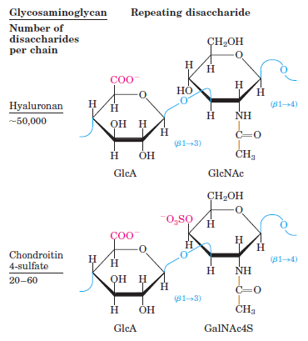
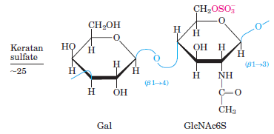
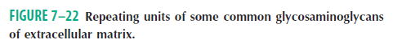
- They are unique to animals and bacteria and are not found in plants.
- (Table 7–2) summarizes the composition, properties, roles, and occurrence of the polysaccharides.

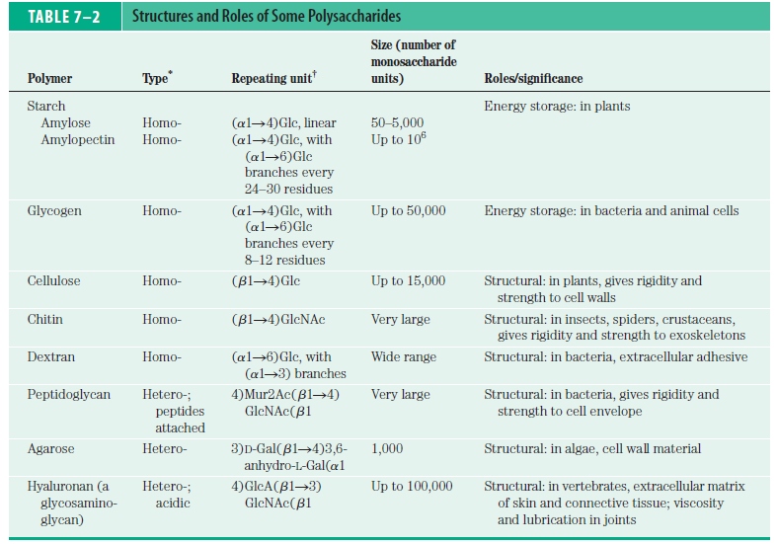

7.3 Glycoconjugates: Proteoglycans, Glycoproteins and Glycosphingolipids
- In addition to their important roles as stored fuels (starch, glycogen, dextran) and as structural materials (cellulose, chitin, peptidoglycans), polysaccharides and oligosaccharides are information carriers.
- some provide communication between cells and their extracellular surroundings
- others label proteins for transport to and localization in specific organelles, or for destruction when the protein is malformed or superfluous
- others serve as recognition sites for extracellular signal molecules (growth factors) or extracellular parasites (bacteria or viruses).
- The informational carbohydrate is covalently joined to a protein or a lipid to form a glycoconjugate, (Fig. 7–23).
- which is the biologically active molecule.

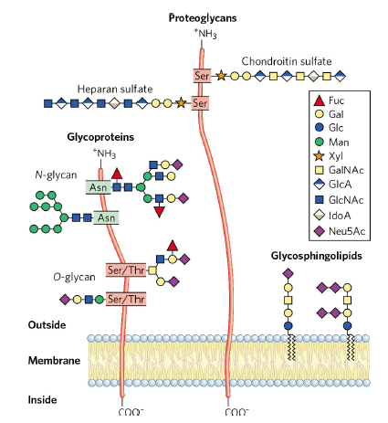

- Proteoglycans are macromolecules of the cell surface or extracellular matrix
- in which one or more glycosaminoglycans chains are joined covalently to a membrane protein or a secreted protein.
- Mammalian cells can produce 40 types of proteoglycans.
- Glycoproteins have one or several oligosaccharides of varying complexity joined covalently to a protein.
- They are found on the outer face of the plasma membrane, in the extracellular matrix, in the blood.
- Protein glycosylation is important in humans because at least 18 different genetic disorders of glycosylation have been found. Some of these disorders are fatal.
- Glycosphingolipids are plasma membrane components
- in which the hydrophilic head groups are oligosaccharides.
- the brain and neurons are rich in glycosphingolipids.

7.4 Carbohydrates as Informational Molecules: The Sugar Code
- Monosaccharides can be assembled into an almost limitless variety of oligosaccharides, which differ in
- the stereochemistry and position of glycosidic bonds
- the type and orientation of substituent groups
- the number and type of branches
- Each of the oligosaccharides presents a unique, three-dimensional face—a word in the sugar code—readable by the proteins that interact with it.
- Glycans are far more information-dense than nucleic acids or proteins.

