18.3 Pathways of Amino Acid Degradation

- The pathways of amino acid catabolism normally account for only 10% to 15% of the human body’s energy production; these pathways are not nearly as active as glycolysis and fatty acid oxidation.
- The 20 catabolic pathways converge to form only six major products.
- They are α-ketoglutarate, succinyl-CoA, fumarate, oxaloacetate, pyruvate and acetyl-CoA. All of them enter the citric acid cycle (Fig. 18-15).
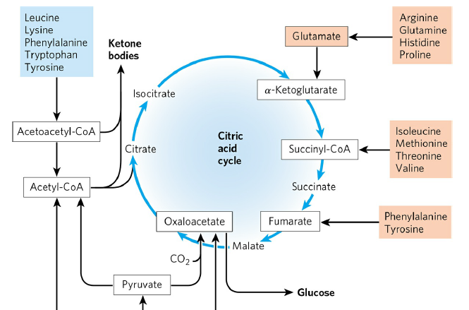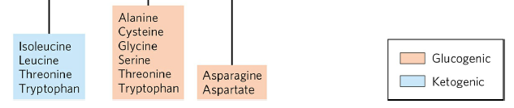

FIGURE 18-15 Summary of amino acid catabolism.

- Some amino acids can be converted to glucose. They are called glucogenic amino acids.
- Some amino acids can be converted to ketone bodies. They are called ketogenic amino acids.
- Some amino acids (tryptophan, phenylalanine, tyrosine, threonine, and isoleucine) can be converted to both glucose and ketone bodies.
- Remember. Catabolism of both carbohydrates and lipids produces NADH and FADH₂.
- The degradation of amino acids also results NADH and FADH₂ through the action of the citric acid cycle.

