The Citric Acid and Urea Cycles Can Be Linked
- Fumarate produced in the urea cycle is also an intermediate of the citric acid cycle.
- These two cycles are interconnected by fumarate (Fig. 18-12).
- Several enzymes of the citric acid cycle, including fumarase and malat dehydrogenase, are also present as isozymes in the cytosol.
- The fumarate can be converted to malate in the cytosol. The malate can be transported into mitochondria for use in the citric acid cycle.
- Aspartate formed in mitochondria by transamination between oxaloacetate and glutamate
can be transported to the cytosol.
- Aspartate serves as nitrogen donor in the urea cycle reaction.
- These reactions provide metabolic links between the separate pathways. It is called aspartate-argininosuccinate shunt.

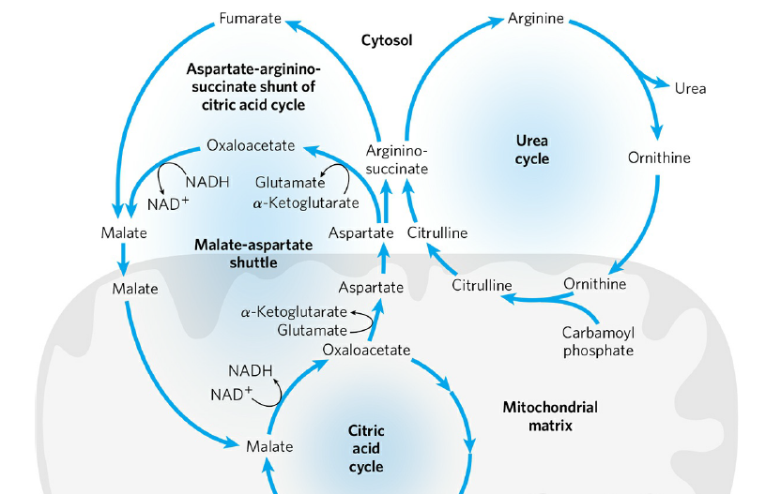
FIGURE 18-12 Links between the urea cycle and citric acid cycle.

