Chapter 24 Genes and Chromosomes

- The size of DNA molecules presents an interesting biological puzzle.
- These molecules are generally much longer than the cells or viral particles.
- How do they fit into their cellular or viral packages?
- Answer is the tertiary packaging of DNA into chromosomes.

24.1 Chromosomal Elements
- There are the different types of DNA sequences and structural elements within chromosomes.

Genes Are Segments of DNA That Code for Polypeptide Chains and RNAs
- A gene is encodes the primary sequence of some final gene product, which can be either a polypeptide or an RNA with a structural or catalytic function.
- DNA also contains other segments or sequences that have a regulatory function.
- Regulatory sequences provide signals that may denote the beginning or the end of genes, or influence the transcription of genes, or function as initiation points for replication or recombination.
- Some genes can be expressed in different ways to generate multiple gene products from a single segment of DNA.
- Each amino acid of a polypeptide chain is coded for by a sequence of three consecutive nucleotides in a single strand of DNA called as codons (Fig. 24–2).
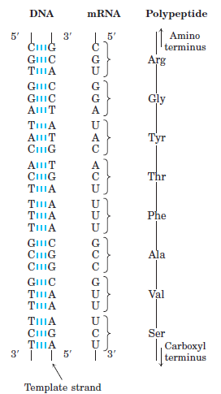

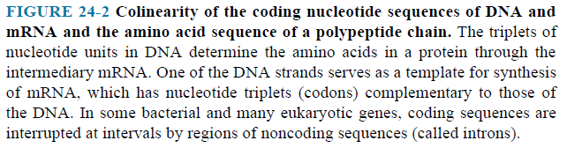

DNA Molecules Are Much Longer Than the Cellular or Viral Packages That Contain Them
- The genomes of DNA viruses vary greatly in size (Table 24–1).
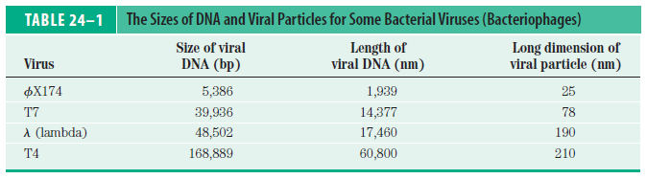

- The chromosome of an E. coli cell is a single, double-stranded circular DNA molecule. Its 4,641,652 bp have a contour length of about 1.7 mm, some 850 times the length of the E. coli cell (Fig. 24–3).

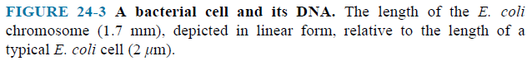

- Each type of chromosome in eukaryotes carries a characteristic set of genes (Table 24–2).

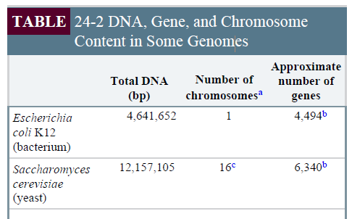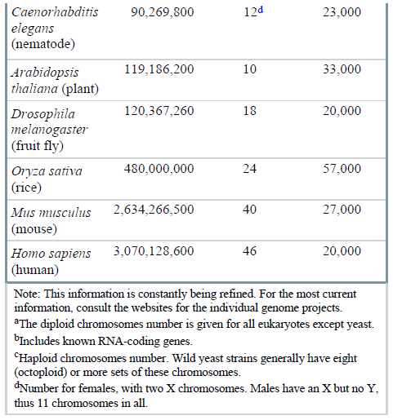

- A human cell has 46 chromosomes (Fig.24-5).
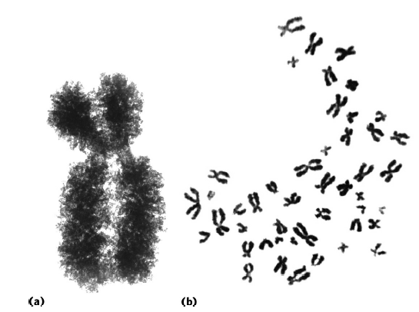

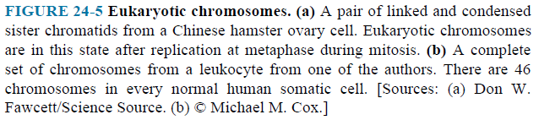

- The DNA molecules in the 24 different types of human chromosomes (22 matching pairs plus the X and Y sex chromosomes) vary in length.
- Most human cells are diploid and each cell contains a total of 2 m of DNA, some 20,000 times the length of the human cell (100 μm).
- An adult human body contains approximately 10¹⁴ cells and thus a total DNA length of 2 x 10¹¹ km.
- Compare this with the circumference of the earth (4 x 10⁴ km), (5 million times), or the distance between the earth and the sun (1.5 x 10⁸ km), (650 times roundtrip)—a dramatic illustration of the extraordinary degree of DNA compaction in our cells.
- Eukaryotic cells also have organelles (mitochondria and chloroplasts) that contain DNA.
- Mitochondrial DNA (mtDNA) molecules are much smaller than the nuclear chromosomes.
- In animal cells, mtDNA contains fewer than 20,000 bp (16,569 bp in human mtDNA) and is a circular duplex. Plant cell mtDNA ranges in size from 200,000 to 2,500,000 bp.
- Chloroplast DNA (cpDNA) also exists as circular duplexes and ranges in size from 120,000 to 160,000 bp.
- Mitochondrial DNA codes for the mitochondrial tRNAs and rRNAs and for a few mitochondrial proteins. More than 95% of mitochondrial proteins are encoded by nuclear DNA.

Eukaryotic Genes and Chromosomes Are Very Complex
- Their nucleotide sequences contain one or more intervening segments of DNA that do not code for the amino acid sequence of the polypeptide product.
- Nontranslated DNA segments in genes are called intervening sequences or introns, and the coding segments are called exons.
- Few bacterial genes contain introns.
- In higher eukaryotes, the typical gene has much more intron sequence than exon sequence (Fig. 24–7).

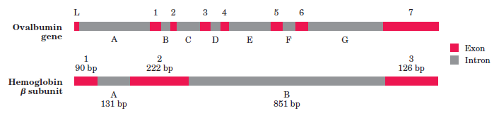
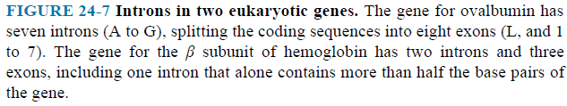

- The function of introns is not clear.
- In total, only about 1.5% of human DNA is “coding” or exon DNA, carrying information for protein or RNA products.

24.2 DNA Supercoiling
- Cellular DNA is extremely compacted.
- Supercoiling means the coiling of a coil.
- A typical phone cord is coiled like a DNA helix (Fig. 24–9).
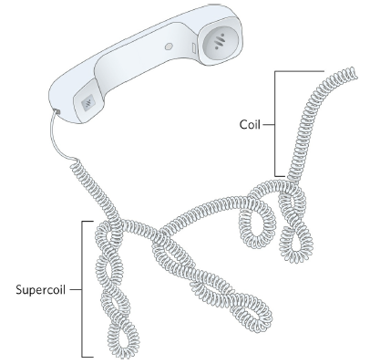
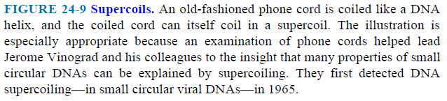
  - The coiled cord can itself coil in a supercoil.
- Replication and transcription of DNA are affected by supercoiling.
  - Both processes require a separation of DNA strands.
- Topological properties are changed only by breakage and rejoining of the backbone of one or both DNA strands.
- Small circular DNA can be relaxed or supercoiled (Fig. 24–12).

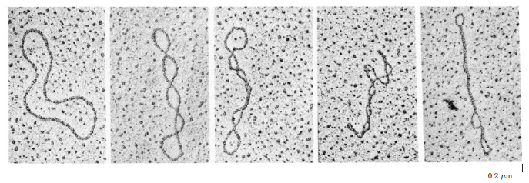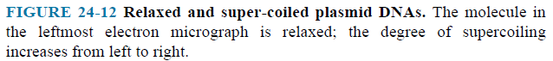

- DNA underwinding is defined by topological linking number.
- Linking number is a topological property of double-stranded DNA (Fig. 24–14).
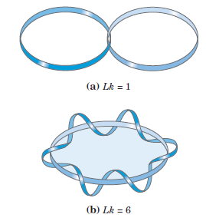
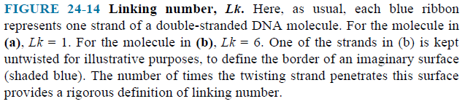

Topoisomerases Catalyze Changes in the Linking Number of DNA
- Every cell has enzymes with the function of underwinding and/or relaxing DNA.
- Topoisomerases increase or decrease the extent of DNA underwinding.
- These enzymes play an important role in processes of replication and DNA packaging.
- There are two classes of topoisomerases.
- Type I topoisomerases act by breaking one of the two DNA strands, passing the unbroken strand through the break and rejoining the broken ends.
- Type II topoisomerases cleave both strands of a DNA molecule and pass another duplex through the break.
- Type I and II topoisomerases generally relax DNA by removing supercoils (Fig. 24–20 and 21).
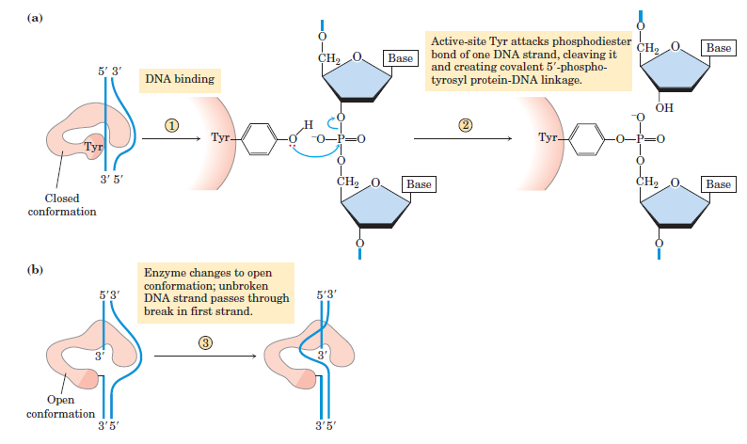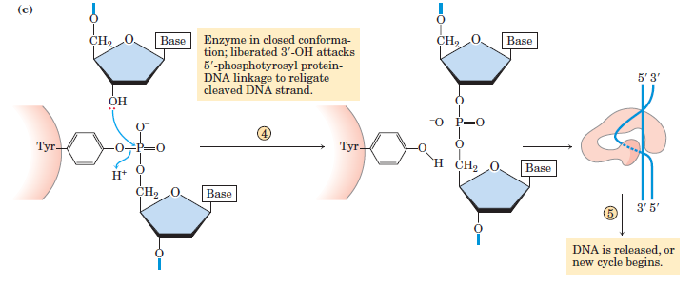
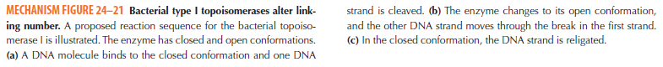
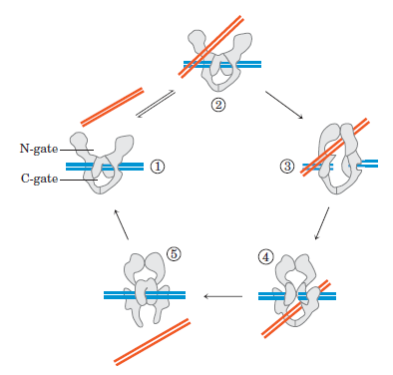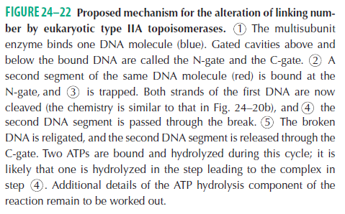

  - The Structure of Chromosomes
- The eukaryotic cell cycle produces remarkable changes in the structure of chromosomes.
- Chromosome is a single large DNA molecule and its associated proteins, containing many genes; stores and transmits genetic information (Each chromosome producing two sister chromosomes called sister chromatids).
- Chromatin is a filamentous complex of DNA, histones, and other proteins, constituting the eukaryotic chromosome.
- The DNA in the chromatin is associated with proteins called histones.
- Histones are small, basic proteins (the basic amino acids arginine and lysine).
- Histones package and order the DNA into structural units called nucleosomes (Fig. 24–24).
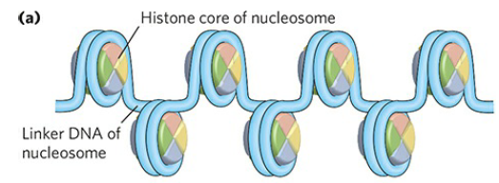

- Nucleosomes are the fundamental organizational units of chromatin.
- The compaction of a DNA molecule involves several levels of highly organized folding.
- Nucleosomes are packed into higher-order structures.
- Nucleosome cores seem to be organized into a structure called the 30 nm fiber (Fig. 24–30).
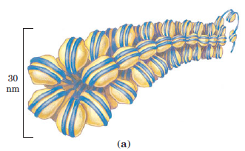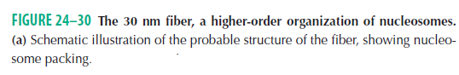
- The 30 nm fiber—a second level of chromatin organization—provides an approximately 100-fold compaction of the DNA (Fig. 24–33).
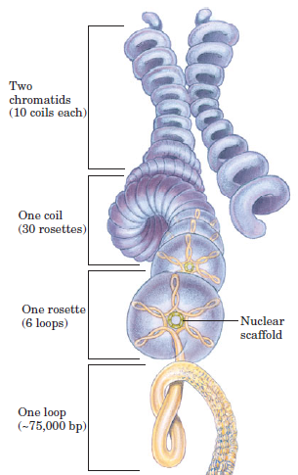
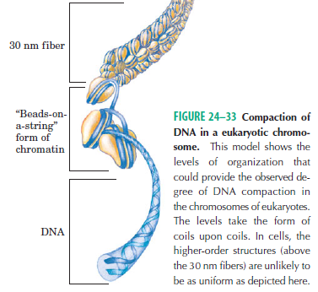
- DNA compaction in eukaryotic chromosomes is likely to involve coils upon coils upon coils…..

Bacterial DNA Is Also Highly Organized
- Bacterial DNA is compacted in a structure called the nucleoid.
- Bacterial DNA does not seem to have any structure comparable to the local organization provided by nucleosomes in eukaryotes.
- Histonelike proteins are abundant in E. coli.
- But these proteins bind and dissociate within minutes, and no regular, stable DNA-histone structure has been found.

