Chapter 5 Protein Function
- It will be explored how proteins interact with other molecules.
- The functions of many proteins involve the reversible binding of other molecules called ligand.
- A ligand may be any kind of molecule, including another protein.
- A ligand binds at a site on the protein called the binding site.
- is complementary to the ligand in size, shape, charge, and hydrophobic or hydrophilic character.
- Interaction between protein and ligand is specific.
- The binding is coupled to a conformational change in the protein since proteins are flexible.
- The structural adaptation occurring between protein and ligand is called induced fit.
- In a multisubunit protein, a conformational change in one subunit often affects the conformation of other subunits.
- Enzymes bind and chemically transform other molecules called reaction substrates rather than ligands.
- The ligand-binding site is called catalytic site or active site.

5.1 Reversible Binding of a Protein to a Ligand: Oxygen-Binding Proteins
- Myoglobin and hemoglobin may be the most-studied and best-understood proteins.
- They are examples for the reversible binding of a ligand to a protein.

Oxygen Can Bind to a Heme Prosthetic Group
- Oxygen is poorly soluble in aqueous solutions and cannot be carried to tissues in sufficient quantity if it is simply dissolved in blood serum.
- Diffusion of oxygen through tissues is also ineffective.
- Some proteins could transport and store oxygen.
- However, none of the amino acid side chains in proteins are suited for the reversible binding of oxygen molecules.
- Multicellular organisms exploit the properties of metals, most commonly iron, for oxygen transport.
- Iron is often incorporated into a protein-bound prosthetic group called heme.
- Heme consists of a complex organic ring structure, protoporphyrin, to which is bound a single iron atom in its ferrous (Fe²⁺) state (Fig. 5-1).

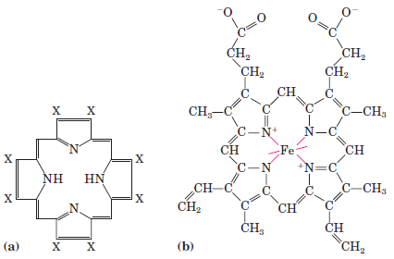

- The iron atom has six coordination bonds, four to nitrogen atoms that are part of the flat porphyrin ring system and two perpendicular to the porphyrin.
- Iron in the Fe²⁺ state binds oxygen reversibly; in the Fe³⁺ state it does not bind oxygen.
- One of these two coordination bonds is occupied by a side chain nitrogen of a His residue.
- The other is the binding site for molecular oxygen (O₂) (Fig. 5–2).
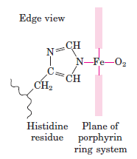

- Heme is found in many oxygen-transporting proteins.
- When oxygen binds, the electronic properties of heme iron change; this accounts for the change in color from the dark purple of oxygen-depleted venous blood to the bright red of oxygen-rich arterial blood.
- Some small molecules, such as carbon monoxide (CO) and nitric oxide (NO), coordinate to heme iron with greater affinity than does O₂. When a molecule of CO is bound to heme, O₂ is excluded, which is why CO is highly toxic to aerobic organisms.

Myoglobin Has a Single Binding Site for Oxygen
- It is a simple oxygen-binding protein found in almost all mammals, primarily in muscle tissue.
- As a transport protein, it facilitates oxygen diffusion in muscle.
- It is a single polypeptide of 153 amino acid residues with one molecule of heme.
- About 78 % of the amino acid residues in the protein are found in α helices.
- The polypeptide is made up of eight α-helical segments connected by bends (Fig. 5-3).

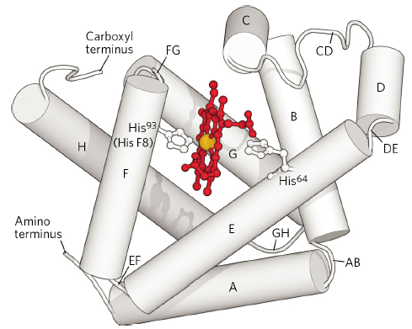

Protein-Ligand Interactions Can Be Described Quantitatively
- The function of myoglobin depends on the protein’s ability not only to bind oxygen but also to release it when and where it is needed.
- Function in biochemistry revolves around a reversible protein-ligand interaction of this type.
- A quantitative description of this interaction is a central part of many biochemical investigations.
- The reversible binding of a protein (P) to a ligand (L) can be described by a simple equilibrium expression:
P + L PL
- The reaction is characterized by an equilibrium constant, K_{a},
K_{a} = [PL] / [P][L]
- K_{a is} an association constant.
- K_{a} provides a measure of the affinity of the ligand for the protein.
- A higher value of K_{a} corresponds to a higher affinity of the ligand for the protein.
- It is more common to consider the dissociation constant, K_{d},
K_{d} = 1 / K_{a}
- K_{d} is the equilibrium constant for the release of ligand.
- In practice, K_{d} is used much more often than K_{a} to express the affinity of a protein for a ligand.
- A lower value of K_{d} corresponds to a higher affinity of ligand for the protein.

Protein Structure Affects How Ligands Bind
- The specificity of heme is different for its various ligands.
- CO binds about 40 times better than O₂.

Hemoglobin Transports Oxygen in Blood
- Oxygen is bound and transported by hemoglobin in erythrocytes (red blood cells).
- Erythrocytes are destined to survive for only about 120 days.

Hemoglobin Subunits Are Structurally Similar to Myoglobin
- It is a tetrameric protein containing 4 heme prosthetic groups (4 O₂-binding sites)
- one associated with each polypeptide chain (Fig. 5-10).
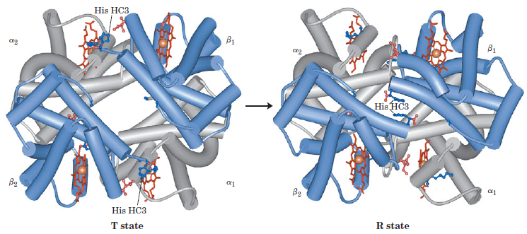

- It contains two α chains (141 residues each) and two β chains (146 residues each).
- The three-dimensional structures of the two types of subunits are very similar.
- Their structures are very similar to myoglobin.

Hemoglobin Undergoes a Structural Change on Binding Oxygen
- Interactions among the subunits cause conformational changes
- alter the affinity of the protein for oxygen.
- Hemoglobin has 2 major conformations: R state and T state (relaxed and tense) (Fig. 5-10).
- Although oxygen binds to hemoglobin in either state, it has a significantly higher affinity in the R state.
- oxygen binding stabilizes the R state.
- When oxygen is absent, the T state is more stable (deoxyhemoglobin).
- The binding of O₂ to a subunit in the T state triggers a change in conformation to the R state.
Hemoglobin Binds Oxygen Cooperatively
- Hemoglobin must bind oxygen in the lungs and release oxygen in the tissues.
- O₂ binding to individual subunits of hemoglobin can alter the affinity for O₂ in adjacent subunits.
- The first molecule of O₂ binds to a subunit in the T state.
- Its binding leads to conformational changes that are communicated to adjacent subunits, making it easier for additional molecules of O₂ to bind.
- T R transition occurs in the second subunit once O₂ is bound to the first subunit.
- The last (fourth) O₂ molecule binds to a heme in a subunit that is in the R state. It binds with much higher affinity than the first molecule.
- Binding of a ligand to one site affects the binding properties of another site on the same protein.
- Cooperative binding of a ligand to a multimeric protein is a form of allosteric binding.
- Hemoglobin is called an allosteric protein.

Hemoglobin Also Transports H⁺ and CO₂
- In addition to carrying all the O₂ required by cells from the lungs to the tissues
- hemoglobin carries two end products of cellular respiration H⁺ and CO₂ from the tissues to the lungs and the kidneys, where they are excreted.
- The CO₂, produced by oxidation of organic fuels in mitochondria, is hydrated to form bicarbonate:
CO₂ + H₂O H⁺ + HCO₃⁻
- This reaction is catalyzed by carbonic anhydrase, an enzyme particularly abundant in erythrocytes.
- The hydration of CO₂ results in an increase in the H⁺ concentration (a decrease in pH) in the tissues.
- The binding of O₂ by hemoglobin is influenced by pH and CO₂ concentration.
- Hemoglobin transports about 40% of the total H⁺ and 15% to 20% of the CO₂ formed in the tissues to the lungs and kidneys.
- The binding of H⁺ and CO₂ is inversely related to the binding of oxygen.
- At the relatively low pH and high CO₂ concentration of peripheral tissues,
- the affinity of hemoglobin for oxygen decreases as H⁺ and CO₂ are bound, and O₂ is released to the tissues.
- Conversely, in the capillaries of the lung, as CO₂ is excreted and the blood pH consequently rises,
- the affinity of hemoglobin for oxygen increases and the protein binds more O₂ for transport to the peripheral tissues.
- This effect of pH and CO₂ concentration on the binding and release of oxygen by hemoglobin is called the Bohr effect.
- When the O₂ concentration is high, as in the lungs,
- hemoglobin binds O₂ and releases protons.
- When the O₂ concentration is low, as in the peripheral tissues,
- H⁺ is bound and O₂ is released.
- O₂ and H⁺ are not bound at the same sites in hemoglobin.
- O₂ binds to the iron atoms of the hemes, whereas H⁺ binds to any of several amino acid residues in the protein.
- Hemoglobin also binds CO₂, inversely related to the binding of oxygen.
- CO₂ binds as a carbamate group to the α-amino group at the amino-terminal end of each globin chain, forming carbaminohemoglobin.
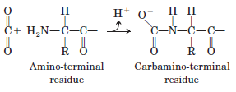

- This reaction produces H⁺, contributing to the Bohr effect.

Oxygen Binding to Hemoglobin Is Regulated by 2,3-Bisphosphoglycerate
- 2,3-Bisphosphoglycerate (BPG) is present in relatively high concentrations in erythrocytes.

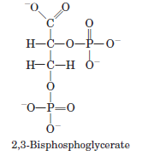

- BPG reduces the affinity of hemoglobin for O₂
- there is an inverse relationship between the binding of O₂ and the binding of BPG.
- BPG binds at a site distant from the O₂-binding site and regulates the O₂-binding affinity of hemoglobin.

Sickle-Cell Anemia Is a Molecular Disease of Hemoglobin
- Almost 500 genetic variants of hemoglobin are known to occur in the human population.
- Most variations consist of differences in a single amino acid residue.

