YILDIZ TECHNICAL UNIVERSITY

BIOMEDICAL ENGINEERING DEPARTMENT

BME3402- MEDICAL INSTRUMENTATION LABORATORY

EXP-3 ELECTROCARDIOGRAPHY (ECG-2)

- Einthoven’s Law—Simulated Confirmation: Lead I + Lead III = Lead II

Table 1 Supine
Lead | Same Single Cardiac Cycle | mV* | *Include the polarity (+ or -) of the Delta result since R-waves may be inverted on some of the leads.
Lead I
Lead III
Lead II

- Mean Electrical Axis of the Ventricles (QRS Axis) and Mean Ventricular Potential—Graphical Estimate

Table 2
CONDITION
 | Lead I | Lead III
Supine (Recording 1)
Seated
Start of inhale
Start of exhale

Create two plots on each of the following graphs, using data from Table 2 Use a different color pencil or pen for each plot.
Graph 1: Supine and Seated
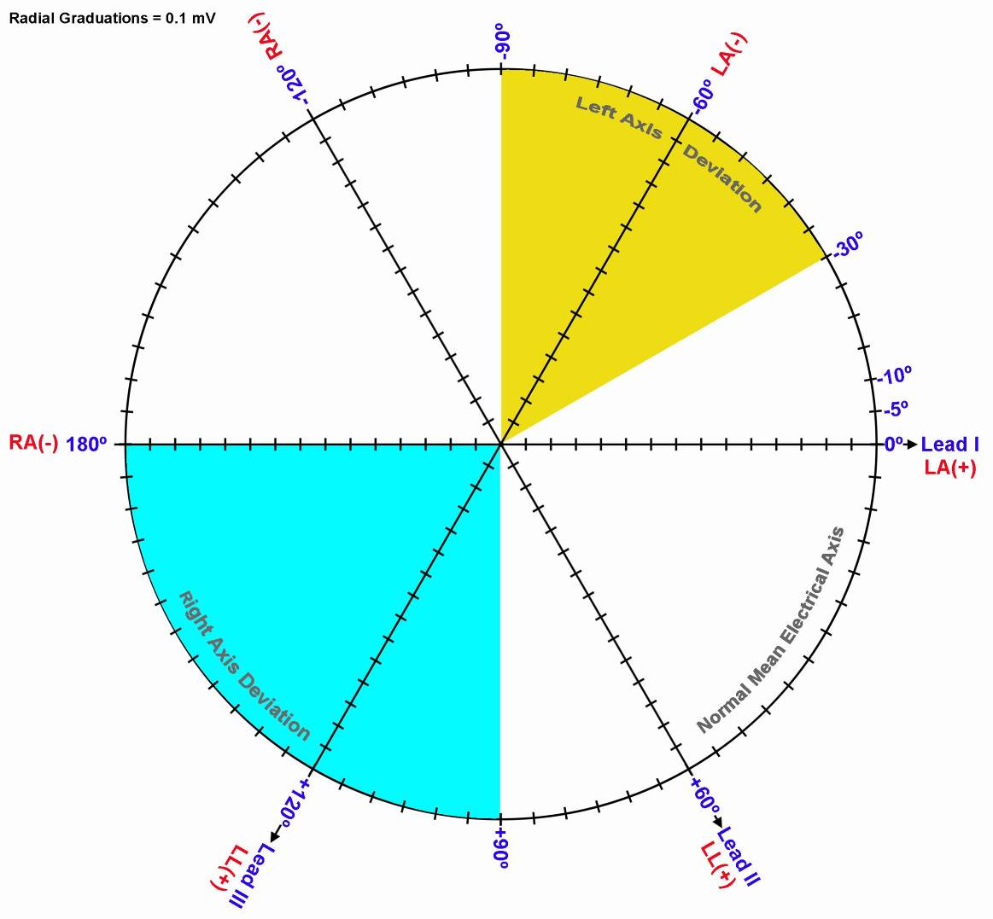
From the above graph, find the following values:

Condition |  | Mean Ventricular Potential |  | Mean Ventricular (QRS) Axis
Supine
Seated

Graph 2: Inhale /Exhale

From the above graph, find the following values:

Condition |  | Mean Ventricular Potential |  | Mean Ventricular (QRS) Axis
Start of inhale
Start of exhale

- Mean Electrical Axis of the Ventricles (QRS Axis) and Mean Ventricular Potential—More Accurate Approximation
Use Table 3 to add the Q, R, and S potentials to obtain net potentials for Recording 1—Supine.
Table 3
POTENTIAL
 | Lead I | Lead III
Q
R
S
QRS Net

Graph 3: Supine
From the above graph, find the following values:

Condition |  | Mean Ventricular Potential |  | Mean Ventricular (QRS) Axis
Supine

Questions

- Define ECG ?
- Define Einthoven’s Law.
- Define Einthoven’s Triangle and give an example of its application.
- What normal factors effect a change the orientation of the Mean Ventricular (QRS) Axis?
- Define Left Axis Deviation (LAD) and its causes.
- Define Right Axis Deviation (RAD) and its causes.
- What factors affect the amplitude of the R wave recorded on the different leads?

