The next item in our agenda is to plot
$$y_{2}=\frac{3}{x_{2}}.$$
To do this in a more systematic fashion, let us analyze the steps that should be taken to plot a graph. There are three main steps that one should take to plot a graph.
Step 1: Find the intercept points. This means solve for $y$ given $x=0$ and solve for $x$ given $y=0.$ If there is no solution, this means the graph does not touch to the vertical ($x=0)$ or the horizontal ($y=0)$ axis.
Step 2: Find the slope by computing
$$\frac{dy}{dx}.$$
If the derivative is positive, then the graph is upward sloped. If the derivative is negative, then it is downward sloped. If the slope is zero (at a single point), then it is either a maximum or a minimum. If the slope is zero everywhere, then the graph would be a flat line parallel to the horizontal axis.
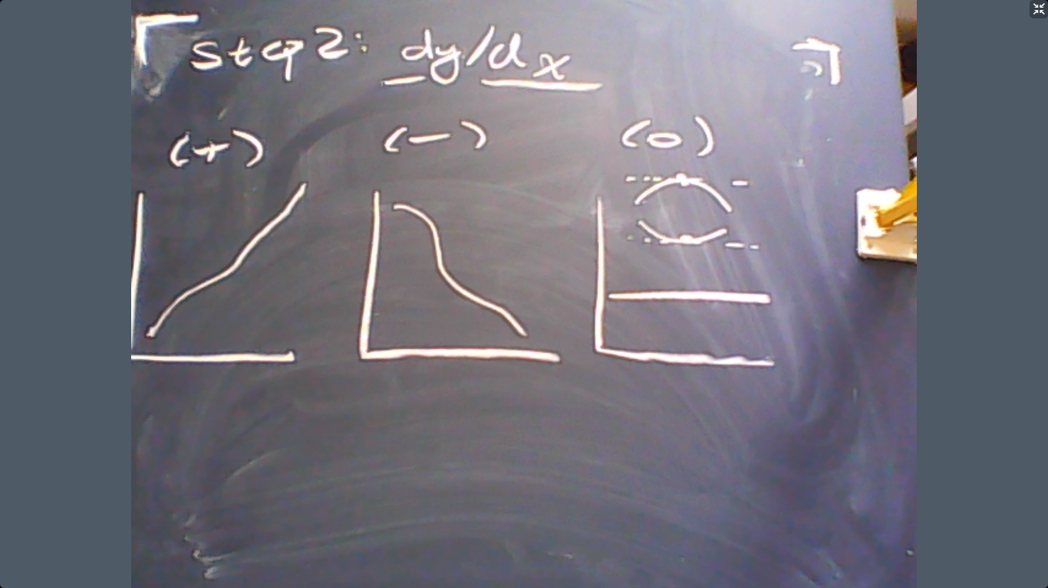
The graphs above demonstrate these three possibilities.
Step 3: Determine the curvature. To do so, take the 2nd order derivative. If the derivative is (+), then the graph is convex. If the derivative is (-), then the graph is concave.
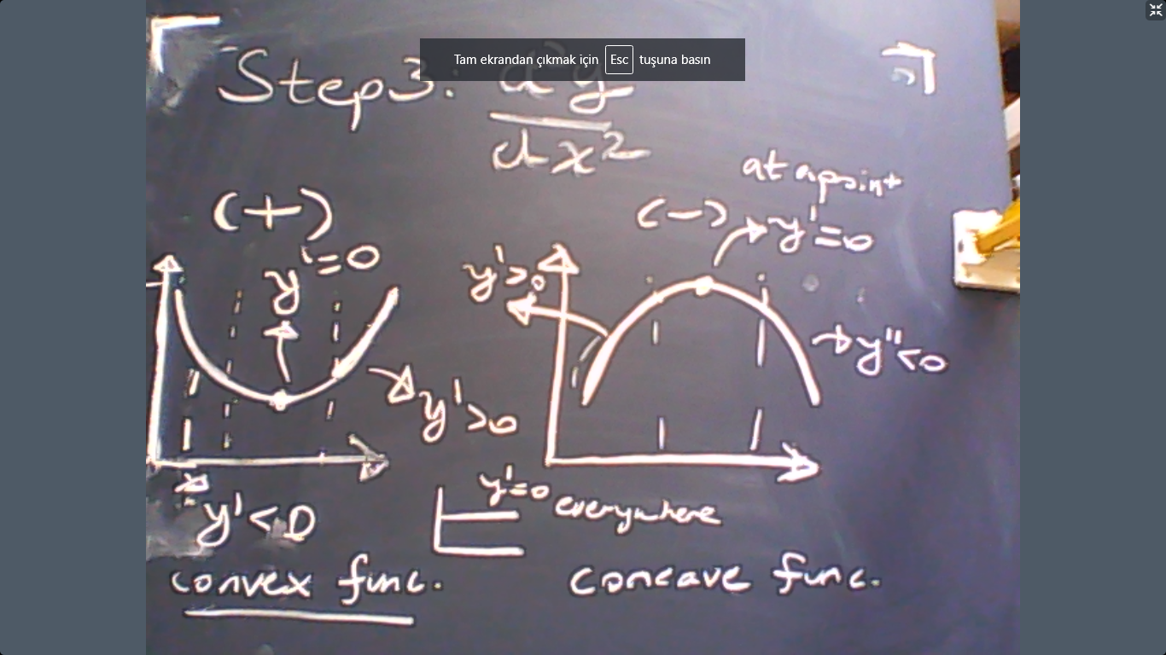
Example: $y_{2}=3/ x_{2}.$
Step 1: Now we should solve for $y$ given $x=0$ and solve for $x$ given $y=0.$ Since there is no solution for either case, we conclude that our graph does not touch to the axis.
Step 2: Find the slope. The answer is
$$\frac{dy_{2}}{dx_{2}}=-\frac{3}{{\left(x_{2}\right)}^{2}}<0.$$
This is a downward sloped graph. Let us have a look what we know until now:
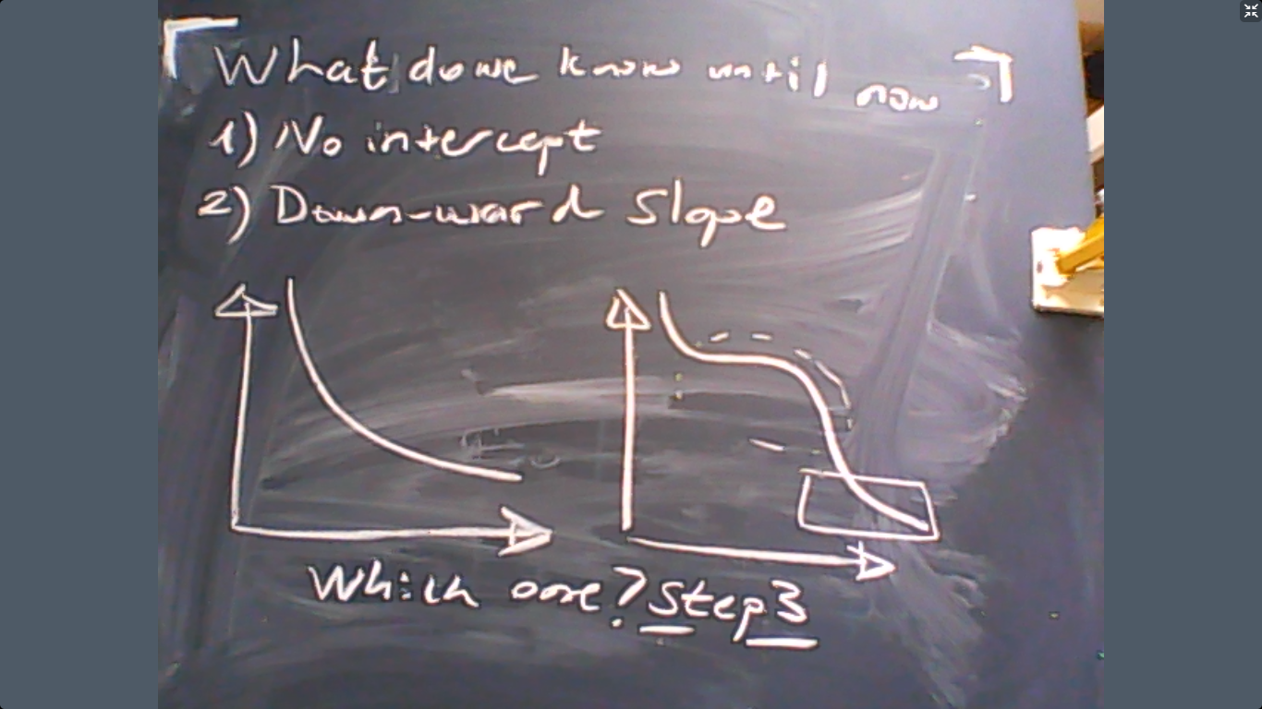
Step 3: Find the curvature. Compute
$$\frac{d^{2}y_{2}}{dx_{2}^{2}}=6{\left(x_{2}\right)}^{-3}>0.$$
The answer is a convex function. So the graph is

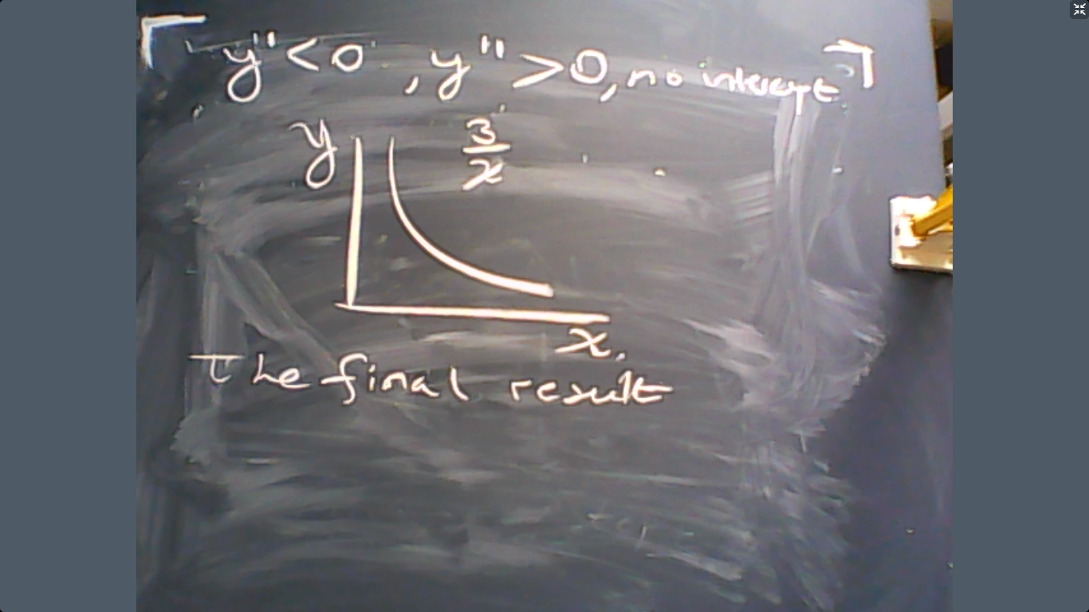
Now we can add the indifference curve of individual 2 to the Edgeworth Box that we were drawing last week.
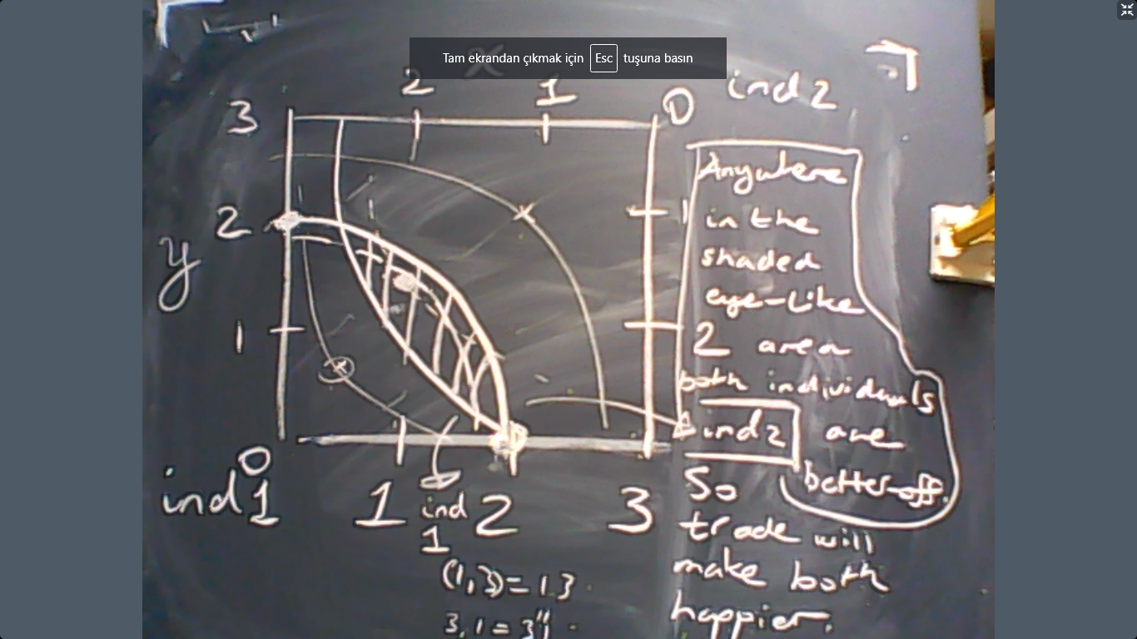
What do we learn from this Edgeworth Box? If an allocation is Pareto-inefficient, then the indifference curves that pass through the allocation creates an eye-like shape. Otherwise, (if the allocation is Pareto-efficient) then the indifference curves that pass through the allocation actually are tangents.

Now let us calculate the competitive equilibrium in this economy. The utility of individual 1 is
$$u_{1}=\ln{x_{1}}+y_{1}.$$
Her endowments are $e_{1}=\left(2,0\right).$ The utility of individual 2 is
$$u_{2}=x_{2}y_{2}.$$
Her endowments are $e_{1}=\left(1,3\right).$ Competitive equilibrium means everyone maximizes her utility and demand = supply.
Let us start with individual 1. Given that the prices of $x$ and $y$ are $p_{x}$ and $p_{y}$, the income level of individual 1 is $\left(2,0\right)×(p_{x}$,$p_{y})=2p_{x}$. So she solves
$$\max{\ln{x_{1}}+y_{1}} s.t. 2p_{x}=p_{x}x_{1}+p_{y}y_{1}.$$
We solve this maximization problem by using
$$MRS=\frac{p_{x}}{p_{y}}$$
$$Budget constraint.$$
So the MRS is
$$\frac{\frac{du_{1}}{dx}}{\frac{du_{1}}{dy_{1}}}=\frac{1}{x_{1}}=\frac{p_{x}}{p_{y}}.$$
The result is
$$x_{1}=\frac{p_{y}}{p_{x}}.$$

Let us continue with individual 2. The income level of individual 2 is $\left(1,3\right)×(p_{x}$,$p_{y})=p_{x}+{3p}_{y}$. So she solves
$$\max{x_{2}y_{2}} s.t. p_{x}+{3p}_{y}=p_{x}x_{2}+p_{y}y_{2}.$$
Again, we can solve this maximization problem by using
$$MRS=\frac{p_{x}}{p_{y}}$$
$$Budget constraint.$$
So the MRS is
$$\frac{\frac{du_{2}}{dx}}{\frac{du_{2}}{dy_{1}}}=\frac{y_{2}}{x_{2}}=\frac{p_{x}}{p_{y}}.$$
The result is
$${p_{x}x}_{2}=p_{y}y_{2}.$$
Plug this into the budget constraint to see
$$p_{x}+{3p}_{y}=2{p_{x}x}_{2}.$$
Therefore,
$$x_{2}=\frac{3p_{y}+p_{x}}{2p_{x}}.$$
Since the total amount of $x$ in the economy is 2+1, the demand for $x$ should satisfy
$$x_{1}+x_{2}=3$$
This means
$$\frac{p_{y}}{p_{x}}+\frac{3p_{y}+p_{x}}{2p_{x}}=3.$$
However, only the relative price matters, let us call it
$$a=\frac{p_{y}}{p_{x}}.$$
Then the equation above becomes
$$a+\frac{3}{2}a+\frac{1}{2}=3.$$
The solution is
$$a^{*}=1=\frac{p_{y}}{p_{x}}.$$
In words, if the goods have equal prices, then supply and demand are equal in the market. The allocation would be
$$\left(x_{1}^{*},y_{1}^{*}\right)=\left(1,1\right)$$
$$\left(x_{2}^{*},y_{2}^{*}\right)=\left(2,2\right).$$
Now we can plot this on our Edgeworth Box.
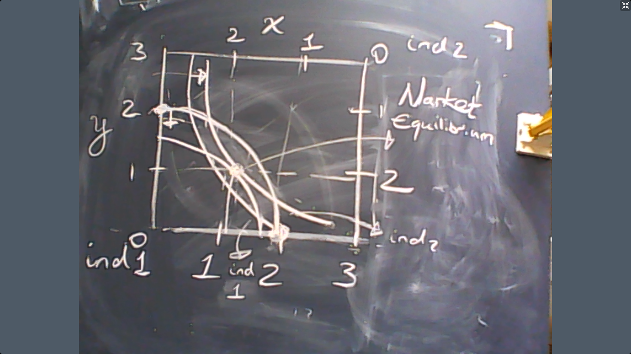
As we can see in the graph above, the eye-like shape that appears at the autarky completely disappears at the market equilibrium. This means that market equilibrium is Pareto-efficient: there is no alternative where both individuals would be better-off (or, equivalently, any other alternative would harm at least one of the individuals). This is Adam Smith’s “invisible hand”: The market system allocates the resources as if an external agent is trying to the best for everyone.
In layman’s terms, the market system is efficient. No alternative would be good for everyone. In more abstract terms, all surplus from trade is fully realized.
Labor Supply (Leisure-Consumption Trade-off)
Until now, we discussed economies where goods are not produced. Individuals own each good as an initial endowment. Now let us focus on production. This, however, requires an analysis of labor supply because production is made by using labor. Our next subject, therefore, is labor supply. When we finish this discussion, labor demand will also be analyzed.
Consider an individual who enjoys $c$, which denotes consumption, and $l$, which stands for leisure. The total amount of time that is available to the individual (worker) is normalized to $1$ (for example, 1 day or 1 year). This means the worker would work $1-l$ units of time. The price of labor per unit of time is $w$ so that the labor income of the worker is
$$w×\left(1-l\right).$$
The worker chooses $(c,l)$ to solve
$$\max{u\left(c,l\right)}$$
s.t.
$$p×c=w×\left(1-l\right).$$
where $p$ is the price of consumption. How can we solve this problem? We first need to find the MRS between $c$ and $l$. This would give us how much extra unit of consumption that the worker would be willing to trade for working more. Based on this MRS, we should solve
$$MRS_{l,c}=\frac{w}{p}$$
together with
$$p×c=w×\left(1-l\right).$$
The solution to these two equations would be sufficient to solve the utility maximization of the worker.
Please try to prove this claim using the Lagrange method. I would appreciate if you send me your proof.
Example: Suppose that the utility function is
$$u=c×l.$$
Then we should compute
$$MRS_{l,c}=\frac{c}{l}.$$
Therefore, the equation system becomes
$$\frac{c}{l}=w$$
together with
$$c=w×\left(1-l\right)$$
where $p=1$ so that $c$ is the numeriare (by setting the price to 1, we actually calculate the purchasing power of the wage, which is also known as the real wage). Now the equations above can be stated as
$$c=wl$$
$$c=w\left(1-l\right)$$
The result is $l=1/2$ and the consumption demand is
$$c=w/2.$$
And the labor supply is
$$1-l=\frac{1}{2}.$$
This is known as “inelastic labor supply”. It means 1% change in $w$ leads to no change in labor supply. What is the intuition that explains inelastic labor supply? Why would anyone ignore wages when he/she decides how much to work? The explanation is follows: when wage increases, then you are motivated to work more (obviously). This is called the substitution effect: you want to substitute your free time with consumption. But when income increases, you would want to work less because leisure is fun and you have money. This is called the income effect.
So income and substitution effects move in opposite directions. In our example income effect and substitution effect are exactly identical so the net effect (this is known as the price effect) is zero.
Example: Now let us generalize our example by assuming that the individual receives a non-labor income (e.g. rent income, government transfers, etc.) denoted by $T$. So the individual solves
$$\max{c×l}$$
s.t.
$$c=w\left(1-l\right)+T.$$
(Please try to solve this with Lagrange as well. Do send me your results if you think that you have a good answer.)
My solution is the following. Substitute $c$ in the utility by using the budget. This would give us:
$$\max{(w\left(1-l\right)+T)×l}.$$
Differentiate with respect to $l$ and equate the result to zero to see:
$$\frac{d(w\left(1-l\right)+T)l}{dl}=w\left(1-2l\right)+T=0.$$
So the solution is
$$l^{*}=\frac{T+w}{2w}.$$
And thus the labor supply is
$${1-l}^{*}=\frac{w-T}{2w}=\frac{1}{2}-\frac{T}{2w}=0.5-0.5×T×w^{-1}.$$
Note that we return to our original result $1-l^{*}=1/2$ if we impose $T=0.$
Moreover,
$$\frac{d\left(1-l^{*}\right)}{dT}=-\frac{1}{2w}<0.$$
This is the income effect: free money makes you work less. Another result is the following:
$$\frac{d\left(1-l^{*}\right)}{dw}=0.5Tw^{-2}>0.$$
Wages increase labor supply when we have non-labor income in this particular example.
***********************
Example: Now let us generalize our example one step further by assuming that $T$ is the transfer income financed by income tax. The income tax rate is $t$. For example if $t=1/2$, then half of your wage income goes to the government. So the individual solves
$$\max{c×l}$$
s.t.
$$c=w\left(1-l\right)(1-t)+T.$$
So the worker earns labor income net of taxes and transfers.
(Please try to solve this with Lagrange as well. Do send me your results if you think that you have a good answer.)
My solution is the following. Substitute $c$ in the utility by using the budget. This would give us:
$$\max{(w\left(1-l\right)(1-t)+T)×l}.$$
Differentiate with respect to $l$ and equate the result to zero to see:
$$\frac{d(w\left(1-l\right)(1-t)+T)l}{dl}=w\left(1-2l\right)(1-t)+T=0.$$
So the solution is
$$l^{*}=\frac{T+w(1-t)}{2w(1-t)}.$$
And thus the labor supply is
$${1-l}^{*}=\frac{1}{2}-\frac{T}{2w(1-t)}.$$
Note that we return to our original result $1-l^{*}=1/2$ if we impose $T=0.$
Moreover,
$$\frac{d\left(1-l^{*}\right)}{dT}=-\frac{1}{2w(1-t)}<0.$$
The budget constraint of the government is
$$w\left(1-l\right)t=T$$
$$Taxes=Transfers.$$
Of course, this assumes balanced government budget, which is sometimes not true (but in the long-term it should be true). Plug this information into the labor supply above to see
$${1-l}^{*}=\frac{1}{2}-\frac{w\left(1-l^{*}\right)t}{2w\left(1-t\right)}=\frac{1}{2}-\frac{\left(1-l^{*}\right)t}{2\left(1-t\right)}$$
$${1-l}^{*}=\frac{1}{2}-\frac{\left(1-l^{*}\right)t}{2\left(1-t\right)}$$
$$\frac{1}{2}=l^{*}-\frac{\left(1-l^{*}\right)t}{2\left(1-t\right)}$$
$$\frac{1}{2}=\frac{2\left(1-t\right)l^{*}-\left(1-l^{*}\right)t}{2\left(1-t\right)}$$
$$\frac{1}{2}=\frac{2l^{*}-2tl^{*}-t+tl^{*}}{2\left(1-t\right)}$$
$$\frac{1}{2}=\frac{2l^{*}-tl^{*}-t}{2\left(1-t\right)}$$
$$1-t=2l^{*}-tl^{*}-t$$
$$1=\left(2-t\right)l^{*}.$$
$$l^{*}=\frac{1}{2-t}.$$
So the labor supply with transfer/taxes with a balanced government budget is
$${1-l}^{*}=\frac{1-t}{2-t}.$$
Does labor supply increase or decrease with taxes (which gives us higher transfers)? So the answer is taxes reduce labor supply.
(Try to plot the labor supply with respect to taxes. Send me your answers if you think that you plot correctly. Show all your work if you send me an answer.)
At this point, it is interesting to note that $t=0$ implies no tax income but $t=100\%$ also yields zero tax income because no one would work if the tax rate is zero. Therefore, there is a level of tax rate that would maximize the government’s tax income. What is this level?
First we need to express the level of tax revenues in terms of tax rate. The answer is
$$Total Tax Revenue=w\left(1-l\right)t=wt\frac{1-t}{2-t}.$$
In other words, the tax revenue of the government is
$$w\frac{t-t^{2}}{2-t}.$$
What we need to do is to differentiate this expression with respect to $t$ and equate the result to zero to maximize the tax revenues. The result would be:
$$w\frac{\left(1-2t\right)\left(2-t\right)+t-t^{2}}{{\left(2-t\right)}^{2}}=0$$
Solving this is equivalent to
$$\left(1-2t\right)\left(2-t\right)+t-t^{2}=0$$
which is a 2nd degree polynomial, whose root is approximately 0.58. So the government would earn the highest level of taxes if the tax rate was around 60%.
This is the end of the lecture.

