Income Redistribution and Political Competition
Consider a society where each individual $i$ has a utility function
$$U_{i}=C_{i}×G$$
where $C_{i}$is the private consumption good and $G$ is the public good produced by the government. Recall that a public good has no rivalry and no excludability in consumption. No-rivalry means that a commodity/service can be enjoyed by multiple consumers. No-excludability means that everyone is allowed to enjoy the commodity/service.
To finance the public provision of the public good, each individual $i$ pays a lump-sum tax $T$. Therefore, the consumption by $i$ is
$$C_{i}=Y_{i}-T$$
where $Y_{i}$ is the market income of individual $i$. Assume that the market income is fixed. If there are $N$ individuals, then the government’s budget constraint is
$$N×T=G.$$
As a consequence, we can express the utility of $i$ as
$$U_{i}=\left(Y_{i}-T\right)×N×T.$$
What is the most preferred $T$ by individual $i$? We should calculate
$$\frac{dU_{i}}{dT}=NY_{i}-2NT=0$$
and solve for $T$ so that the result is
$$T_{i}^{*}=\frac{Y_{i}}{2}.$$
We can visually analyze this problem:
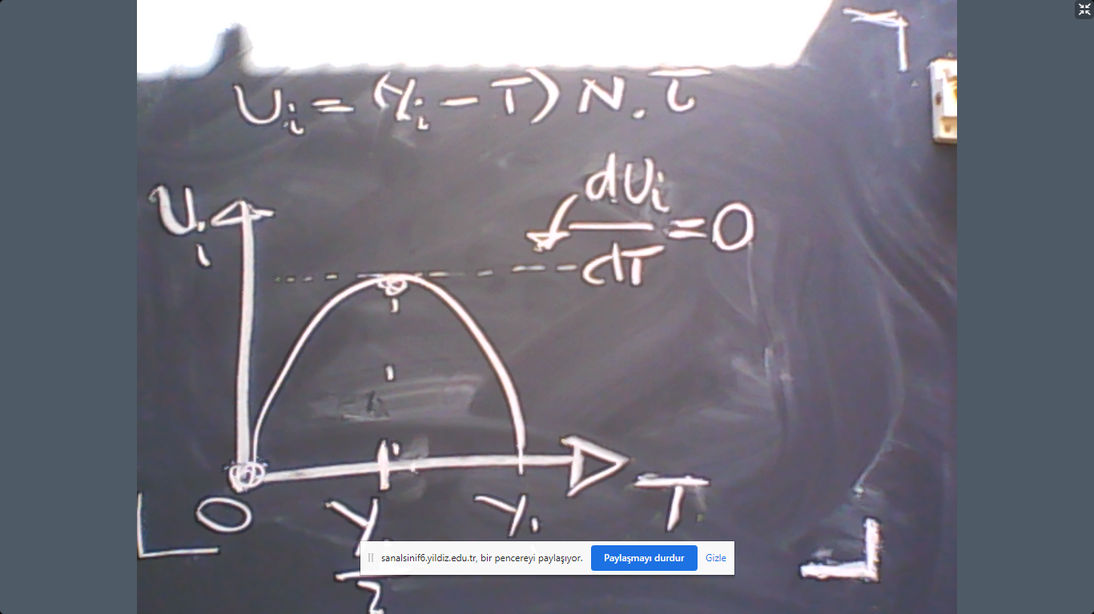
The graph shows that the preferences is single-peaked. Therefore, the Median Voter Theorem applies. The Condercet winner for the tax rates is
$$T^{*}=\frac{Y_{median}}{2}.$$
So if two political parties which aim to maximize their vote shares propose a tax $T$ in this society, both parties would enter the elections proposing the Condercet winner above.
For example, the number of individuals is $N=5$ and their income levels are given by
$$Y=\left\{10,12,14,16,28\right\}.$$
Therefore, total income is $Y_{1}+…+Y_{5}=80$, average income is $\overline{Y}=16$ and the median voter’s income is $Y_{median}=14$. So int this society the winning tax rate in the elections would be
$$T^{*}=\frac{14}{2}.$$
So let us see how the median voter theorem works. Suppose that Part A proposes T=7 and Party B proposes T=8. We will see Party A will win the elections.
 | 1 | 2 | 3 | 4 | 5
Party A, 7 | X | X | X
Party B, 8 |  |  |  | X | X

Now let us ask the same question with a different taxation system. The utility function of $i$ is still
$$U_{i}=C_{i}×G.$$
However, we assume now
$$C_{i}=Y_{i}×\left(1-t\right)$$
where $t$ is the income tax-rate. For instance $t=0.2$ means 20% of income is paid to the government as income tax by each individual. The budget constraint of the government is
$$G=t×\sum_{i}{Y_{i}}.$$
This means that the utility of individual $i$ can be represented by
$$U_{i}=Y_{i}×\left(1-t\right)× t×\sum_{i}{Y_{i}}.$$
In order to find the most preferred income tax rate by individual $i$ we should take the derivative of this function with respect to $i$ to see
$$\frac{dU_{i}}{dt}=Y_{i}\left(1-2t\right)\sum_{i}{Y_{i}}.$$
Equating this expression to zero, we obtain
$$t^{*}=\frac{1}{2}.$$
In visual terms, this computation can be expressed as follows:
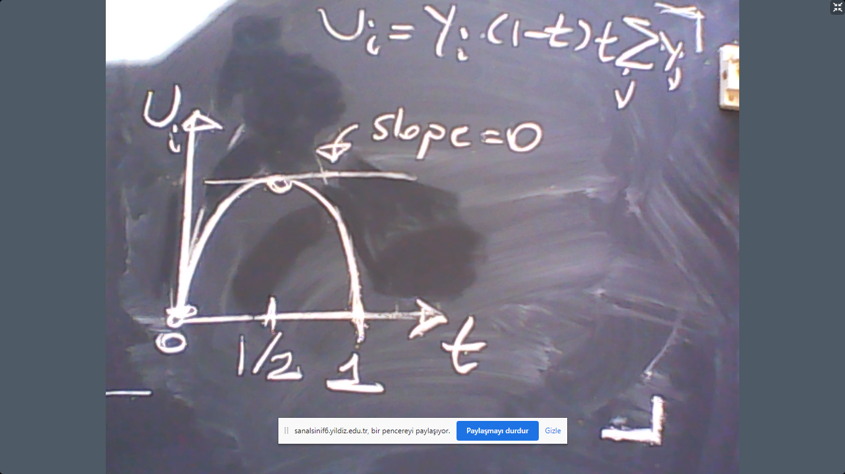
As can be also seen in the graph above, everyone prefers the same tax rat so there is no conflict of interest. The election would be peaceful.
Now let us use a little bit more general utility function. Assume that each individual $i$ has a utility function
$$U_{i}=C_{i}^{a}×G^{1-a}$$
where $a∈(0,1)$ gives the relative weight of consumption over public good in the utility function. To finance the public provision of the public good, each individual $i$ still pays a lump-sum tax $T$. Therefore, the consumption by $i$ is
$$C_{i}=Y_{i}-T$$
The government’s budget constraint is
$$N×T=G.$$
As a consequence, we can express the utility of $i$ as
$$U_{i}={\left(Y_{i}-T\right)}^{a}{\left(N×T\right)}^{1-a}.$$
To calculate the most preferred $T$ by individual $i$, we should compute
$$\frac{dU_{i}}{dT}.$$
To this end, consider the following reasoning:
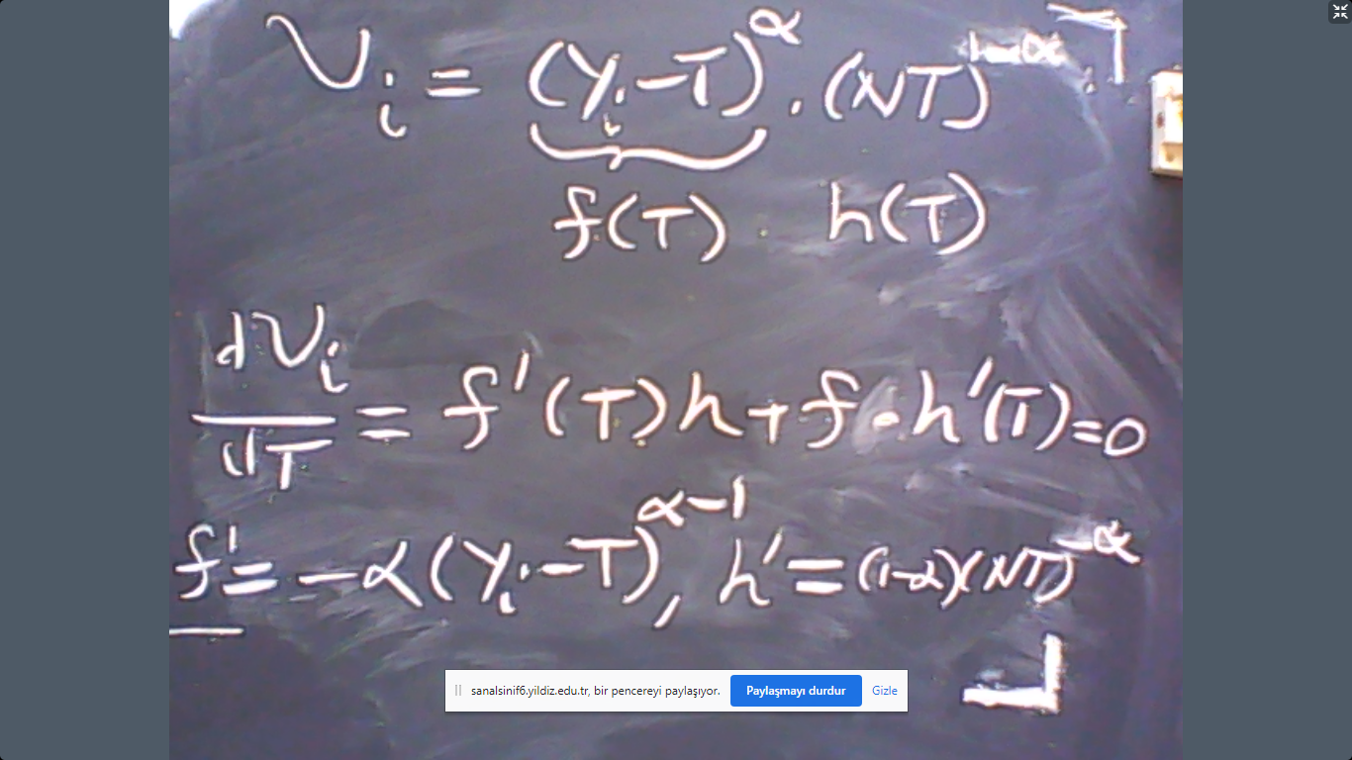

$$\frac{dU_{i}}{dT}=-a{\left(Y_{i}-T\right)}^{a-1}{\left(NT\right)}^{1-a}+\left(1-a\right){\left(Y_{i}-T\right)}^{a}{\left(NT\right)}^{-a}N=0$$
To simplify this equation, note that it implies
$$a{\left(Y_{i}-T\right)}^{a-1}{\left(NT\right)}^{1-a}=\left(1-a\right){\left(Y_{i}-T\right)}^{a}{\left(NT\right)}^{-a}N$$
$$a{\left(Y_{i}-T\right)}^{-1}{\left(NT\right)}^{1}=\left(1-a\right)N$$
$$aT=\left(1-a\right)\left(Y_{i}-T\right)$$
$$T=\left(1-a\right)Y_{i}.$$
How can we interpret this? What is the economic mechanism? The reason is that the utility is
$$U_{i}=C_{i}^{a}×G^{1-a}.$$
Hence, $1-a$ represents the weight of the public good in the utility. So the individual wants to spend more on the public good if she puts more weight on the utility derived from consuming the public good.
Income Inequality
In our first example, the market income was
$$Y=\left\{10,12,14,16,28\right\}.$$
and the winning tax in the elections would be
$$T^{*}=\frac{14}{2}=7.$$
So the post-tax income distribution (disposable income distribution) is
$$\left\{3,5,7,9,21\right\}.$$
Let us ask which income distribution is more equal or unequal. To answer this question we need a measure to calculate the level of income inequality. The most common method is the Lorentz curve (visual) and the Gini coefficient (numerical).
To use the Lorentz curve approach, we first rank the individuals from poorest to the richest according to income. (This is already done). Then we add the income of the next person to the previous income levels. This would give us
$$\left\{10,10+12,10+12+14,10+12+14+16,80\right\}=\left\{10,22,36,52,80\right\}.$$
Then we divide this sums by the total income which would give
$$\left\{\frac{10}{80},\frac{22}{80},\frac{36}{80},\frac{52}{80},1\right\}.$$
Now we plot the following graph:
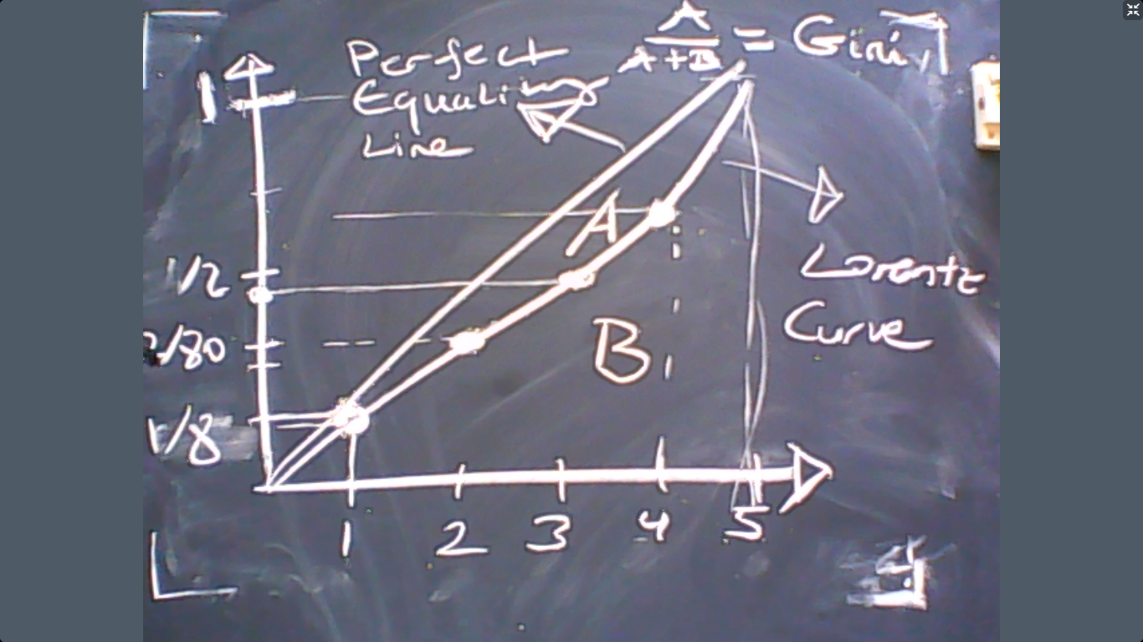

The Gini coefficient measures the income inequality. If Gini=0, then everyone has the same level of income. If, however, Gini=1, then all income is owned by 1 single person and all other people has zero income.
The geometric approach to calculate the Gini coefficient is tedious
$$Gini=\frac{A}{A+B}.$$
Instead, we can use the formula below:
$$Gini=2\frac{∑i×Y_{i}}{N×∑Y_{i}}-\frac{N+1}{N}.$$
where $Y_{i}≤Y_{i+1}$. In our first example,
$$Y=\left\{10,12,14,16,28\right\}.$$
So the Gini would be
$$Gini=2\frac{1*10+2*12+3*14+4*16+5*28}{5*80}-\frac{5+1}{5}=0.20.$$
Let us ask how the income distribution changed after the elections. Since the election is won by $T=7$
$$Y=\left\{3,5,7,9,21\right\}.$$
The level of inequality is
$$Gini=2\frac{1*3+2*5+3*7+4*9+5*21}{5*(45)}-\frac{6}{5}=2\frac{3+10+21+36+105}{225}-\frac{6}{5}=2\frac{175}{225}-\frac{6}{5}=2*0.7777-\frac{6}{5}=0.355…$$

