Economic Policy, Welfare, and Consumer Demand
Now we will consider another example where we can use our graphical techniques to analyze the problem at hand. Suppose that we would like to help a single mother to raise her child. Her utility depends on $x=child care$, and $y=all other goods$. Our question is what is the best method to help the mother with a fixed budget to aid her? The first option is to directly give the money to the mother. The second option is to subsidize childcare to reduce its price. This means effectively childcare would be cheaper for the mother. But which of these two options better for the mother?
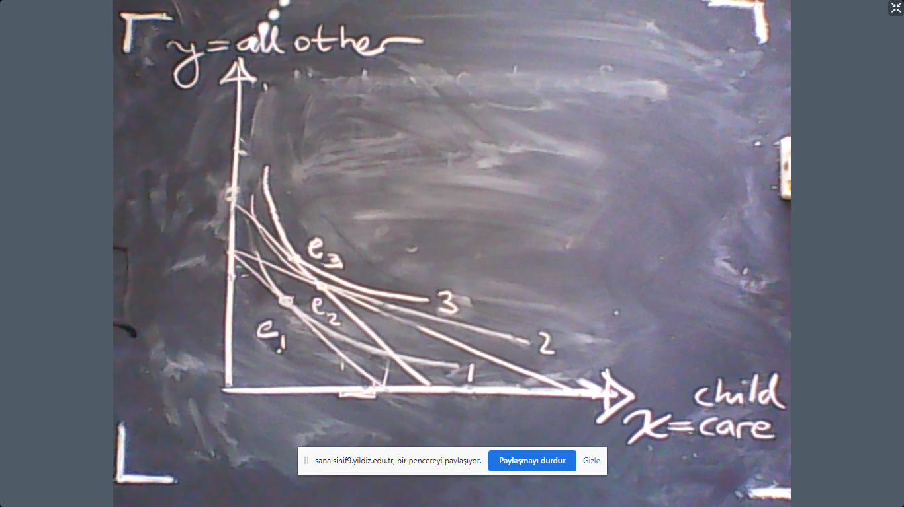
As the graphical solution demonstrates above, the mother benefits from childcare subsidies as her consumption moves to $e_{2}$ from $e_{1}$. But if we directly pay to the mother the money that we spend on subsidies – this is a direct transfer – then he consumption would be $e_{3}$. But the utility level at $e_{3}$ is higher than both $e_{1}$ and $e_{2}$. That is because, the third indifference curve lies above all other indifference curves. The same scenario is depicted in the graph below again.
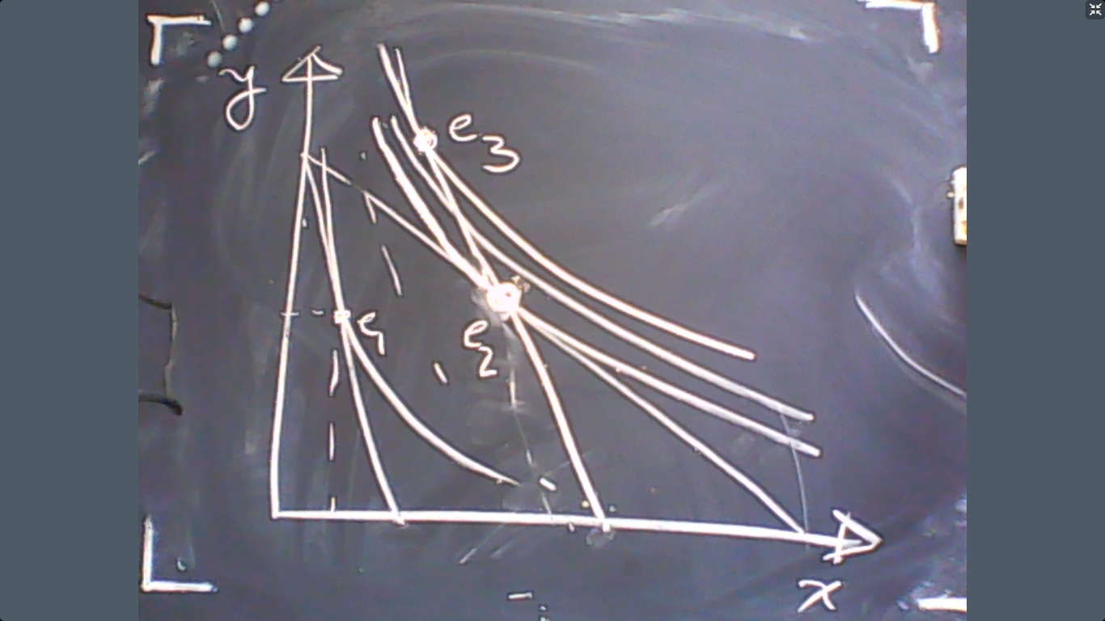
In all these instance, (aiding the single mothers, or Google’s employee is compensated for moving to London) we see that price changes (cheaper childcare or more expensive housing in London) have two effects. The first effect is that price changes practically change the income level of the individual. Lower prices have the impact of raising purchasing power of the consumer similar to higher income. Or, higher prices have the impact of reducing purchasing power of the consumer similar to lower income. The second effect is that higher prices motivate to replace a good with others. Or, lower prices motivate to consumers to replace other goods with the cheaper commodity.
In fact, we can always decompose these two distinct impacts as we shall see graphically below:
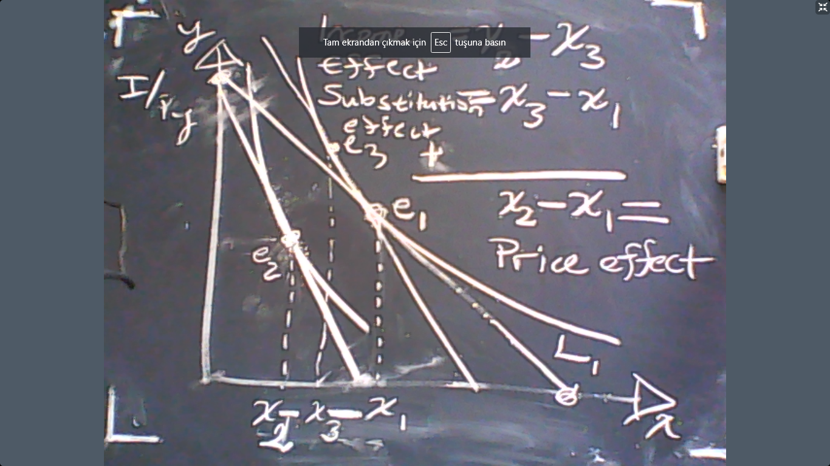
So there are two effects:
Income effect = $x_{2}-x_{3}$
Substitution effect = $x_{3}-x_{1}.$
Their sum is the price effect.
IE+SE=Price effect=$x_{2}-x_{1}.$
Consumption-Leisure Trade-off (Labor Supply)
Let us consider a very significant subject in microeconomics: consumption-leisure trade-off. This issue is based on the workers’ decision of how much labor to supply optimally. In fact, the major trade-off that a worker faces is how much time should be substituted for consumption in exchange for wage in the market.
In mathematical terms, suppose that the individual chooses $x$, denoting free-time (leisure) and $y$, consumption level. If the individual has 24 hours per day, then the time that she works would be
$$24-x.$$
If the hourly wage is denoted by $w$, and the price of the consumption good is $p$, then the budget constraint is
$$p×y=w×\left(24-x\right).$$
Assume that the utility of the worker is
$$u(x,y)$$
then she would solve
$$\max{u\left(x,y\right)}$$
s.t.
$$py=w\left(24-x\right).$$
But this can be re-phrased as
$$\max{u\left(x,y\right)}$$
s.t.
$$py+wx=w24.$$
This problem can be solved using the standard MRS=px/py rule. In other words, the utility maximizing worker would solve
$$\frac{MU_{x}}{MU_{y}}=\frac{price of x}{price of y}=\frac{w}{p}$$
and
$$py+wx=w24.$$
If the solution to these two equations is $(x^{*},y^{*})$ then the labor supply of the individual is $24-x^{*}$. Let us see that graphically:
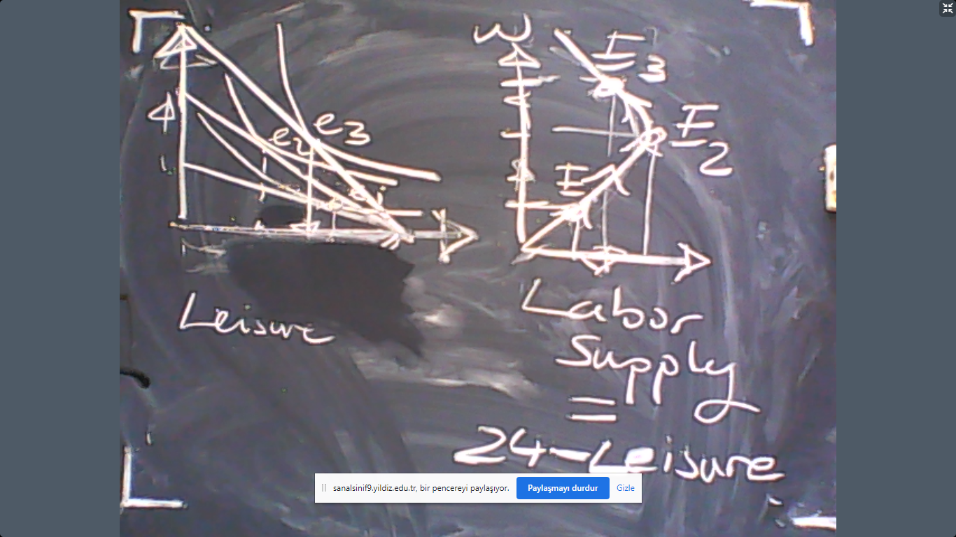
In this graphical example, we see that labor supply first increases with wages but then decreases with wages. The reason is that the income effect is small initially so the individual does not consume more leisure as she becomes richer. But as the wage rises even further, the income effect starts to bite, and eventually dominates. Therefore, we obtain a backward bending labor supply curve.
Of course, this graphical result does not need to be true for all possible utility functions. In some other cases, we can have a positively sloped labor supply while there can be a negatively sloped labor supply in other cases. In the next example, we will see a utility function where the labor supply is constant: neither increases nor decreases with the wage rate, $w$.
Ex: Suppose that $u=x×y$. Then the MRS rule would imply
$$\frac{y}{x}=\frac{w}{p}$$
because MRS=x/y with this utility function. In other word,
$$py=wx.$$
Therefore, the budget constraint
$$py+wx=w24$$
implies that
$$wx+wx=w24.$$
Conclude that
$$x^{*}=12.$$
So the labor supply is
$$24-x^{*}=12.$$
So this means the individual would work for 12 hours per day whatever the wages are.
Consumer Surplus:
Based on our analysis, we can, in principle, calculate the social benefit or damage that a fundamental change would cause in the economy. For example, what would be the impact of a new commodity to be introduced by the producers such as the smartphones? Or, would it be social desired if we build a new bridge? Another question that we ca answer using the tools that we developed could be how to measure the benefit of technological progress.
These questions could be answered by calculating
$$u_{new}^{*}-u_{old}^{*}$$
where $u_{old}^{*}$ is the maximized utility before the fundamental change takes place and $u_{new}^{*}$ is the maximized utility after the fundamental change takes place. Nevertheless, utility is inherently unobservable by the third parties. So practically this approach is futile.
There is, however, a method that we can answer the same question based on observables, namely, the demand function. The method is calculating the consumer surplus. The consumer surplus is the difference between the maximum amount of money that consumers would pay for the market production and the actual payment that they do. This is a measure of the value for the existence of such a market. Let us see in an example.

So the consumer surplus can be easily computed by the area between the demand curve and the price. This area measures the value attributed to the existence of such a market. The unit of this measure is money. This is a money-measure of subjective value. Since the unit is money, it can be compared to the cost of creation of this surplus.
Let us see the example below:
Suppose that the market price is initially $p^{*}$, implying the consumer surplus to be equal to $A$. If technological progress reduces the price to $p^{'}$, then the total consumer surplus would be $A+B$. Conclude that the technological progress would increase the consumer surplus by
$$ΔCS=A+B-A=B.$$
Because $B$ is measured in money, it also shows how much money that the society would be willing to invest in improving the technology to reduce prices.
End of lesson.

