We analyzed the price elasticity of demand with linear demand in the last class. Now let us see an example with non-linear demand.

Example: Suppose that demand The figure below shows this function for different values of :

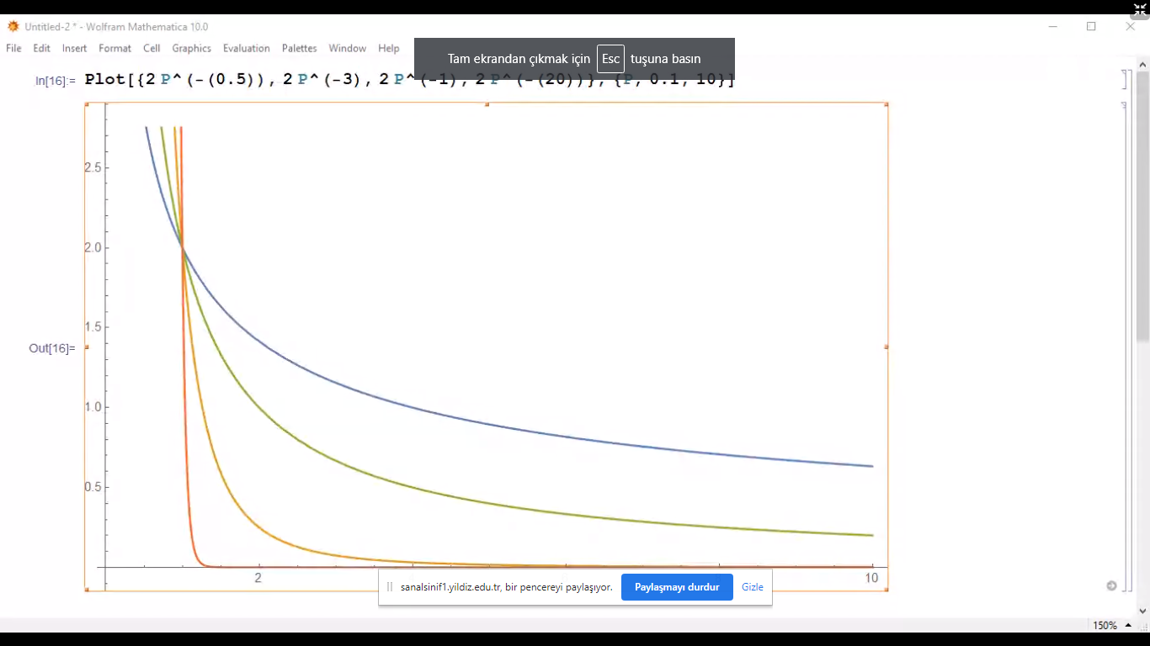

Now let us see why is so crucial. The price elasticity of demand is

In other words, if is the demand function, then the price elasticity of demand is .

**Other elasticities**

Demand is influenced by many factors so we can calculate the elasticity of demand with respect to different variables. For example: Income.

Recall that we studied a particular linear demand in the previous class:

What is the percentage change in demand (Q) due to 1% increase in income (Y)? The income elasticity of demand is

In the example, we assumed and calculated . Therefore, the final result would be

In this example, if income rises by 1%, then demand for coffee increases by 0.35% (or 10% increase in income causes 3.5% increase coffee demand).

In general we can calculate the elasticity between any two variables, say and . This leads to the analysis of supply elasticity.

**Supply Elasticity**

Suppose that is the supply function. Then the price elasticity of supply is

Let us consider an example. Assume that

This is a linear supply function. Therefore,

If, for example, , then this expression boils down to

This is called unit elastic supply: 1% increase in price leads to 1% increase in supply. In general we say that supply is elastic if . If , then supply is inelastic. And we know that due to the law of supply (higher prices imply higher supply).

Elasticities in practice: The price elasticity of oil demand is and the price elasticity of supply is Currently, the equilibrium quantity of oil produced and consumed in the world market is (billion barrels of oil) at the price per barrel. Estimations show that the Arctic oil reserves would allow 0.8 (billion barrels) of extra oil.

To see how this new reserve would change the price of oil, assume

What we need to do is to calculate . Let us start with :

First of all, we know that

The elasticity of demand, assuming , would be

In the question, Therefore,

Put this back into the demand function above to see

So that

So now we know the demand function:

What about supply? The elasticity of supply, assuming , would be

In the question, Therefore,

Put this back into the supply function above to see

This gives

So the supply function is

while the demand is calculated to be

After the extra oil production in the Arctic equal to , the new supply would be

With this new supply function the market equilibrium would be:

The percentage change in price would be

The quantity of production would be billion barrels. The percentage change in quantity would be

Note that the increase in production is 0.4 which is less than the Artic reserves, 0.8. The reason is that Artic reserves would reduce the price of oil, which would discourage other oil producers in the world. This reduces the impact of extra reserves. The process can be seen in the graph below:

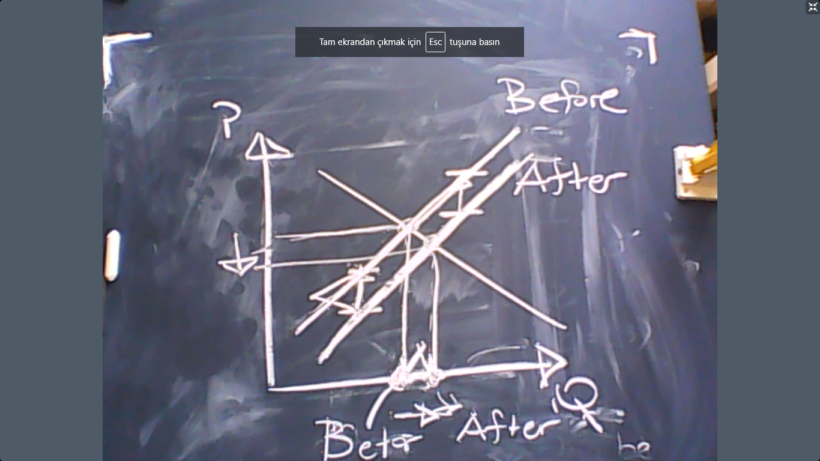

**Consumers**

What is the source of demand? Consumers. In this new subject, we will analyze how consumers make their decisions.

Each consumer chooses a bundle or a basket. Of course, we – as the consumers – donot think equally for all bundles. We like some more than others and we dislike some other bundles. This ranking of all possible bundles is called the preferences, typically denoted by . For example if you like bundle A no less than bundle B, then we write

In this case, A is preferred to B.

In economics rationality is actually 3 conditions imposed on the preferences .

**Condition 1**: Transitivity: If A is preferred to B and B is preferred to C, then A must be preferred to C.

**Condition 2**: Completeness: For any two bundles either A is preferred to B or B is preferred to A or the consumer is indifferent.

**Condition 3**: More is better. If bundle A includes more of everything compared to B then A is preferred to B.

There is a mathematical proof which shows that any rational preference ( which satisfies Condition 1-2-3) can be represented by a function. What do we mean by representation. The function would assign a numerical value to each bundle so that higher numbers would correspond to more preferred bundles:

This function is called “the utility function”. Theoretically, there is no difference between a utility function and a preference relation. However, for computational purposes, the utility function is practically more convenient. So we will continue our analysis using the utility function.

**Example:** Suppose that a consumer can buy two goods, and . The preference of the consumer of all possible bundles of and is . However, this preference of the consumer can be represented by a utility function

How can we understand the preference of this individual with this function. The easiest way is to plot Now let us do this.



Both graphs show us the same utility function. However, drawing the second graph on the right-hand side is clearly easier. The black lines show us certain levels of utility that do not change while we vary and . These lines are called “indifference curves”. In terms of plotting and understanding preferences, they are very essential.

Indifference curves satisfy the following properties (assuming condition 1-2-3 above):

1. No indifference curves intersect. If they did, then there would exist a single bundle which give different levels of utility.
2. Indifference curves are negatively sloped. If there was a positively sloped indifference curve, then the utility would be same despite consuming more of everything. This contradicts “more is better”.
3. Indifference curves cannot be thick. A thick indifference curve would mean more consumption does not necessarily make the consumer happier.

