**Technology and Firm Behavior**

Technology affects firms’ behavior. For example, ATMs and human bank tellers are perfect substitutes. How does this technology affect banks’ employment and investment decisions? How does the slaughterhouse behave knowing that cattle and butchers are perfect complements? How does the US economy behave given its Cobb-Douglas technology? So let us analyze this question: how does technology affect choices of input and output by firms.

To answer this question, we make a very strong assumption: all markets are perfectly competitive. Perfectly competitive markets mean all prices (including the prices of inputs) are given at the market level, and no firm can affect the prices of inputs or outputs. Moreover, firms maximize profits in perfectly competitive markets.

Now consider a representative firm which has a technology . So the profit of the representative firm is

where is the price of the good produced, is the price of capital (rent), and is the price of labor (wage). The firm, of course, wants to earn money as much as possible. So it maximizes the profit by choosing and . We write this profit maximization problem as

**Exercise:** Prove the following claim. If the technology exhibits CRS, then in a perfectly competitive market.

Assuming all markets are perfectly competitive, the solution to the profit maximization problem is given by the first order conditions

Now let us compute these derivatives in more detail. By definition,

In other words, if the firm wants to earn money as much as possible in a perfectly competitive economy, then its choice of should satisfy

**Remark:** These two equations fully determine output, employment and capital utilization levels. Also note that

are purely technological concepts since they are derived simply by differentiating with respect to and . Since these technological concepts determine how much a firm produces or employs labor or utilizes capital, they are extremely important, and they have specific names in economic analysis.

**Definition:** If is a given production technology, then

are called the marginal productivity of labor, and capital, respectively.

Marginal productivity measures the increase in output due to a small increase in input. Hence, tells us how much output would increase if a firm would hire a new worker. Likewise, tells us how much output would increase if a firm would add a new computer its capital.

**Exercise:** Show profit maximization requires

In economics, is called the real wage. It measures the wage in terms of output.

**Exercise:** What if the equation above does not hold?Interpret

in simple and plain terms. How would a firm increase its profit in the first and the second cases?

As an example, let us calculate the marginal productivities for the Cobb-Douglas technology . The answer is

The terms on the right hand-side, and , have a particular name.

**Definition:** Average productivities of labor and capital are

Marginal and average productivities are different concepts. Average productivity gives output per unit of input. Marginal productivity gives the increase in output by increasing input in a small amount.

**Distribution of income**

We have seen that the technology fully determines output, employment, and capital utilization at given prices. Now we shall see this also means technology determines how income is shared among entrepreneurs, rentiers, and workers. Now let us see how this works.

Profit is entrepreneurs’ income. Rent is rentiers’ income. Wage fund is workers’ income. By definition, profit is

If you leave alone, then

This equality says

Dividing both sides by (total output’s market value) gives

This equality says

Think “Total Output” as a cake, which is also “Total income”. Now we will see how technology determines who gets the most from this huge cake. First recall

due to profit maximization. Divide each equation by average productivity AP to see

But average productivities are and . Hence the equation above means

However, the left hand-side of each equation has a very interesting interpretation in terms of distribution of income:

Conclude

In words, marginal productivity divided by average productivity gives us the share from total income (=output) for labor and capital. The remaining share is the profit share:

since

This means marginal productivity and average productivity, which are purely technological concepts, determine how total income is shared between capitalists and workers. Technology determines the levels of output, employment, capital utilization, and how output is divided between workers, rentiers, and entrepreneurs.

Let us finally remark that MP/AP corresponds to a very interesting concept in economic analysis of technology: input elasticity of output.

**Definition:** Labor elasticity of output is

This is a measure of technological sensitivity of production to a small change in labor input. In particular, labor elasticity of output is the percentage change in due to 1% change in . Why? Note that

If you divide the first expression to the second you get the labor elasticity of output

If is high, then the production process is sensitive to labor as an input. Otherwise, if is low, then the production process is insensitive to labor as an input. Therefore, it is reasonable to expect that would operate as the bargaining power of labor. If the production process is sensitive to labor, then workers would have a strong position, and the labor share in income would be high.

But what is surprising is that this measure of technological sensitivity, , gives exactly the labor share of income. To see this, recall

which means

So we have the most important economic result in this course until now

**Theorem:** In a perfectly competitive economy, technology determines the distribution of income as follows:

Since the same analysis can carried out for capital, it follows

These two expressions mean

**Interpretation:** The technological sensitivity of output to inputs fully determines how production is distributed among workers, rentiers, and entrepreneurs.

**The rise of the Cobb-Douglas technology**

Now let us apply our results to the Cobb-Douglas technology. If , then the elasticities are

The next exercise asks for a proof of this claim.

**Exercise*:** Prove that and assuming Cobb-Douglas technology.

Therefore,

when technology is Cobb-Douglas, and the markets are perfectly competitive. That is the reason why, is often called “the distribution parameter” in the Cobb-Douglas technology.

This is a very bold prediction that can be tested against the data. So now let us do that, and check the actual data. Recall that Cobb-Douglas estimated . So, according to Cobb-Douglas, the share of capital was predicted to be 0.25, and the share of labor was predicted to be 0.75. The actual share of capital and labor are indeed staggeringly close, 0.26 and 0.74, at least so claims Paul Douglas.

This is a tremendous achievement both for Cobb-Douglas and perfect competition. Not only does Cobb-Douglas technology accurately predict output, but it also pins down (together with perfect competition) how income is shared between labor and capital. This is arguably the most important reason why the Cobb-Douglas formulation is so popular.

Cobb-Douglas technology pulls another rabbit out of its hat. Note that this technology also predicts the share of capital and labor are and , which are completely independent of level of capital and labor. That is, regardless of how much input is used and how much is produced, factor shares are always constant according to Cobb-Douglas technology. So, if Cobb-Douglas technology is an accurate description of real life technology and if (this is a big “if”) the markets are perfectly competitive then we should observe constant factor shares. For a long time, this was believed to be true. So true that it is one of the stylized facts of growth: factor shares are constant over time. Now we will discuss this issue.

**The fall of the Cobb-Douglas technology**

The Cobb-Douglas technology has always been under serious criticism. For example, Kravis (1959) documents labor share is neither constant, nor approximately 75% despite the claims of Paul Douglas and Charles Cobb.



Source: Kravis (1959), “Relative Income Shares in Fact and Theory”, AER

In recent years, the arguments against the Cobb-Douglas technology has been louder. The critiques estimate for the CES technology

just like Cobb and Douglas estimated for the Cobb-Douglas technology.

In this more general case, the Cobb-Douglas hypothesis claims that . However, the estimates of are typically between and . There is a very vast literature on this, and the evidence is clear. For example, according to Lawrence (2015), .

This means capital and labor are complements, and the Leontief technology is a better representation of the relation between these inputs. This contradicts the Cobb-Douglas technology.

**Remark:** Recent estimates show that labor and capital are complements contradicting Cobb and Douglas.

Now let us analyze the implications of this result. The marginal productivity of labor with the CES technology is

Thus, the labor share in income is

Since estimates of are typically negative, labor share should increase with average income .

**Exercise*:** Assume the labor share is

where . Show that this is an increasing function of average productivity .

However, conclusion does not hold in real life. Average productivity has a positive time trend almost in all countries. So typically increases. Given complementarity between labor and capital, this would mean higher labor share. However, labor share is shrinking in most of the developed world. The graph below is from Lawrence (2015).



As can be seen in this graph, the labor share in the US (actually, also around the world) is in decline although increased more than 2 folds over this period. A similar trend is also observed in other OECD countries.

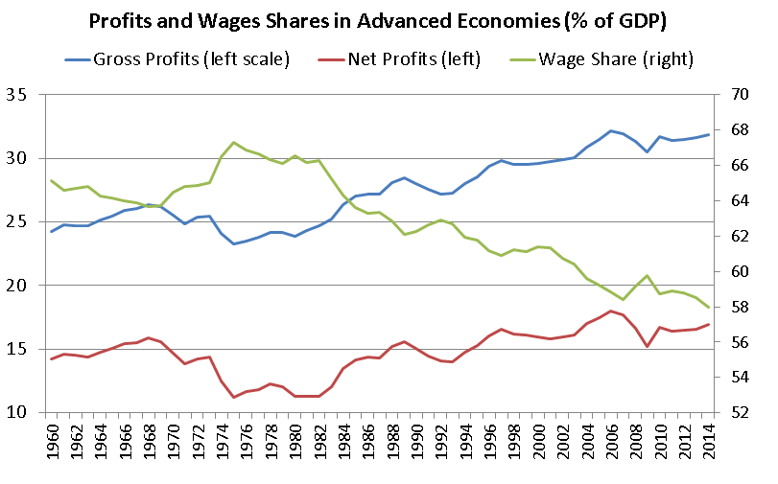

So how can we reconcile declining labor share with the complementarity between labor and capital? The answer lies in the formula:

As Lawrence (2015) points out, the growth of is the “labor augmenting” technological progress. So if the labor augmenting technology grows faster than average income , then labor share would decrease while labor and capital are complements.

**Cost minimization**

Of course, profit maximization implies cost minimization. If you want to earn money as much as possible, then you have to be very efficient, and operate at the minimum cost possible. The problem of cost minimization can be stated as

s.t.

where is a fixed level of output. Now we make three important observations about this cost minimization problem.

1) The solution to this problem in is called the input demand.

2) This solution is a function of .

3) evaluated at the input demand is the total cost function.

**Example:** Let us derive the input demand, and the cost function for the Cobb-Douglas technology. So we want to solve

s.t.

The Lagrange conditions of this problem are

The solution to this problem is

These are the “input demand” since these capital and labor minimize cost to produce a certain level of output, . The level of cost at the input demand can also be computed as follows:

But this complicated expression can be simplified to

where

which is a fixed number from the perspective of the firm. So the total cost of the firm is

**Exercise*:** Draw the graph of when the technology is Cobb-Douglas assuming .

**Exercise:\*** Derive the cost function for the Leontief technology.

**Remark:** The interpretation of in is “total factor productivity” as it measures how much output is produced when 1 unit of capital and 1 unit of labor are used together in production. So is a composite productivity measure of labor and capital together.

In general the profit of the firm now can always be stated as

where is the minimum level of cost for producing level of output, as we discussed above. All technological information is contained in . The derivative of is called the marginal cost

The marginal cost is the extra cost of extra production.

**Exercise*:** Show that maximizing implies

This condition is equivalent to profit maximization conditions based on marginal productivities. This result is very important. It shows us that cost function conveys all the relevant information about technology.

**Remark:** Production technology and cost function are the two sides of a coin.

Now let us see some applications of this result.

**Exercise*:** Discuss how a firm could increase its profit if

If is a linear function of , as in the case of Cobb-Douglas technology, then is a constant with respect to the output level. This means that extra production always costs the same. This is called “constant marginal cost technology”. Constant marginal cost is actually equivalent to a very important technological property that we analyzed earlier:

**Theorem:** If the production technology is CRS, then the marginal cost is a constant.

This result is intuitive. Suppose CRS technology. So output can be doubled by doubling input, which doubles the cost level. Conclude that cost is just a linear function of output. But linear total cost simply means constant marginal cost.

There are corresponding results for the increasing and decreasing returns to scale technologies.

**Theorem:** If the production technology IRS, then the marginal cost is decreasing in output.

**Theorem:** If the production technology DRS, then the marginal cost is increasing in output.

Let us conclude this section with the following exercises:

**Exercise*:** Find the returns to scale if the cost function is .

**Additional Questions**

1. In this chapter, we argue that the first order conditions of the profit maximization problem are:

Explain the role of perfect competition in these first order conditions.

2. Suppose that the production technology in Hungary is Cobb-Douglas:

We also know that Hungary is a perfectly competitive economy. If the workers’ income is 40% of the total output then what is in Hungary?

3. Assume that the technology is .

a) Find the marginal productivities.

b) Compute the profit maximizing level of inputs assuming wage is , and the rate of return is .

c) Compute the average productivities at these optimal levels.

d) Compute the input elasticities of output.

e) Compute the labor, capital, and profit shares.

f) Calculate the cost function, and the marginal cost.

g) Discuss whether this technology exhibits CRS/DRS/IRS?

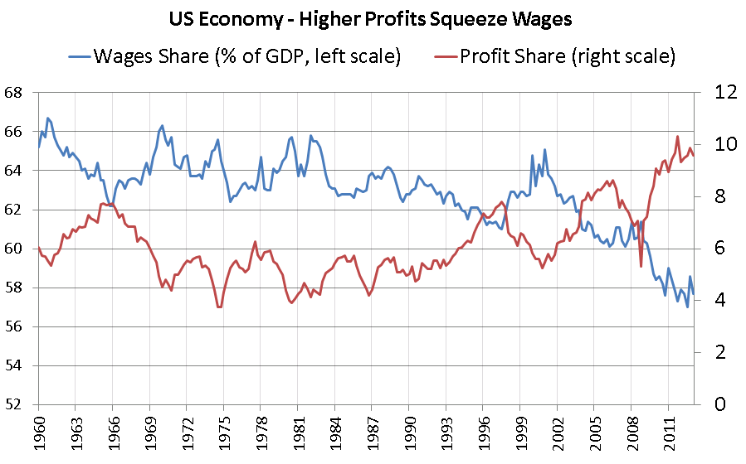

Source: Financial Times