Automotive
Engineering Body Materials
(Past, Present and Future Analysis)

Steel Becomes the “Material of Choice”
for Auto Bodies

• Original bodies made of wood
& steel
• Quick to tool, easy to change
• Large number of skilled workers

Benz Patent Motorwagen 1886 (Replica)

• 1914 Dodge & Budd produce

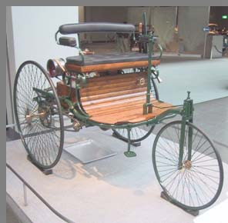

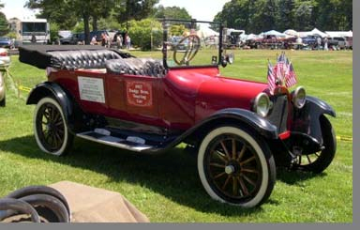

5,000 all-steel bodies
• All-steel body was lighter, stronger, easier to make
• Most significant advantage was in painting

Dodge Brothers Touring Car 1917

“Every time the price of steel goes up,
auto makers moan in anguish and intensify their search for
replacements”

gas
“Every time the price of steel goes up, auto makers moan in anguish and intensify their search for
replacements”

Materials Causing the Biggest Stir in Body

Technology

Plastics

-“been getting the big play …
as successor to steel”

Aluminum Alloys

-“about as strong as steel, less than half the weight”

-“used …since birth of auto”

-“most plentiful metal on earth”

Magnesium Alloys

-“even lighter than aluminum, stronger for its weight than steel”

-“most easily machined and cast”

-“enough in the ocean…
to provide 100,000,000 tons a year”

Published October 1953

“The day of the passenger car made primarily of iron and steel is on the wane! Some sources predict that
by 1960 a Cadillac will weigh less than a 1953 Chevrolet
and a Chevy will probably weigh about as much as a motorcycle.”

Prediction 50+ Years Ago…

Steel
Mg

Al Plastics

PAST
FUTURE

Key Product Drivers & Resulting Vehicles

Clean Air Act

Highway Safety Act

Global

Customer

Safety

Focus
Oil
Shock
Competition
Personalization

1950
1960
1970 1980
1990 2000+

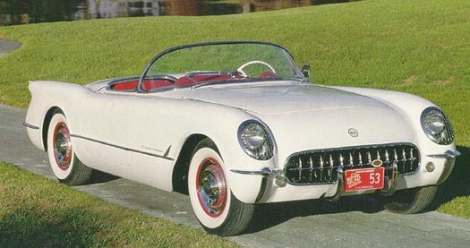

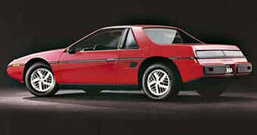

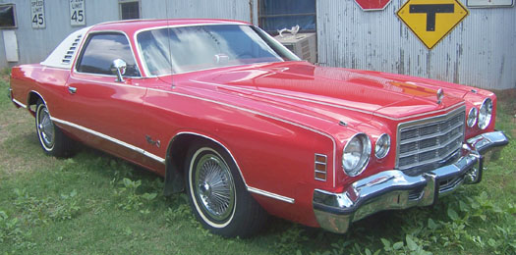

1997199720062006–– AudiAudi–– TheTheintroduceintroduceC6C6 Z06Z06
19841984 –– PontiacPontiac releasesreleases
ththee allall aluminumaluminumCorvetteCorvette volumeisvolumeis released.released.
FieroFiero.. Small,Small, fuelfuel
efficientefficientcar.car.sporsporUtilizesUtilizesTheThetstsAluminumAluminumcarcarcarboncarbonthatthat frfiberfiber
usesusesweighweighcompositecompositefenders,fenders,uupp totopanelspanelslesslesswheelwheelthanthanhouses,houses,
toto reducereducesteelsteelfloors,floors,ovovfrframeseameserralalll andandweweofofiightghtcompanan.. aluminumaluminum
design.design.frame.frame.

Late 1970’s – Dodge releases
Charger XL that applies higher
strength steel and aluminum components that resulted in a

ces thethe dy.
es allall
285kg reduction in vehicle mass.

ss thethe firstfirst
roduction 19531953 –– ChevroletChevrolet Introdu
ames CorvetteCorvette ww// ffiberglassiberglass bo
40%40% ooff LightweightLightweight bodybody imprimprov arable aspectsaspects ofof perfperformance.ormance.

Steel Mass Reduction

0%

10%
MILD STEELS

CONV HSS

20%

30%

40%

50%

1970
Mass Reduction
Opportunity

1980
1990 2000 2010 2020

Time
2030

Current Body and Closure
Metallic Material Content

Advanced
HSS

Aluminum & Magnesium
Source: Ducker Worldwide
2007

Conventional
HSS

12.7%

9.5% 0.8%

Medium
HSS

15.8%
Mild Steel

54.6%

Bake Hardenable Steel
6.6%

850 Pounds

Comparison of Materials by Performance

 | Density |  | Modulus | Tensile  Strength | Elongation | Corrosion  Resistance
Mild Steel
 |  | - - - - - - - - - - BASELINE - - - - - - - - - -
Aluminum | + |  | - | 0 | 0 | 0 / +
Magnesium | + |  | - - | 0 | - | 0 / -
Polymers & Composites | + |  | 0 / - | - / 0 / + | - | +
HSS/AHSS | 0 |  | 0 | + + | 0 / - | 0

Comparison of Materials by Manufacturability

Steel &

HSS/AHSS

Aluminum

Magnesium
Polymer/ Composites

Advantages:

• Formability

• Weldability

• Infrastructure

• Painted Surface

Disadvantages:

• Castability
Advantages:

• Formability

• Castability

• Painted Surface

Disadvantages:

• Lower formability than steel

• Weldability
Advantages:

• Castability

Disadvantages:

• Formability

• Elevated temperature stamping & hemming
Advantages:

• Low cost tooling

• Shorter lead time

Disadvantages:

• Cycle Time

• Infrastructure

• Difficult to repair

• Painted

• Weldability

Surface

Comparison of Materials by

Other Important Characteristics

 | Cost  (Est. $/lb.) | Availability (Annual Metric Ton Production) | Environment (Primary Production Emissions reported by industry)
Mild Steel  (Baseline) | $0.50 | 110 Million | • easy to recycle  • Emissions = 2.3 – 2.7 kg CO2/kg
Aluminum  (Al) | $1.00 | 2.5 Million | • easy to recycle  • Emissions = 13.9 – 15.5 kg  CO2/kg
Magnesium  (Mg) | $1.50 | 0.5 Million | • easy to recycle  • Emissions = 18.0 – 24.8 kg  CO2/kg
PMC | $1.20 -  6.50 | Unknown | • difficult to recycle  • Emissions = 2.5 – 23.0 kg CO2/kg
HSS/AHSS | $0.55 | Included in Mild  Steel | • easy to recycle  • Emissions = 2.3 – 2.7 kg CO2/kg

Steel Strategy

70

60 Second Generation AHSS

50 Conventional HSS
IF- HS

ISO

40
Mild
30 BH

20

10

0

First Generation AHSS

MART

0 300
600
900
1200
1600

Tensile Strength (MPa)
Elongation (%)

Business Strategy

Manufacturability
& Cost:
• material
• design
• manufacturing
Government Regulations
• Fuel Economy
• Crash Performance
• Emissions
& Customer Requirements
• Cost
• Quality/Styling

• Features

Steel Mass Reduction Opportunities

0%

10%

20%

30%
MILD STEELS

CONV HSS

Without DOE Support

AHSS

40%

50%

With Steel Strategy
& DOE Support

FreedomCAR GOAL

Technology
Decision
MASS COMPOUNDING
3rd GENERATION

Mass Reduction
Opportunity

1970

1980

1990 2000 2010 2020

Time

2030

800
V eh icles p er T h o u sa n d P eo p le
Global Transportation Growth

Source: Joe Carpenter, DOE

U.S.

600

400

Industrialized Pacific

Western Europe

200

0

Africa
China
Eastern Europe

Mid-East
Former Soviet Union
Latin America
Developing Asia

U.S. Historic

1900 1910 1920 1930 1940 1950 1960 1970 1980 1990

China, with 13 vehicles per 1000 people, is where the U.S. was in 1913
China’s population is currently 4 times the population of the U.S.

What materials will be used
to meet these demands?

NORTH AMERICAN
LIGHT VEHICLE METALLIC MATERIAL TRENDS

Body and Closure Metallic Material Content by Type

2007 2015

Con. HSS

Advanced
HSS
9.5%
12.7%
Aluminum & Magnesium
0.8%

Advanced
HSS

34.8%
Aluminum & Magnesium

2.5%

Mild Steel

29.0%

15.8%
Medium
HSS

6.6%
54.6%

Mild Steel

10.2%

23.5%

Bake Hardenable

Conventional
HSS
Bake Hardenable and
Medium HSS

850 Pounds

Source: Ducker Worldwide
800 Pounds with an Equal
Footprint to 2007

NORTH AMERICAN
LIGHT VEHICLE METALLIC MATERIAL TRENDS

North American Light Vehicle Material Content Per in Pounds

 | 1975 | 2005 | 2007 | 2015 | Change From  1975 to 2015
Mild Steel | 2,180 | 1,751 | 1,748 | 1,314 | Down 866 lbs.
High Strength Steel | 140 | 324 | 334 | 315 | Up 175 lbs.
Advanced HSS | -- | 111 | 149 | 403 | Up 403 lbs.
Other Steels | 65 | 76 | 76 | 77 | Up 12 lbs.
Iron | 585 | 290 | 284 | 244 | Down 341 lbs.
Aluminum | 84 | 307 | 327 | 374 | Up 290 lbs.
Magnesium | -- | 9 | 9 | 22 | Up 22 lbs.
Other Metals | 120 | 150 | 149 | 145 | Up 25 lbs.
Plastic/Composites | 180 | 335 | 340 | 364 | Up 184 lbs.
Other Materials | 546 | 629 | 634 | 650 | Up 104 lbs.
Total Pounds | 3,900 | 3,982 | 4,050 | 3,908* | Up 8 lbs.

Source: Ducker Worldwide
* Same vehicle mix and average footprint as 2007

NORTH AMERICAN
LIGHT VEHICLE METALLIC MATERIAL TRENDS

Body and Closure Metallic Material Content by Type

Advanced
HSS

34.8%
North America

Aluminum & Magnesium

2.5%

Mild Steel

29.0%

PHS, TWIP
& Others
12.0%
Europe

Aluminum & Magnesium
3.0%

Mild Steel & BH

25.0%

10.2%

Conventional
HSS

23.5%
Bake Hardenable and
Medium HSS
30.0%
AHSS

30.0%
Conventional HSS

2015

Why is this reasonable?

• No real changes in basic trends over past 50 years

• “Cash is King” – customer paying less than before & demanding more

• Infrastructure not ready

• Availability – Infrastructure of metal production

• Global Differences in Needs

What could ‘disrupt’ this prediction

• Fuel Cost & Availability

• Material Cost & Availability

• Economic Stability

• Government Regulations

• Technological Discoveries/Advances

Conclusions

• Always be a need/desire to push to lightweight materials for the auto industry

• Doesn’t mean no steel

• Current prediction is mainly some form of steel

– Best value to customer (performance/cost)

• However, disruptive event(s) is as likely, or even more likely, than ever before

