CHASSIS MATERİALS
Materials used in chassis is shown in the following Table . These materials are used in the forms of channel, tabular, tube and box section profiles, rods, plates and sheets.

a. Channel Section - Good resistance to bending
b. Tabular Section - Good resistance to torsion
c. Box Section - Good resistance to both bending and torsion

The most widely used chassis materials are shown in the following table
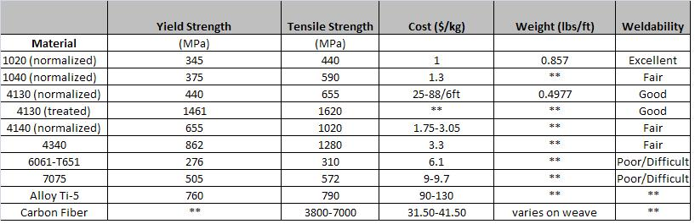
Chemical compositions of chassis matarials are as follows;
1020 steel low carbon and low strength steel
C = % 0.17-0.23, Mn= %0.30-0.60, S=<0.050, P = <0.040
1040 steel medium strength steel
C= % 0.35-0.45 Si = % 0.05-0.35, Mn = =.60-1.0 S = 0.06, P = % 0.06

4130 steel High strength steel
Carbon |  | 0.28 - 0.33
Chromium |  | 0.8 - 1.1
Manganese |  | 0.7 - 0.9
Molybdenum |  | 0.15 - 0.25
Phosphorus |  | 0.035 max
Silicon |  | 0.15 - 0.35
Sulphur |  | 0.04 max
4140 steel High strength steel
Carbon | 0.42%
Silicon | 0.30%
Molybdenum | 0.20%
Manganese | 1.00%
Chromium | 1.00%
4340 steel High strength steel
Carbon | 0.40 %
Silicon | 0.25 %
Molybdenum | 0.25 %
Manganese | 0.70 %
Chromium | 0.80 %

Nickel 1.85 %

6061 Aluminium Alloy Medium strength heat treatable wrought Al-Mg-Si alloy

Manganese (Mn) | 0.0 - 0.15
Iron (Fe) | 0.0 - 0.70
Magnesium (Mg) | 0.80 - 1.20
Silicon (Si) | 0.40 - 0.80
Copper (Cu) | 0.15 - 0.40
Zinc (Zn) | 0.0 - 0.25
Titanium (Ti) | 0.0 - 0.15
Chromium (Cr) | 0.04 - 0.35
Aluminium (Al) | Balance

7075 Aluminium Alloy High strength heat treatable aluminum wrought alloy
7075 aluminum alloy's composition roughly includes 5.1–6.1% zinc, 2.1–2.9% magnesium, 1.2–2.0% copper, and less than half a percent of silicon, iron, manganese, titanium, chromium, and other metals.

Ti-5 Alloy
Component | Wt. %
Al | 5
Fe | Max 0.5
O | Max 0.2
Sn | 2.5
Ti | 92.5

Carbon fiber
Carbon fiber having various diameters ( 3 to 10 microns)

