WATER RESOURCES ENGINEERING

ASSIGMENT-2

DEADLINE: DAY OF FINAL EXAM

Student ID | 060410ba

If b or/and a is 0 take 5 to use in solving problems below.

Question 1. The water surface elevation at the end of water transmission line in a water intake structure is 88,10 m. Friction loss through water transmission line is 3,a m, head loss of transition curve is 0,04 m, head loss of sill of settling basin is 0,08 m, height of the sill at the end of settling basin 0,7a m and other head losses are measured as 0.2b m in this channel. Draw hydraulic profile (crest profile) neglecting friction loss. Find raised water elevation.

Question 2. If minimum spillway head is 0,9b m, maximum spillway head 2,9a m and thalweg elevation is 75,00 m for diversion weir defined in Question 1, find height of the weir and current raised water level and show all values on Figure.

85.00

Question 3. A diversion weir with height of 13,a m is constructed in a river. The width of the diversion weir is 9b m and gravel passage is %12 of this width. The width of middle piers and side piers are 1.7 m and 3 m, respectively. Find the effective length of the diversion weir. (k_{o}= 0,015, k_{a} = 0,01, n=10 (number of middle piers), Q_{min} = 4b m³ /s, Q_{max} = 4ab m³ /s, Q_{intake}. = 18 m³ /s).

Question 4. Draw static profile and crest profile (hydraulic profile) according to Creager’s method for the diversion weir above. Make the stability controls against overturning and sliding. (m = 0,7, n = 0,2, γ_{b} = 2,4 t/m³ , f = 0,7b).

X | 0,50 | 0,75 | 1,00 | 2,00 | 4,00 | 6,00 | 8,00 | 10
Y | 0,06 | 0,12 | 0,20 | 0,68 | 2,38 | 4,93 | 8,28 | 12,37

Question 5. Find the height of the gate and pier if the diversion weir defined in Question 3 is constructed as gated diversion weir (Q_{min.} = 4a m³/sn Q_{max..} = 4ab m³/sn, Q_{a.} = 16 m³/sn). The width of the middle pier and side pier are 2,b m, and 4.a, respectively Find the number of gates if width of the gate is 8 m. Draw rating curve for gated diversion weir. (Take minimum 12 data for gap of the gates).

Question 6. Find profile gaps for each gate and type of profile for the gated diversion weir. If thickness of I profile is 1.a, calculate weight of the gate and find the force that is needed to lift the gate. (Friction coefficient for gates is 0,2b)

Question 7. Make analyzes of the diversion weir using Lane method (C=4,b). Determine if the length of the sheet pile and stillling basing thickness is sufficent or not. (γconcrete = 2,4 t/m3)
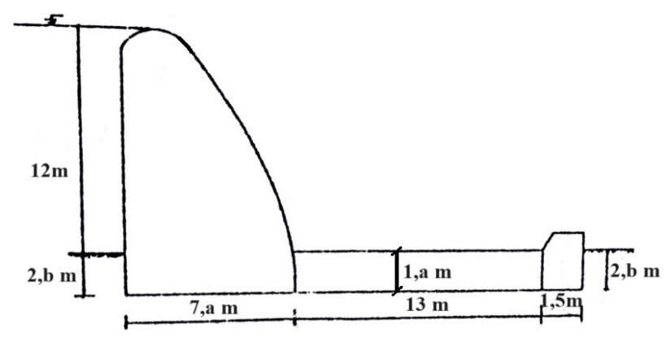

Question 8. Determine the water depths on upstream and downstream side of hydraulic jump. Maximum spillway head 3,18 m, height of the diversion weir 12,18 m and effective length of diversion weir is 60. (Take discharges from Question 5) . If downstream water level is 3,7 m, decide type of the stilling basin .If it is necessary, determine type of the energy dissipater.

