1
2
3
Preparation of Papers for Article Submission

1
2
A. Author, B. Author and C. Author
Yildiz Technical University, Civil Engineering Department, Istanbul, Turkey
email1@yildiz.edu.tr, email2@yildiz.edu.tr, email3@yildiz.edu.tr
1
D. Author
Yildiz Technical University, Department of Architecture, Istanbul, Turkey
email4@yildiz.edu.tr
1
2

Abstract
1
These instructions give you guidelines for preparing papers for INS5004 research methods and scientific ethics cource.. The abstract and paper must be in the English language. Use this document as a template if you are using Microsoft Word 6.0 or later. Otherwise, use this document as an instruction set. The electronic file of your paper must be in this format. Define all symbols used in the abstract. Do not cite references in the abstract. Maximum words shall not exceed 200 words.
1

Keywords: keywords or phrases in alphabetical order, separated by commas.
1
2

Introduction
1
When you open INS5004_FullPaper-Template.doc, highlight a section that you want to designate with a certain style, and then select the appropriate name on the style menu. The style will adjust your fonts and line spacing. Do not change the font sizes or line spacing to squeeze more text into a limited number of pages. Use italics for emphasis.
1
To insert images in Word, position the cursor at the insertion point and either use Insert | Picture | From File or copy the image to the Windows clipboard and then Edit | Paste Special | Picture (with “Float over text” unchecked).
1
2

Procedure for Paper Submission
1
Please submit your manuscript electronically for review. Follow the online submission guidelines when submitting. Please give all the required details.
1
Include full mailing addresses and e-mail addresses. This information will be used in the communication of the authors. All tables, figures, and pictures must be inserted in the text in a convenient place.
1
The paper size must be set to A4 (210x297 mm). The document margins should be the following:
- Top: 2.5 cm;
- Bottom: 2.5 cm;
- Left: 2.5 cm;
- Right: 2.5 cm.
1
It is advisable to keep all the given values. The font throughout the paper is Times New Roman with a 12-point font style, justified in one column. The title font is 16 point bold style, centered. Authors’ font is set to 14-point bold style, address 12-point bold and italic style. Email address 12 points italic style. The abstract and keywords section is justified with a font of 12-point italic style. The number of pages shall not exceed 10 pages.
1
2
Equations
1

Use the Microsoft Equation Editor for equations in your paper (Insert | Object | Create New | Microsoft Equation). “Float over text” should not be selected.

1
(1)

1

2
Results

1
Figures and Tables
1
Figures: The position of figures is centered. Place figure captions below the figures with 12-point Times New Roman centered. If your figure has two parts, include the labels (a) and (b) as part of the artwork. Please do not include captions as part of the figures. Do not put captions in “text boxes” linked to the figures. Do not put borders around the outside of your figures.
1
Figure axis labels are often a source of confusion. If label numbers are in thousands of orders use scientific numbering to represent them. Use words rather than symbols. Do not label axes only with units. Figure labels should be legible, 10-point type.
1
Table: The position of tables is centered. Place table captions above the tables with 12-point Times New Roman centered. Please do not include captions as part of the table. Do not put captions in “text boxes” linked to the table. The text and number size should be 12 points.
1

Table 1. This caption is centered.
1
 | Column 1 | Column 2
Raw 1 ($) | 60483.84 | 31518.54
Raw 2 | 3428.56 | 4475.90
1
2

1
Figure 1: This caption is centered.
1
2

References (APA 7th Edition Style)
1
Al-Bahar, J. F., & Crandall, K. C. (1990). Systematic risk management approach for construction projects. Construction Engineering and Management, 116(3), 533-546.
1
Angeli, E. L. (2012). Networks of communication in emergency medical services (Publication No. 3544643) [Doctoral dissertation, Purdue University]. ProQuest Dissertations Publishing.
1
Bach, S., & Grant, A. (2015). Communication and interpersonal skills in nursing (3rd ed.). Learning Matters.
1
Centers for Disease Control and Prevention. (n.d.). Preventing HPV-associated cancers. https://www.cdc.gov/cancer/hpv/basic_info/prevention.htm/
1
Cismas, S. C. (2010). Educating academic writing skills in engineering. In P. Dondon & O. Martin (Eds.), Latest trends on engineering education (pp. 225-247). WSEAS Press.
1
Grima, B. (2019, September 30). A 60,000-year-old cure for depression. BBC. http://www.bbc.com/travel/story/20190929-a-60000-year-old-cure-for-depression
1
Kühberger, A., Schulte-Mecklenbeck, M., & Ranyard, R. (2010). Introduction: Windows for understanding the mind. In M. Schulte-Mecklenbeck, A. Kuehberger, R. Ranyard (Eds.), A handbook of process tracing methods for decision research: A critical review and user’s guide (pp. 1-18). Psychology Press, New York.
1
Samson, J. M. (2016). Human trafficking and globalization [Unpublished doctoral dissertation]. Virginia Polytechnic Institute and State University.
1
In the references, use APA 7th Edition style. You can automatically format all your references by using Google Scholar. After searching for your reference, you can click the button shown in the red rectangle. A window shown in Figure 3 pops up, you need to copy the citation of APA. Then you can paste the copied citation to the references section. Reference list entries should be alphabetized by the last name of the first author of each work. For multiple articles by the same author or authors listed in the same order, list the entries in chronological order, from earliest to most recent.
1
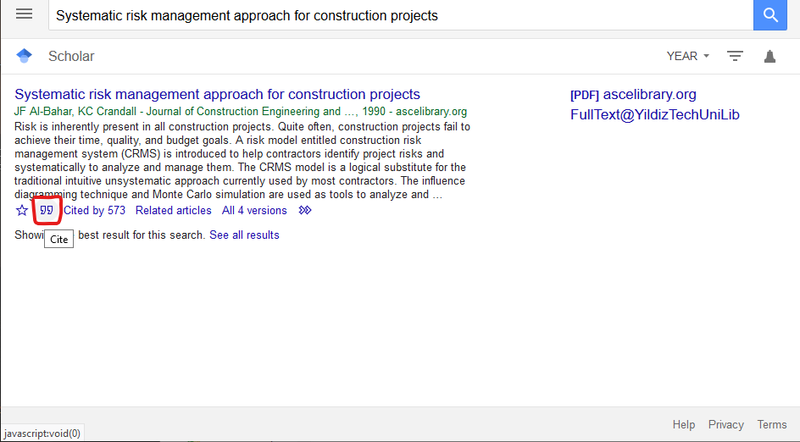
1
Figure 2: The search result window
1
2
1
Figure 3: The reference styles window
In-text citations, you should follow the author-date method. This means that the author's last name and the year of publication for the source should appear in the text, for example, (Jones, 1998) and Jones (1998). The in-text citation can vary according to the number of authors.
1
A Work by Two Authors: Name both authors in the signal phrase or in parentheses each time you cite the work. Use the word "and" between the authors' names within the text and use the ampersand in parentheses.
1
Research by Wegener and Petty (1994) supported...
1
(Wegener & Petty, 1994)
1
A Work by more than two authors: Use the first author's name followed by et al. in the signal phrase or in parentheses.
1
Harris et al. (2001) argued...
1
(Harris et al., 2001)
1
Organization as an Author: If the author is an organization or a government agency, mention the organization in the signal phrase or in the parenthetical citation.
1
According to the American Psychological Association (2000),...
1
Two or More Works in the Same Parentheses: When your parenthetical citation includes two or more works, order them the same way they appear in the reference list (viz., alphabetically), separated by a semi-colon.
1
(Berndt, 2002; Harlow, 1983)
1
Two or More Works by the Same Author in the Same Parentheses: When your parenthetical citation includes two or more works from the same author, list the years of publication in sequence, with the earliest first. Provide in-press citations last. Only list authors' surnames once for each list of dates.
1
(Hoffa, 1956, 1962, 1975)
1
Following this pattern, multiple works from multiple authors can be contained within a single parenthetical. Separate authors' sources with a semicolon. Note, however, that the author's names should be provided in the order they appear in the reference list regardless of when their sources were published.
1
(Jones, 2010, 2018, in press; Smith, 2002, 2003, 2004, 2006; Zepf, 2019)
1
Authors with the Same Last Name: To prevent confusion, use first initials with the last names.
1
(E. Johnson, 2001; L. Johnson, 1998)

You can find more information about this style via this link.

