SORU-1



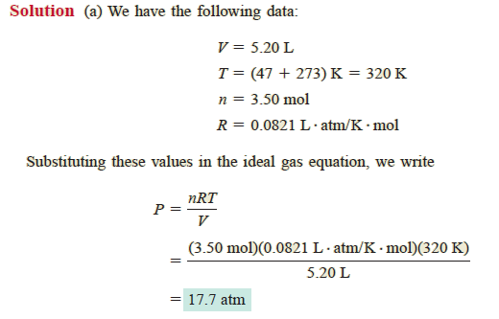

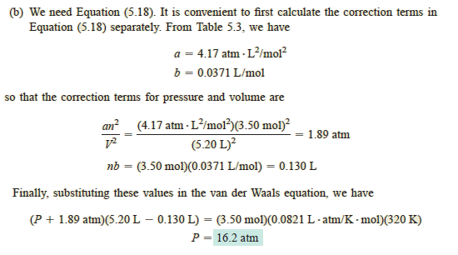

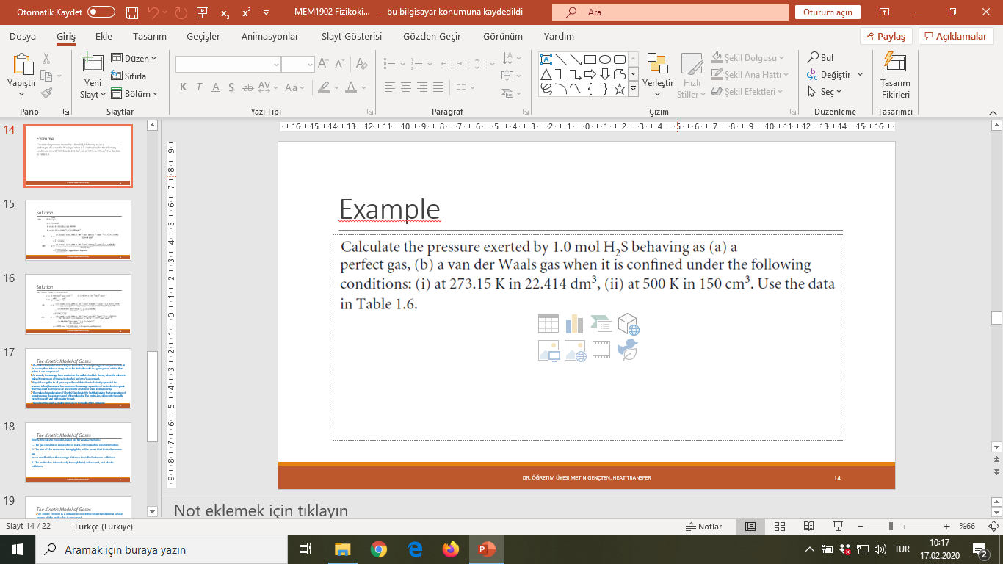

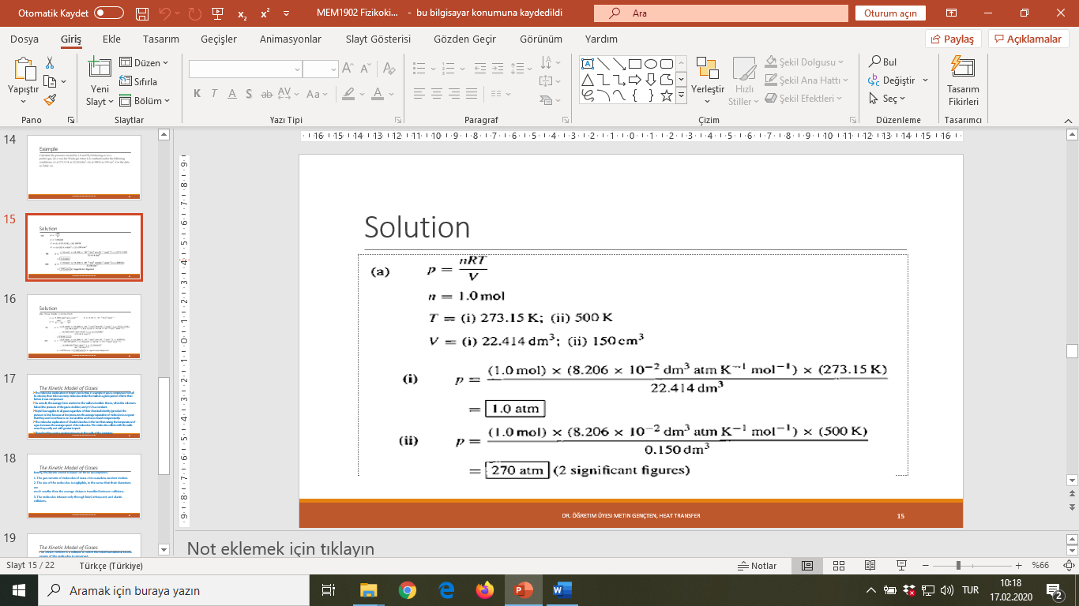

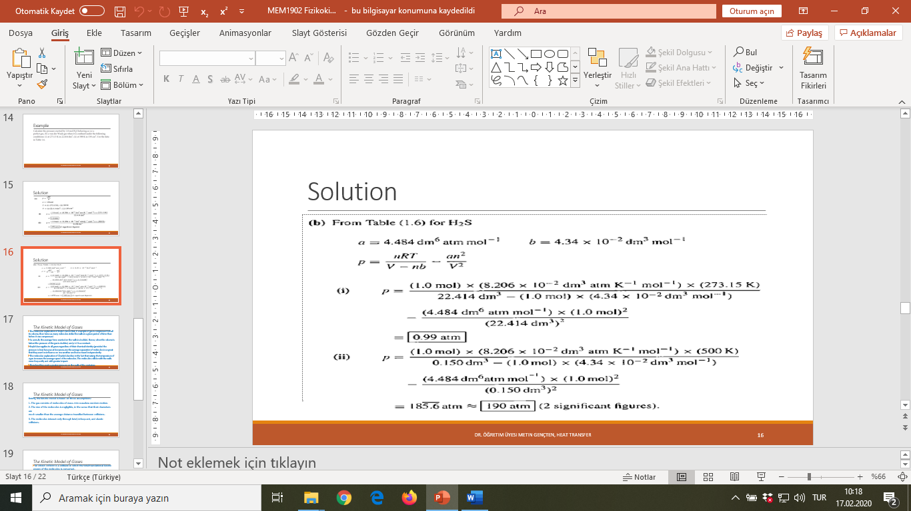

**EXAMPLE**

The mass percentage composition of dry air at sea level is approximately N2: 75.5; O2: 23.2; Ar: 1.3. What is the partial pressure of each component when the total pressure is 1.00 atm?

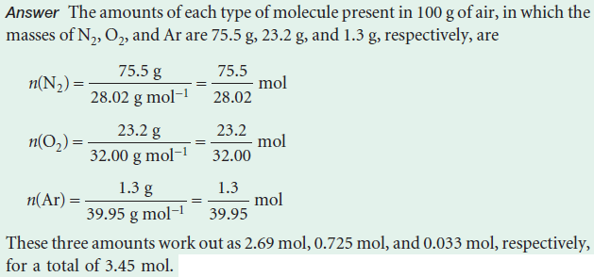

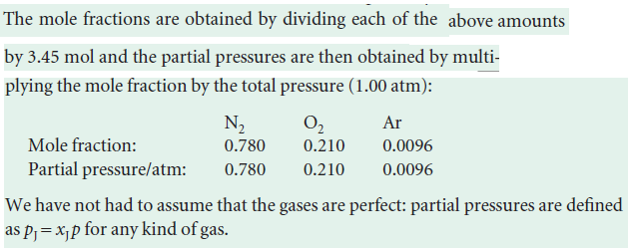

**Q2.** A vessel of volume 22.4 dm3 contains 1.5 mol H2 and 2.5 mol N2 at 273.15 K. Calculate

(a) the mole fractions of each component,

(b) their partial pressures, and

(c) their total pressure

**ANSWER 2**

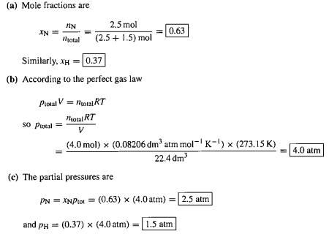



Hint: Relative humidity is the prevailing partial pressure of water vapour expressed as a percentage of the vapour pressure of water vapour at the same temperature (in this case, 35.6 mbar).

Partial pressure of water vapor = 0.6(60%) of 35.6 m bar = 0.6 * 0.0356 = 0.02136 atm

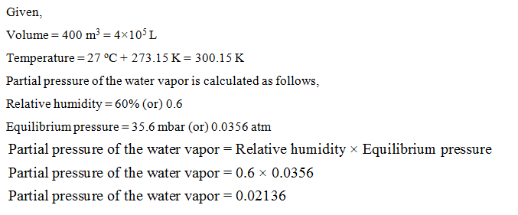

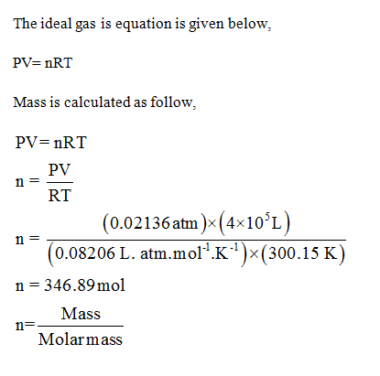

346.89 = m/18

m=6244,02 g =6.24 kg

a) Could 25 g of argon gas in a vessel of volume 1.5 dm3 exert a

pressure of 2.0 bar at 30°C if it behaved as a perfect gas? If not, what pressure

would it exert? (b) What pressure would it exert if it behaved as a van der

Waals gas?

 

Perfect gas undergoes isothermal compression, which reduces its volume by 1.80 dm3. The final pressure and volume of the gas are 1.97 bar and 2.14 dm3, respectively. Calculate the original pressure of the gas in (a) bar, (b) Torr.



PV(nT) = R = PV/nT