The chart below shows the amount of leisure time in hours in a week enjoyed by men and women of different employment status in 1998. Answer the questions below.
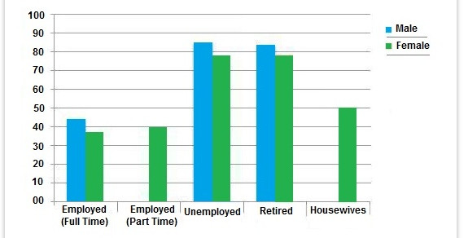

hours

- What does the provided bar graph compare?

It compares the amount of leisure time enjoyed by men and women of different employment status for the year 1998.

- Which tense should be used?

Past tense. For instance: Full time employed men enjoyed about 44 hours of leisure time while the female of this category had approximately 38 hours of leisure time.

- Which points are more important to be mentioned?

- Female - less leisure time
- Retired and unemployed men and women categories - more free time
- The lowest number of hours - full-time employed men and women
- The highest number of hours – unemployed men and women

- Write an introduction paragraph for the graph above.

- Now write the body paragraph using the points you have chosen as important in question 3. Follow the (TREND 1 – sentence with no figure) + (SPECIFIC DETAIL 1 – related info with figure) order for each. Add necessary phrases and linking words.

The graph below gives information about the preferred leisure activities of Australian male and female children in 2016. Write a report for a university lecturer describing the information shown. You should write at least 150 words.
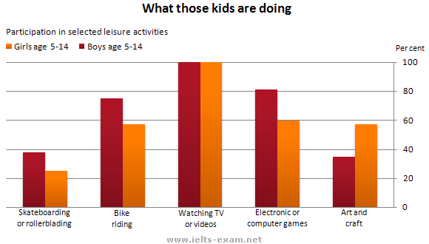
Which points are more important to be mentioned?

a)The most preferred activity for both sexes
b)The least preferred activity for both sexes
c)The activity where the biggest difference between both sexes was seen

- Write an introduction paragraph for the graph above.

- Write the body paragraph using the points you have chosen as important. Follow the (TREND 1 – sentence with no figure) + (SPECIFIC DETAIL 1 – related info with figure) order for each. Add necessary phrases and linking words.

