The chart below shows the amount of leisure time in hours in a week enjoyed by men and women of different employment status in 1998. Answer the questions below.
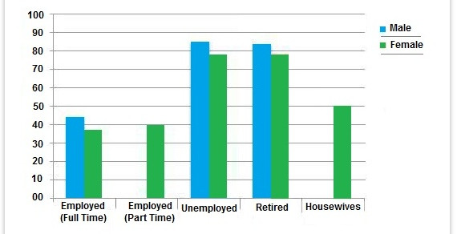

hours

- What does the provided bar graph compare?

It compares the amount of leisure time enjoyed by men and women of different employment status for the year 1998.

- Which tense should be used?

Past tense. For instance: Full time employed men enjoyed about 44 hours of leisure time while the female of this category had approximately 38 hours of leisure time.

- Which points are more important to be mentioned?

- Female - less leisure time
- Retired and unemployed men and women categories - more free time
- The lowest number of hours - full-time employed men and women
- The highest number of hours – unemployed men and women

- Write an introduction paragraph for the graph above.

The provided chart shows the number of leisure hours enjoyed by men and women in a typical week in 1998, according to gender and employment status. As is observed from the graph, the unemployed and retired men and women had more leisure time than the other type of people.

- Now write the body paragraph using the points you have chosen as important in question 3. Follow the (TREND 1 – sentence with no figure) + (SPECIFIC DETAIL 1 – related info with figure) order for each. Add necessary phrases and linking words.
First of all, among all the categories, the full time employed men and women had the shortest leisure time period. As it can be seen from the chart, males had about 45 hours and females had about 38 hours of leisure time on an average per week compared to the others.
Secondly, unemployed and retired people had the longest period for leisure activity both for men and women and men had a bit more hours than the women. As expected, the retired and unemployed people enjoyed about 78 to 90 hours of leisure time per week which is longer than the time people from other employment status stated.
Lastly, men from all types of status had more leisure time than women. Males seemed to have spent more time on leisure activities compared to females, the percentage ranging from around 8 to 50
in all categories.

The graph below gives information about the preferred leisure activities of Australian male and female children in 2016. Write a report for a university lecturer describing the information shown. You should write at least 150 words.
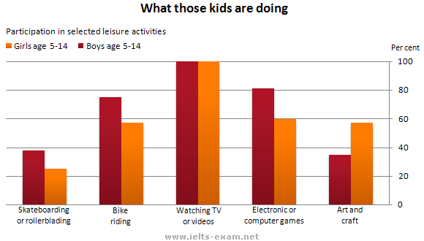

Which points are more important to be mentioned?

- The most preferred activity for both sexes
- The least preferred activity for both sexes
- The activity where the biggest difference between both sexes was seen
The graph shows the preferred leisure activities of Australian children in both sexes aged between 5-14 in 2016. As might be expected, it is clear from the data that sedentary pursuits were far more popular than active ones.
To start with, the most preferred leisure activity is watching TV or videos. Of the 10,000 children that were interviewed, all the boys and girls stated that they enjoyed watching TV or videos in their spare time.
In addition, the least popular activity turned out to be skateboarding or rollerblading. Skateboarding was relatively less popular amongst both boys and girls, although it still attracted 35% of boys and 25% of girls.
Moreover, the biggest difference between both sexes was in art and craft activities. While girls rated activities such as art and craft highly – just under 60% stated that they enjoyed these in their spare time – only 35% of boys opted for creative pastimes.

