BUILDING PHYSICS 1 / 2021-2022 FALL SEMESTER
EXERCISE ABOUT THE SOUND TRANSMISSION LOSS OF THE BUILDING ENVELOPE
Name – Surname : No:

An office building is located nearby a busy traffic road. The building envelope is a composit partition, 50 % of which is constituted from glass. Please calculate the sound transmission loss of the partition for the 1th and 2nd options by considering the required sound transmission loss of the partition. Indicate the relevant partition option and mark the values on the graph properly.
Table1. Sound transmission loss values for the 1th and 2nd options of the building partition.
Elements of the building partition |  |  | Sound transmission loss (dB)
 |  |  | 125 | 250 | 500 | 1000 | 2000 | 4000
1th option | Glass | 4 mm thick glass pane  12 mm thick air gap  4 mm thick glass pane | 21 | 22 | 25 | 35 | 37 | 31
 | Wall | 20 mm inner plaster  200mm concrete wall panel  30 mm outer plaster | 39 | 43 | 53 | 58 | 59 | 62
2nd option | Glass | 4 mm thick glass pane  100 mm thick air gap  4 mm thick glass pane  12 mm thick air gap  5 mm thick glass pane | 29 | 39 | 39 | 42 | 45 | 47
 | Wall | 20 mm inner plaster  200mm concrete wall panel  50 mm solid foam sheet  30 mm outer plaster | 40 | 43 | 43 | 59 | 60 | 63

Sound transmission loss of the composit partition Rc = R_{weak} + 10 log ($ΣS/$S_{weak})
R_{weak} = Sound transmission loss of the weaker component (dB)
$ΣS$ = Total area of the composit partition (13 m²)
S_{weak} = Area of the weaker component (6,5 m²)

Level (dB) / Frequency (Hz) | 125 | 250 | 500 | 1000 | 2000 | 4000
Traffic noise affecting the building envelope (L₁) | 77 | 74 | 71 | 71 | 68 | 62
Acceptable noise level NCB 35 (L₂) | 46 | 40 | 35 | 32 | 28 | 25
Total absorption of the space A (m²) | 14,5 | 20 | 26 | 29 | 35 | 32
R_{required}= L₁ – L₂ +10 log ($ΣS/$A)
Transmission loss of the building envelope Rc (1th option)
Transmission loss of the building envelope Rc (2nd option)
Background noise level (1th option)
Background noise level (2nd option)
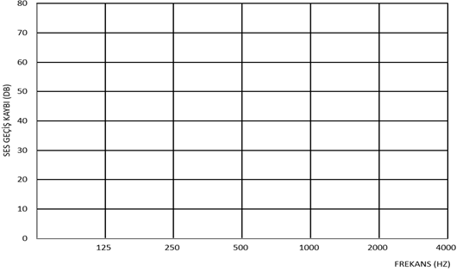
Sound transmission loss (dB)
Frequency (Hz)

