**2017-2018 FALL**

**STRENGTH of MATERIALS I, HW 3**

**YTU CIVIL ENG. FACULTY – CIVIL ENG. DEPT. MECHANICS DIV.**



**ID:**

**GROUP:**

**NAME:**

**NOTE:**

**HWs submitted after due date will not be accepted.**

**DUE DATE:**

**27.12.2017 - 28.12.2017**

**Hours are indicated at the end of this document.**

1. The cross-section of the beam shown is under the effect of  moment.
   1. Find c length such that maximum normal stress in tension is half of the maximum normal stress in compression.
   2. Using the c you have found and assuming that tensile strength is , and compressive strength is , find maximum moment that can be carried safely.

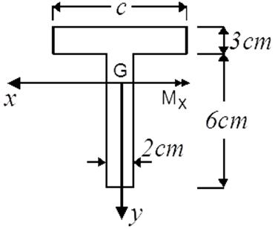

**2)** For the beam system given below, find the maximum tensile and maximum compressive normal stresses.

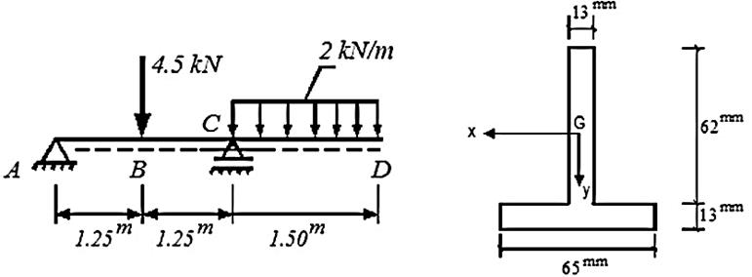

**3)** The composite beam is formed by A and B materials with ,  then,

1. What should be h so that the neutral axis passes through the interface of two materials?
2. If , then find max  moment that can be carried safely.

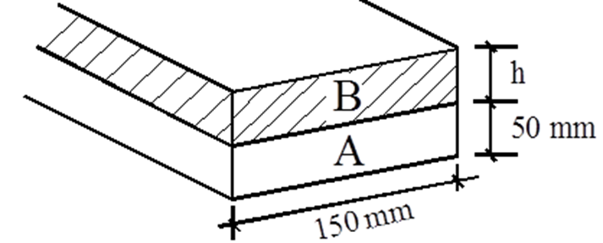

**4)**A cantilever beam with a length of  is loaded at the free end. The loading and the cross-section is depicted below. If  then,

1. Find max. P that can be carried by the beam.
2. Draw the normal stress distribution for the most critical beam section.

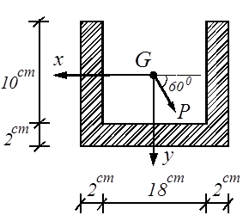

**5)**The cross-section given below is under the effect of bending moment Me. If then,

1. Find max value of bending moment Me that can be carried safely.
2. Draw the normal stress distribution diagram for max Me.

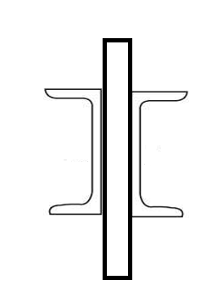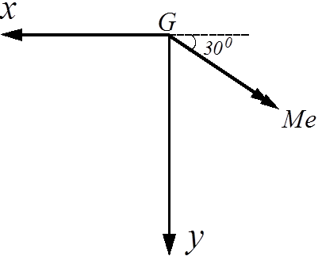

UPN 400



UPN 400

**Note:**  cross-section info:



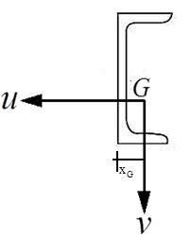

11 cm

40 cm

1.4 cm

**6)**  The cross-section of a beam is shown in the figure and it is under the effect of bending moment . Draw the normal stress distribution diagram.

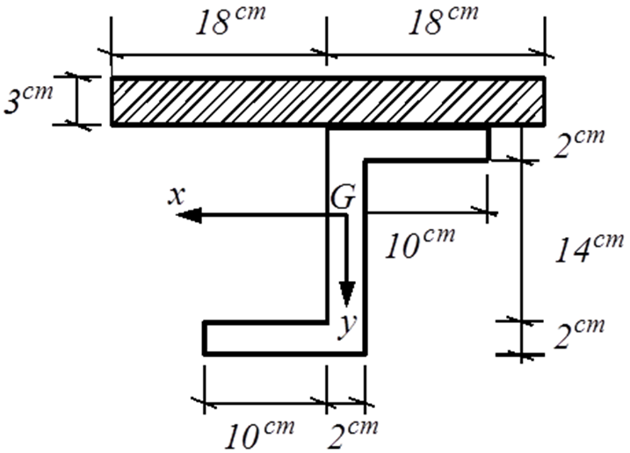

**HW SUBMISSION HOURS:**

**27.12.2017 Time: 09:00 - 17:00**

**28.12.2017 Time: 09:00-17:00**

**NOTE: HWs are to be submitted EXACTLY on time as indicated above!!**

**For all groups oral examination will be done by Res. Ass. Dr. Esra Eylem Karataş.**

**(Civ. Eng. Dept. Block B Room#1-039)**

***Answers:***

1. 
2. 



1. 
2. 
3. 
4. 
5. 
6. 
7. 