Anionic Surfactants as MBAS (Methylene blue active substances)
Surfactants are compounds that lower the surface tension of a liquid, the interfacial tension between two liquids, or that between a liquid and a solid. The term surfactant is a blend of surface active agents
Surfactants play an important role as cleaning, wetting, dispersing, emulsifying, foaming and anti-foaming agents in many practical applications and products, including:
- Detergents
- Fabric softeners
- Emulsions
- Paints
- Adhesives
- Inks
- Anti-fogs
- Ski waxes, snowboard wax
- Deinking of recycled papers, in flotation, washing and enzymatic processes
- Laxatives
- Agrochemical formulations
  - Herbicides (some)
  - Insecticides
- Quantum dot coatings
- Biocides (sanitizers)
- Cosmetics:
  - Shampoos
  - Hair conditioners (after shampoo)
  - Toothpastes
- Spermicides (nonoxynol-9)
- Firefighting
- Pipelines, liquid drag reducing agent
- Alkali Surfactant Polymers (used to mobilize oil in oil wells)
- Ferrofluids
- Leak Detectors

Some surfactants are known to be toxic to animals, ecosystems, and humans, and can increase the diffusion of other environmental contaminants Despite this, they are routinely deposited in numerous ways on land and into water systems, whether as part of an intended process or as industrial and household waste.
The two major surfactants used in the year 2000 were linear alkylbenzene sulfonates (LAS) and the alkyl phenol ethoxylates (APE). They break down in the aerobic conditions found insewage treatment plants and in soil.
Ordinary dishwashing detergent, for example, will promote water penetration in soil, but the effect would last only a few days (many standard laundry detergent powders contain levels of chemicals such as alkali and chelating agents that can be damaging to plants and should not be applied to soils). Commercial soil wetting agents will continue to work for a considerable period, but they will eventually be degraded by soil micro-organisms. Some can, however, interfere with the life-cycles of some aquatic organisms, so care should be taken to prevent run-off of these products into streams, and excess product should not be washed down
Anionic surfactants can be found in soils as the result of sludge application, wastewater irrigation, and remediation processes. Relatively high concentrations of surfactants together with multimetals can represent an environmental risk. At low concentrations, surfactant application is unlikely to have a significant effect on trace metal mobility.

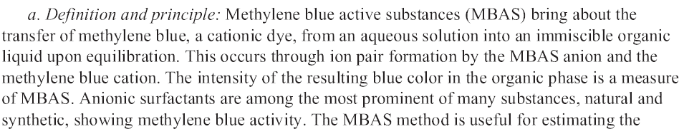
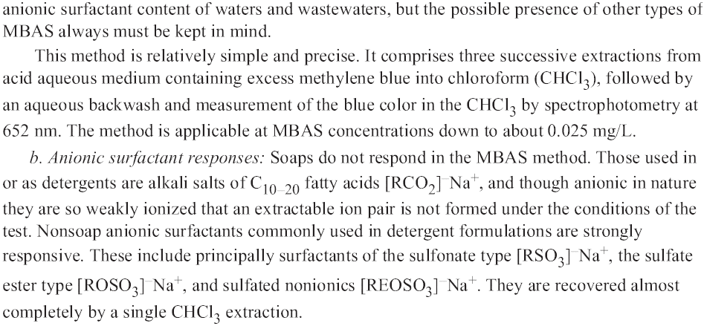
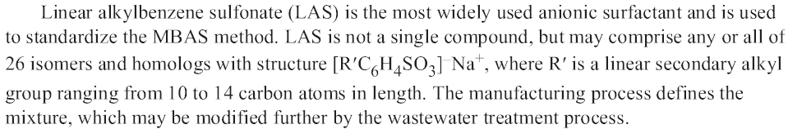

Apparatus
- Spectrophotometer, for use at 652 nm, providing a light path of 1 cm or long
- Separatory funnels, 500 mL
Reagents
- Stock LAS Solution
- Standard LAS solution
- Phenolphthalein indicator solution
- Sodium hydroxide, NaOH, 1N
- Sulfuric acid, H₂SO₄, 1N ve 6N
- Chloroform, CHCl₃
- Methylene blue reagent
- Wash solution
- Methanol, CH₃OH
- Hidrojen peroksit, H₂O₂, %30
- Glass wool
Procedure

