Yildiz Technical University,
Faculty of Naval Architecture and Maritime

[Report Name]

Authors:
Serdar Turgut İnce, [Your Name], Naval Arch. and Marine Eng. [Department]

Instructor:
Dr. Serdar Turgut İNCE
Abstract [Times New Roman, Bold, Size 12, Line space 1.5]
A report abstract is a brief summary of a calculations [Times New Roman, Size 11, Line space 1.5] It typically outlines four elements relevant to the completed work: the research focus (i.e. statement of the problem(s)); the analze methods used (experimental research, case studies, etc.); the results/findings of the experiment; and the main conclusions and recommendations.
[One empty row, Size 11, Line space 1.5]
Keywords: Experiment reports, Writing Abstract, Length of abstract
[One empty row, Size 11, Line space 1.5]
Serdar Turgut İnce*[Author]
*Yildiz Technical University, Turkey[Times, Bold], serince@yildiz.edu.tr,
[One more empty row, Size 11, Line space 1.5]

1. Introduction [Section: Times New Roman, Bold, Size 12, Line space 1.5]
The introduction is certainly the most read section of any deliverable, [Times New Roman, Size 11, Line space 1.5] and it largely determines the attitude the reader/reviewer will have toward the work. Therefore, it is probably the most delicate part of the writing of a report[To give a reference in the text, place only the authors’ last name and the date of publication in parentheses.] (Grubišić et al., 1990). An Introduction should contain the following three parts:

You should find the following question in introduction: Why do we need this analysis? What is the purpose of it? How and where did you get the data?
If you write an equation in this section you should use this format (Eq1).
$F=m\frac{dv}{dt}$ [Equation aligned left, Equation number aligned right] (1)
[One empty row, Size 11, Line space 1.5]
2. The Method of Analyze [Section: Times New Roman, Bold, Size 12, Line space 1.5]
What kind of calculations have you performed? Where did you get the data?
[One empty row, Size 11, Line space 1.5]
2.1. Calculations and graphs [Sub-section: Bold, Size 11, Line space 1.5]
Explain step by step calculations and graphs (Zadeh, 1978). If you use a figure in text, you should mention in text. An example of the figure is shown in Fig 1.
[One empty row, Size 11, Line space 1.5]

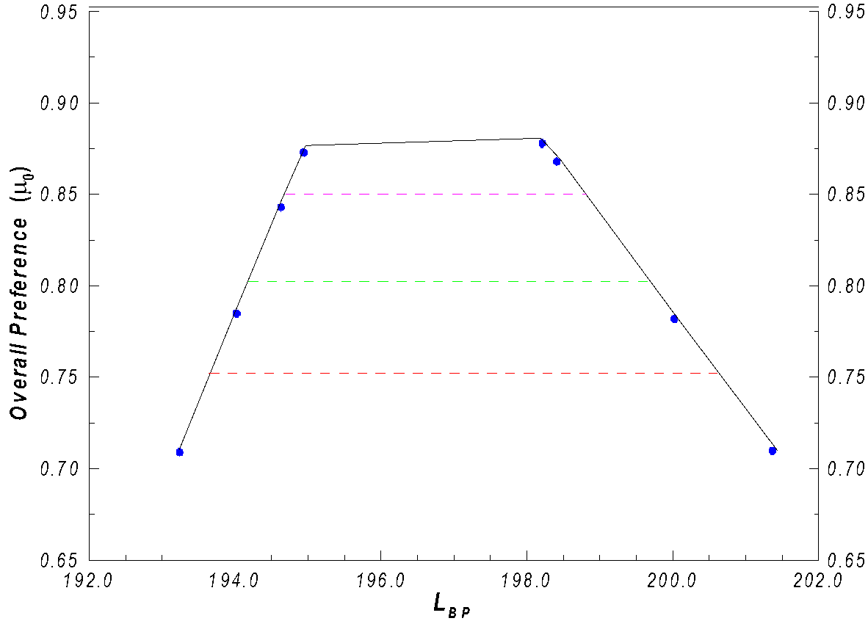
Fig. 1. The α-cuts of ship length at given overall preferences
[Figure captions, Times New Roman, Size 10, Paragraph Before: 0.8 pt, Line space 1.5]
[One empty row, Size 11, Line space 1.5]
2.2. Uncertainty analysis [Sub-section: Bold, Size 11, Line space 1.5]
You need to explain the accuracy of the analysis and calculate the uncertainties. An example of the table is shown in Table 1. Mention about errors and uncertainty.
[One empty row, Size 11, Line space 1.5]
Table 1. Intervals of design variables [Centred, Size 10, Paragraph After=4 pt]
Design variable | d₁ | d ₂ | d ₃ | d ₄ | d ₅ | d ₆
Minimum value | 184.00 | 23.80 | 6.40 | 0.900 | 0.610 | 0.590
Maximum value | 200.00 | 32.25 | 7.40 | 0.950 | 0.640 | 0.710
[One empty row, Size 11, Line space 1.5]
3. Conclusions
Please find the answer of the following questions in this section: What did you obtain? How is the price list of the product and uncertainties, recommendations. Last but not least, giving reference is important. If you get the product information from somewhere else you should decelerate it. Take care with the reference sequence.
[One empty row, Size 11, Line space 1.5]
References [Times New Roman, Bold, Size 12, Line space 1.5]
Grubišić, I., Žanić, V. and Trincas, G. (1990). Concept Design System for Interactive Optimization of Fishing Vessels. Proceedings of the ICED-90, Dubrovnik, Hubka and Kostelić Editors, Vol. 1, pp. 463-470.
Zadeh, L.A. (1978). Fuzzy Sets as a Basis for a Theory of Possibility. Fuzzy Sets and Systems, Vol. 1, pp. 3-28.
[For all reference items: List in alphabetical order with respect to author surnames. Only author names are bold, Times New Roman, Size 10, Line space 1, Paragraph After 8 pt]

